FOR IMMEDIATE RELEASE
MAY 15, 2019

BEN PLATT COMES TO RADIO CITY MUSIC HALL
ON SEPTEMBER 29, 2019

GRAMMY®, TONY®, AND EMMY® AWARD-WINNER MAKES ANNOUNCEMENT DURING
SOLD-OUT NYC SHOW LAST NIGHT

- PRE-SALE BEGINS 5/28 + GENERAL ON-SALE ON 5/31 -

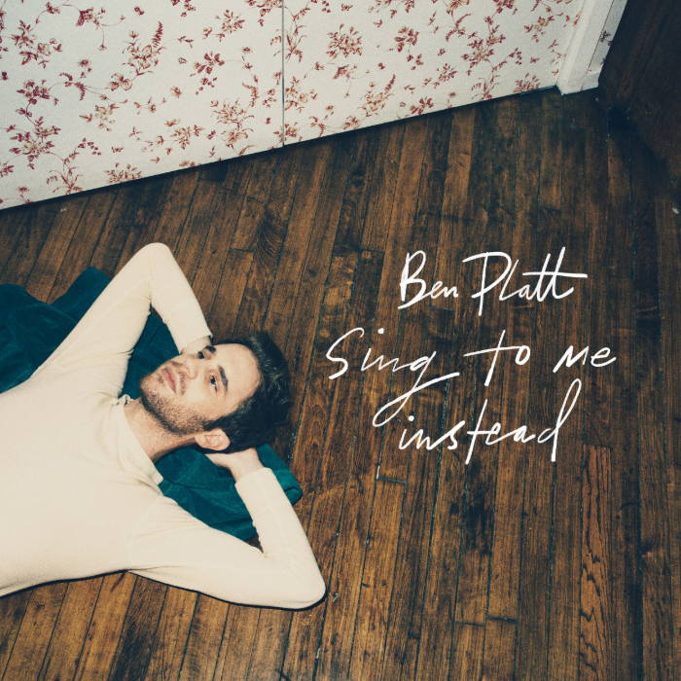
download hi-res album artwork download hi-res press image

Grammy®, TONY®, and Emmy® Award-winning artist Ben Platt has announced official details of his upcoming show at Radio City Music Hall on September 29, 2019. The concert follows a sold-out show yesterday evening at New York City’s Beacon Theatre – during which Platt first broke the news of the September show to fans in the audience – and a wildly successful tour with stops throughout the US and Canada in support of Platt’s debut solo LP Sing to Me Instead.

General on-sale for his show at Radio City Music Hall will begin on Friday, May 31 @ 10 AM (local). American Express® Card Members can purchase tickets before the general public beginning Tuesday, May 28 at 10 AM (local) through Thursday, May 30 at 10 PM (local). A limited number of VIP packages will be available, including post show receptions with Ben, meet & greets, photos, Q&A’s and more.

This March, Platt released his eagerly awaited album – Sing to Me Instead – available now via all digital music retailers and streaming services. The album has proved a full-fledged sensation, amassing over 60 million global streams and earning acclaim from fans and critics alike. Highlights include “Bad Habit,” “Ease My Mind,” “Grow As We Go,” and “Temporary Love,” all of which are joined by official companion videos streaming now HERE.

“Sing to Me Instead is a pop record with a singer-songwriter sensibility, inspired by the likes of Joni Mitchell and James Taylor, blended with the soulful styling of Stevie Wonder and Ray Charles”
– ENTERTAINMENT WEEKLY

“…earnest vocals and achingly specific lyrics…” – USA TODAY

“‘Bad Habit’ and ‘Ease My Mind’ showcase Platt’s signature vibrato and guttural vulnerability” – LOS ANGELES TIMES

“A consummate live performer who embraces vulnerability” – BILLBOARD

The winner of the 2017 Tony Award for Best Leading Actor in a Musical for his performance as Evan Hansen in the smash hit, Dear Evan Hansen, Platt is one of today’s most extraordinary talents – a truly multi-faceted actor, singer, and all-around performer. Sing to Me Instead sees him making a remarkable arrival as recording artist and songwriter, co-writing all of the album’s songs. Tracks like “Bad Habit” and “Ease My Mind” reveal a striking, deeply emotive amalgam of classic popcraft with sweeping vocals and Platt’s own undeniable charm and versatility.

Sing to Me Instead marks Platt’s first recorded output since his stunning duet with Lin-Manuel Miranda in March 2018 on “Found/Tonight.” The track – which debuted at No. 1 on Billboard's Digital Song Sales chart – was an installment in Miranda’s ‘Hamildrop’ series, and featured vocals from both men in an original medley of “The Story of Tonight” from Hamilton and “You Will Be Found” from Dear Evan Hansen.

Prior to “Found/Tonight,” Platt appeared as a lead vocalist on Dear Evan Hansen (Original Broadway Cast Recording), Atlantic Records’ Grammy® Award-winning companion to the Tony® Award-winning musical. One of only seven cast albums to reach the top 20 of the Billboard 200 in the last 50 years, the LP made a momentous chart debut upon its initial February 2017 release, entering the Billboard 200 at #8 – the highest debut position for an original cast album since 1961, and second highest digital sales debut ever for a cast album.

Platt received a Grammy® Award for his role on the Dear Evan Hansen (Original Broadway Cast Recording), as well as a 2018 Daytime Emmy Award for his part in the cast’s powerful performance of “You Will Be Found” on NBC’s TODAY. His rapidly growing body of work also includes memorable roles in the Tony® Award-winning original Broadway production of The Book of Mormon and the blockbuster films, Pitch Perfect and Pitch Perfect 2, amongst many others. Platt will next lead an all-star cast in the much-anticipated new series, The Politician, produced by Ryan Murphy, Brad Falchuk, and Ian Brennan (Glee) and co-starring Jessica Lange, Gwyneth Paltrow, and Zoey Deutch. Co-executive produced by Platt, The Politician will premiere September 27 on Netflix. He most recently starred in “Run This Town” – which premiered at this year’s SXSW Film Festival – and the upcoming film “Broken Diamonds.”

+++
CONNECT WITH BEN PLATT
TWITTER
FACEBOOK
INSTAGRAM

