FOR IMMEDIATE RELEASE
MARCH 29, 2019

BEN PLATT UNVEILS SING TO ME INSTEAD

GRAMMY®, TONY®, AND EMMY® AWARD-WINNER
RELEASES HIGHLY ANTICIPATED DEBUT ALBUM

PLATT CELEBRATES RELEASE DAY WITH TWO LIVE PERFORMANCES
ON NBC’S TODAY – “OLDER” AND “GROW AS WE GO”

NORTH AMERICAN HEADLINE TOUR GETS UNDERWAY MAY 3RD IN CHICAGO

SING TO ME INSTEAD AVAILABLE EVERYWHERE NOW

(DOWNLOAD HI-RES ALBUM ARTWORK)

GRAMMY®, Tony®, and Emmy® Award-winner Ben Platt has officially announced today’s release of his highly anticipated debut album. SING TO ME INSTEAD is available now via Atlantic Records at all music retailers and streaming services.

Platt celebrated the arrival of SING TO ME INSTEAD earlier this morning with a stellar pair of performances on NBC’s TODAY, including renditions of the LP’s “Older” and “Grow As We Go,” (watch here: Older | Grow As We Go). Next week will see the acclaimed star performing “Older” on CBS’s The Late Late Show with James Corden, set for Tuesday, April 2nd (check local listings). Platt has already heralded SING TO ME with a number of high profile TV appearances, including “Bad Habit” on CBS’ The Late Show with Stephen Colbert and “Temporary Love” on the nationally syndicated Ellen DeGeneres Show.

SING TO ME INSTEAD has already proved a full-fledged sensation, with tracks released thus far earning more than 16 million global audio and video streams in the weeks leading up to the LP release. Highlights include “Bad Habit,” “Ease My Mind,” “Grow As We Go,” and “Temporary Love,” all of which are joined by official companion videos streaming now at Platt’s official YouTube channel HERE.

In addition to an incredible response from fans, the tracks have been greeted by critical acclaim, with the Los Angeles Times declaring, “‘Bad Habit’ and ‘Ease My Mind’ showcase (Platt’s) signature vibrato and guttural vulnerability. The piano-driven ballads begin a story of love and loss that’s told on his debut solo album.”

Platt is currently gearing up for his highly anticipated SING TO ME INSTEAD headline tour, set to kick off May 3rd at Chicago, IL’s famed Chicago Theatre and travel through North America, culminating with a show at Los Angeles, CA’s iconic Dolby Theatre on May 24th (see attached itinerary). The tour – which features support from Wrabel and Ben Abraham – includes a sold out performance at New York City’s historic Beacon Theatre, a date which completely sold out during the initial pre-sale period. A limited number of VIP packages are available, including post show receptions with Platt, photos, Q & A’s and much more.

The announcement of SING TO ME INSTEAD was celebrated with exclusive performances from Platt at New York’s Bowery Hotel and Los Angeles’ The Nice Guy, followed by returns to both cities for a pair of extraordinary pop-up events. The immersive gallery installations – which saw surprise performances each night from Platt himself – drew unprecedented demand, including three packed nights on NYC’s Lower East Side, and an unplanned second performance added in Los Angeles due to the sheer number of fans lined up down the street and around two blocks.

The winner of the 2017 Tony® Award for Best Leading Actor in a Musical for his performance as Evan Hansen in the smash hit, Dear Evan Hansen, Ben Platt is one of today’s most extraordinary talents – a truly multi-faceted actor, singer, and all-around performer. SING TO ME INSTEAD sees him making a remarkable arrival as recording artist and songwriter, co-writing all of the album’s 12 songs. Described by its creator as “an amalgam of a bunch of different relationships in my past, and the very small amount that I’ve learned while grappling with love and romance,” the LP is marked by a striking, deeply emotive brand of classic popcraft, enlivened with sweeping vocals and Platt’s undeniable charm and versatility.

SING TO ME INSTEAD marks Platt’s first recorded output since his duet with Lin-Manuel Miranda on “Found/Tonight,” a featured installment in the remarkable HAMILDROP series. The track – which debuted at #1 on Billboard’s “Digital Song Sales” chart – sees the two Broadway superstars teaming up for an original medley of Hamilton’s “The Story of Tonight” with “You Will Be Found” from Dear Evan Hansen.

Prior to that, Platt was featured as lead vocalist and star of 2017’s DEAR EVAN HANSEN (ORIGINAL BROADWAY CAST RECORDING), Atlantic Records’ GRAMMY® Award-winning companion to the Tony® Award-winning musical. One of only seven cast albums to reach the top 20 of the Billboard 200 in the last 50 years, the LP made a momentous chart debut upon its initial February 2017 release, entering the SoundScan/Billboard 200 at #8 with sales equivalents in excess of 28,000 – the highest debut position for an original cast album since 1961 and second highest digital sales debut ever for a cast album.

In addition to his Tony® Award triumph, Platt received a GRAMMY® Award for his role on the DEAR EVAN HANSEN (ORIGINAL BROADWAY CAST RECORDING), as well as a 2018 Daytime Emmy Award for his part in the cast’s powerful performance of “You Will Be Found” on NBC’s TODAY. His rapidly growing body of work also includes memorable roles in the Tony® Award-winning original Broadway production of The Book of Mormon and the blockbuster films, Pitch Perfect and Pitch Perfect 2, amongst many others. Platt will next lead an all-star cast in the much-anticipated new series, The Politician, produced by Ryan Murphy, Brad Falchuk, and Ian Brennan and co-starring Jessica Lange, Gwyneth Paltrow, and Zoey Deutch. Co-executive produced by Platt, The Politician will premiere on Netflix on September 27th. Platt will also star in the upcoming film Run This Town, which earned wide-ranging praise upon its premiere earlier this month at Austin, TX’s SXSW Film Festival.

CONNECT WITH BEN PLATT
TWITTER
FACEBOOK
INSTAGRAM
BEN PLATT – SING TO ME INSTEAD
(Atlantic Records)

TRACKLISTING
1. Bad Habit
2. Ease My Mind
3 Temporary Love
4. Grow As We Go
5. Honest Man
6. Hurt Me Once
7. New
8. Better
9. Share Your Address
10. In Case You Don’t Live Forever
11. Older
12. Run Away

# # #
SING TO ME INSTEAD TOUR – NORTH AMERICA 2019
{w/ support from Wrabel and Ben Abraham}

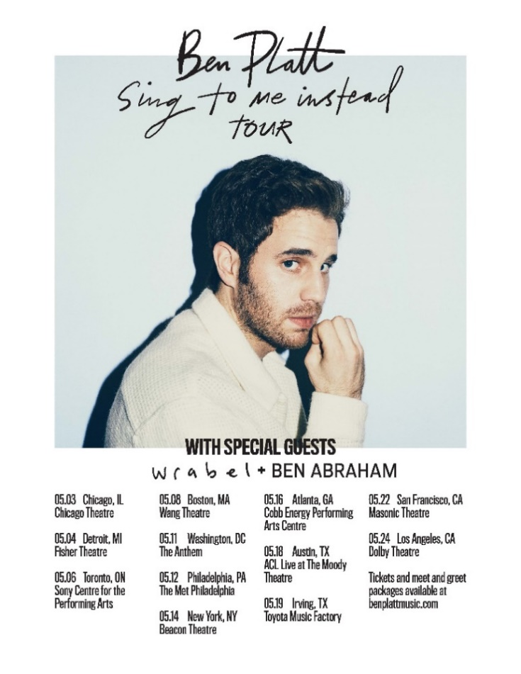
MAY
3 – Chicago, IL – Chicago Theatre
4 – Detroit, MI – Fisher Theater
6 – Toronto, ON – Sony Centre for the PA
8 – Boston, MA – Wang Theatre
11 – Washington DC – The Anthem
12 – Philadelphia, PA – The Met Philadelphia
14 – New York, NY – Beacon Theatre *SOLD OUT*
16 – Atlanta, GA – Cobb Energy PAC
18 – Austin, TX – ACL Live at The Moody Theatre
19 – Irving, TX – Toyota Music Factory
22 – San Francisco, CA – Warfield Theatre
24 – Los Angeles, CA – Dolby Theatre

# # #

