FOR IMMEDIATE RELEASE
MARCH 8, 2019

BEN PLATT DELIVERS FOURTH SOLO TRACK
“TEMPORARY LOVE” –
JOINED BY OFFICIAL VIDEO

GRAMMY, TONY, AND EMMY AWARD WINNER SET TO
PERFORM ON ELLEN MARCH 14TH

TRACK ARRIVES OFF EAGERLY AWAITED DEBUT SOLO ALBUM
‘SING TO ME INSTEAD’ – OUT EVERYWHERE MARCH 29TH

NORTH AMERICAN HEADLINE TOUR KICKS OFF MAY 3RD IN CHICAGO –
NYC SHOW SELLS OUT DURING PRE-SALE PERIOD ALONE

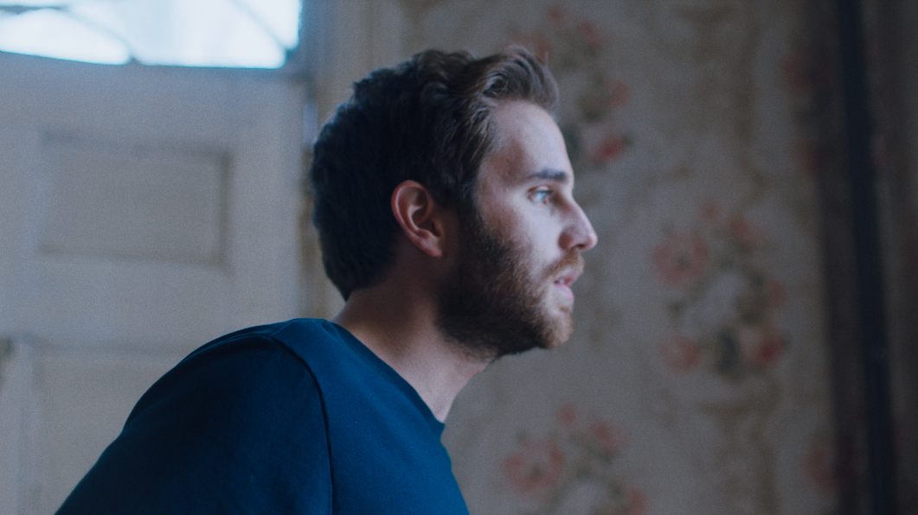

WATCH HERE: https://youtu.be/3dbdzbGED5Q

Grammy®, TONY®, and Emmy® Award-winning artist Ben Platt delivers a new track “Temporary Love,” the fourth song to be released off his debut solo album Sing to Me Instead, out everywhere Friday, March 29th via Atlantic Records. The song comes accompanied by an official music video directed by Nick Lieberman – view HERE.

Platt will make the broadcast debut of “Temporary Love” with a performance and interview on The Ellen DeGeneres Show on Thursday, March 14th (airs 3pm in New York and Los Angeles on NBC; check local listings in other markets).

The visual for “Temporary Love” follows a trilogy of videos unveiled over the past month, all directed by Lieberman. Last week’s release – the video for “Grow As We Go” – also starred dancers Rudy Abreu and Effie Tutko.

Platt made his solo debut last month with the release of “Bad Habit” and “Ease My Mind,” the latter of which starred Platt alongside acclaimed actor Charlie Carver and premiered via People Magazine. The two tracks were met with acclaim from fans and critics alike, with the Los Angeles Times declaring “‘Bad Habit’ and ‘Ease My Mind’ showcase [Platt’s] signature vibrato and guttural vulnerability.”

Last month, Platt outlined details for a North American headline tour in support of the album, set to kick off May 3rd. The tour will include a stop at New York’s Beacon Theatre on May 14th, a date which sold out during the pre-sale period before general on-sale for the tour had even begun. With stops throughout the US and Canada, the run will feature support from Wrabel and Ben Abraham and culminate with a show at LA’s iconic Dolby Theatre on May 24th (full itinerary enclosed). A limited number of VIP packages will be available, including post show receptions with Ben, meet & greets, photos, Q&A’s and more.

Platt recently stopped by “The Late Show with Stephen Colbert” for the stunning television debut performance of “Bad Habit” – watch HERE. This followed exclusive performances from Platt at New York’s Bowery Hotel and LA’s The Nice Guy, as well as a three-night immersive gallery installation for fans in Manhattan’s Lower East Side, marked by surprise performances each night from Platt himself.

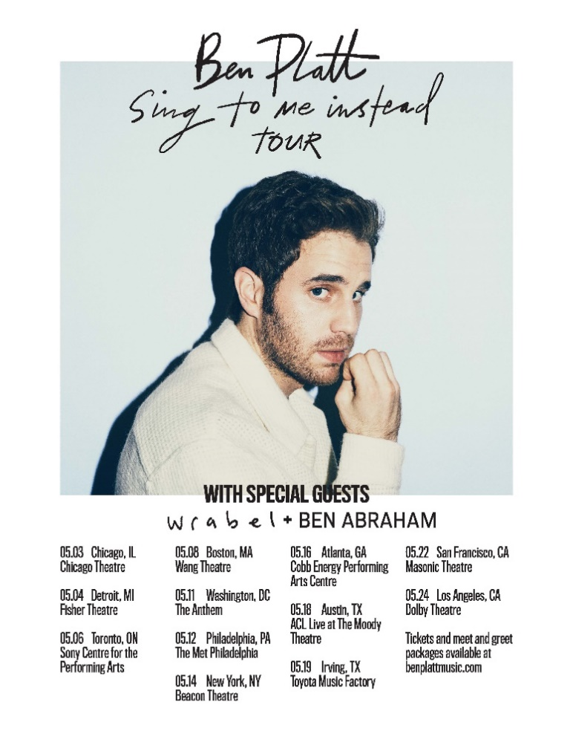

SING TO ME INSTEAD TOUR – 2019
Friday, May 3 | Chicago, IL | Chicago Theatre
Saturday, May 4 | Detroit, MI | Fisher Theater
Monday, May 6 | Toronto, ON | Sony Centre for the PA
Wednesday, May 8 | Boston, MA | Wang Theatre
Saturday, May 11 | Washington DC | The Anthem
Sunday, May 12 | Philadelphia, PA | The Met Philadelphia
Tuesday, May 14 | New York, NY | Beacon Theatre **SOLD OUT**
Thursday, May 16 | Atlanta, GA | Cobb Energy PAC
Saturday, May 18 | Austin, TX | ACL Live at The Moody Theatre
Sunday, May 19 | Irving, TX | Toyota Music Factory
Wednesday, May 22 | San Francisco, CA | Warfield Theatre
Friday, May 24 | Los Angeles, CA | Dolby Theatre
+++

CONNECT WITH BEN PLATT
TWITTER
FACEBOOK
INSTAGRAM

