FOR IMMEDIATE RELEASE
SEPTEMBER 17, 2020

BETCHA ARE BACK WITH “DÉJÀ VU”

NASHVILLE-BASED ALT-ROCKERS UNVEIL ANTHEMIC NEW SINGLE

NEW TRACK HERALDS EAGERLY AWAITED SOPHOMORE EP,
FEELS LIKE WE’VE BEEN HERE BEFORE DUE FRIDAY, OCTOBER 16TH

LISTEN TO “DÉJÀ VU” HERE
WATCH THE LYRIC VIDEO HERE
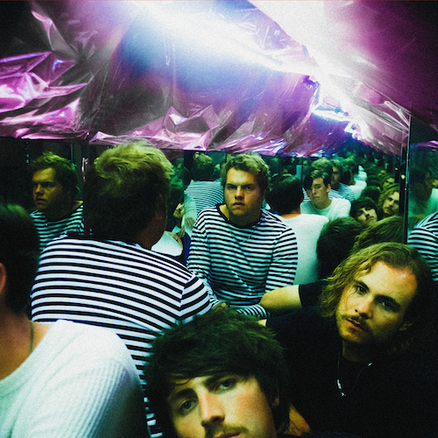
DOWNLOAD ARTWORK HERE

“Betcha are about to be your new favorite alt-rockers.”
– BILLBOARD

“Betcha is one of those bands you should get to know…They are carving their own path and have a distinctness to their sound.”
– BAEBLE

“If you have any concerns about the softening presence of rock in today's music landscape, Betcha is here to remind you that rock is healthy, thriving, and here to stay.”
– ONES TO WATCH

Atlantic Records recording group Betcha has dropped their anthemic new single “Déjà Vu” – available now HERE. The track is joined by an official lyric video, directed by Nashville-based filmmaker Joey Brodnax, streaming now on the band’s official YouTube channel HERE.

The band has also announced the eagerly awaited release of their forthcoming sophomore EP, Feels Like We’ve Been Here Before, arriving on Friday, October 16th. In addition to “Déjà Vu,” Feels Like We’ve Been Here Before further features such widely lauded singles as “If That’s Alright,” “July,” and “Closer To The Sun.”

“If That’s Alright” arrived earlier this year alongside an official companion video featuring a special guest appearance from the Nashville-based band’s good friend, acclaimed troubadour Briston Maroney. Written by Betcha with producer Brian Phillips (blink-182, Saint Motel), the track was met by effusive applause from the likes of Billboard, which named it one of “20 Great Songs To Discover While You're Quarantined,” writing, “The uber-catchy ‘If That’s Alright’ will have you dreaming of sunnier days.” The “upbeat, undeniably catchy” “If That’s Alright” “maintains its rock-infused heart, while also merging in elements of pop,” raved Ones To Watch, adding simply, “Betcha is an electric reminder of why we love rock.”

Produced by Nick Furlong (blink-182, WALK THE MOON, All Time Low, 5 Seconds of Summer), “July” kickstarted the summer with a wave of acclaim from such publications as Alternative Press, which hailed the track as an “undeniably catchy rock tune [that’s] perfect for summer playlists that still need a little bit of edge and a heavy dose of rock grit.” The band performed an exclusive stripped down “Live At Home” performance of “July” that can be viewed HERE.

The high energy “Closer To The Sun” dropped last month, accompanied by a delightful official video, hailed as “brilliant” in its exclusive premiere via Bring The Noise; the clip – once again, directed by Joey Brodnax. In addition, a stripped-down “Closer To The Sun (Acoustic Version)” is streaming HERE.

Feels Like We’ve Been Here Before follows Betcha’s acclaimed debut EP, FALLING, which includes fan favorites such as “Lucy Lucy,” “Coincidental,” and the ebullient title track, the latter of which was featured on The CW’s smash series, Riverdale. In addition, all three tracks are joined by official music videos, streaming now via YouTube HERE.

Known for an irrepressible stage presence honed on countless local stages and national tours alongside such like-minded acts as Kaleo, NEEDTOBREATHE, Matt Maeson and Judah The Lion, Betcha hope to return to the road when it is safe to do so. The band recently performed live in their trusty touring van for Jam In The Van’s “Jam In YOUR Van” fundraiser, with proceeds benefitting the Sweet Relief Musician Fund’s COVID-19 Fund. The full-length performance is streaming now HERE.

ABOUT BETCHA
Betcha – Charlie Green (vocals, guitar), Ben Booth (lead guitar), Taylor Dubray (bass, keys), and Chase Wolford (drums) – first united at Nashville’s Belmont University, winning a school-sponsored “Battle of the Bands” whilst still known as Wilder. Fueled by support from GRAMMY® Award-winning producer Jacquire King (Kings of Leon, Kaleo), the band recorded a series of demos that ultimately saw them signed to the legendary Atlantic Records roster. In 2018, they rechristened themselves as Betcha – an amalgamation of the first letters of each member’s name (Ben, Taylor, Charlie, and Chase) – and moved into a shared house in Nashville where they still hang out, writing, recording, and pushing their unique strain of 21st century rock music further than ever before.

Indeed, Betcha has quickly drawn wide-ranging critical applause for their idiosyncratic fusion of sweetly stoned rock, alternative electronica, and punchy pop anthems. “Betcha is one of those bands you should get to know,” raved Baeble. “They are carving their own path and have a distinctness to their sound.” Ones To Watch hailed “Lucy Lucy” as an “alternative rock banger with vintage vibes,” while further commending the band for “a dynamic sound that spans across alternative rock and pop.”

Feels Like We’ve Been Here Before
Tracklisting
- Déjà Vu
- July
- Pleasure
- Talking to Myself
- Still Love You
- If That’s Alright
- Closer to the Sun

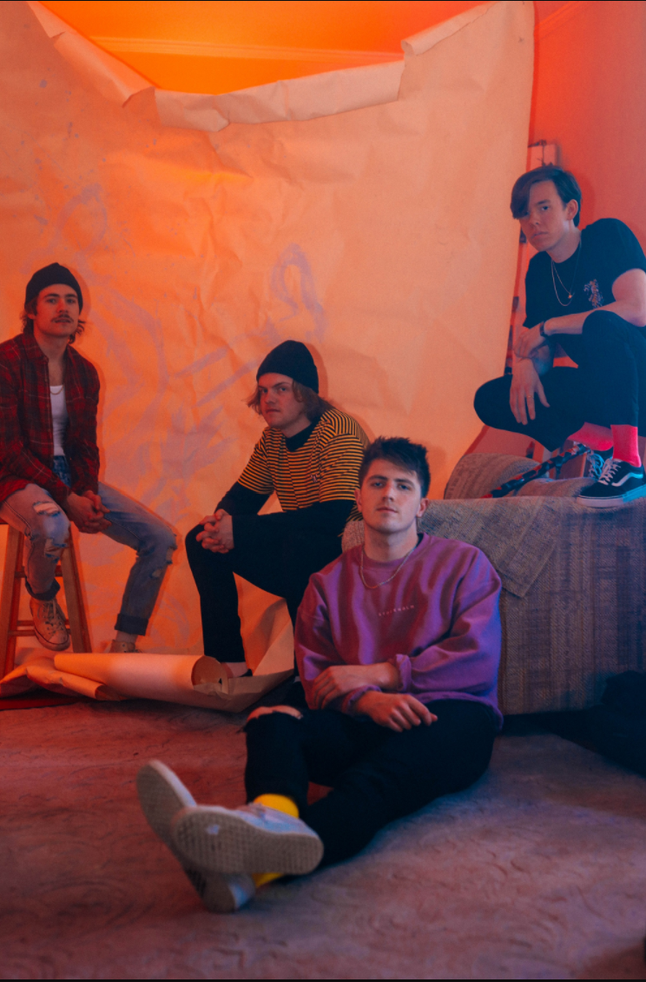
DOWNLOAD PRESS PHOTOS HERE

# # #

CONNECT WITH BETCHA
OFFICIAL | FACEBOOK | INSTAGRAM | TWITTER | YOUTUBE

For press inquiries, please contact
Jessica Nall // Jessica.Nall@atlanticrecords.com

