

**AVONLEA RELEASES INSIGHTFUL AND REFLECTIVE**

**NEW SINGLE “BIG KID”**

**SINGLE TO BE FEATURED IN NETFLIX’S**

**HIGHLY ANTICIPATED “TALL GIRL”**

**DOWNLOAD/STREAM:**

[**https://Avonlea.lnk.to/BigKidPR**](https://nam04.safelinks.protection.outlook.com/?url=https%3A%2F%2FAvonlea.lnk.to%2FBigKidPR&data=02%7C01%7CMegan.Rasmussen%40atlanticrecords.com%7C3ad2cda5f64b41f8da2b08d7362d0b2c%7C8367939002ec4ba1ad3d69da3fdd637e%7C0%7C0%7C637037439391193248&sdata=VkUJF3pezYhWo3%2FATdX7dLeVdTy%2Bm1LOcbsBQjOe6lU%3D&reserved=0)

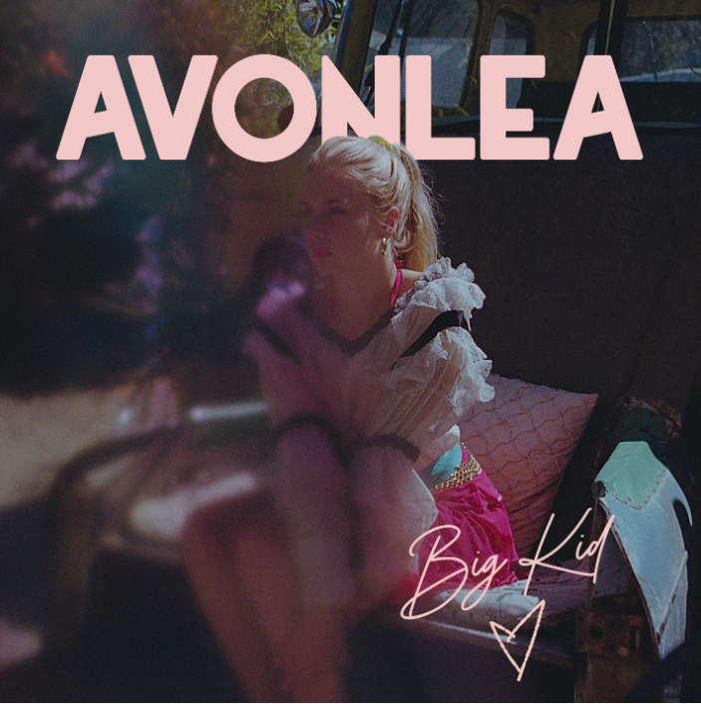

**\****Download Art*[**HERE**](https://warnermusicgroup.app.box.com/s/r3i86a5elthj19ug4r2iuvrsxqsw1wez)*\**

Today, rising singer-songwriter **Avonlea** releases her newest single “Big Kid,” available now at all DSPs and streaming services [HERE](https://Avonlea.lnk.to/BigKidPR). The brand new single is being released ahead of its feature in Netflix’s new original movie “Tall Girl” which takes on teenage insecurities and dramatic love triangles. Avonlea’s superb talent and irresistibly catchy songs are solidifying her as a new artist to watch.

***“Ever since I was little I wanted to be older,”*** Avonlea recalls, ***“I waited my whole life to be 18 and to finally be taken seriously. That never happened. This song is about my expectations for the person I thought I’d become”.***

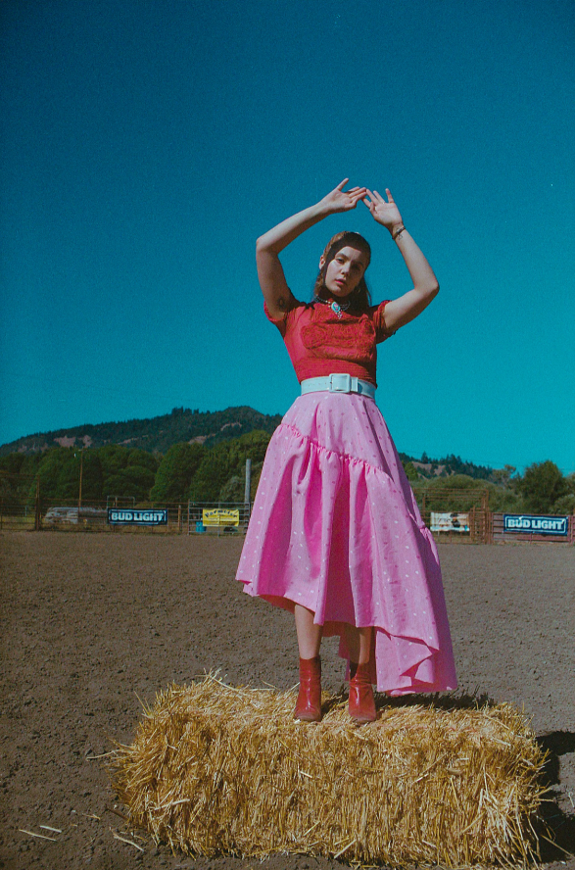 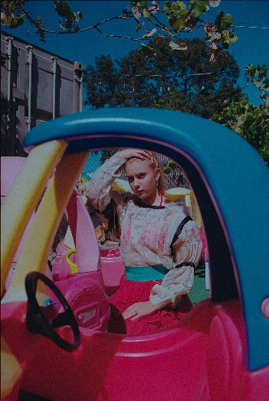

The release of “Big Kid” follows Avonlea’s previously released tracks, “[Stranger](http://avonlea.lnk.to/StrangerPR)” and “[Again](http://avonlea.lnk.to/againPR/youtube).” The “introspective and electrifying track” and the accompanying [video](https://www.youtube.com/watch?v=oBpYk87nWDw) for “Stranger” “describe, with uncanny accuracy, the somberness and freedom that result from the end of a relationship,” says [V Magazine](https://vmagazine.com/article/premiere-embrace-the-unknown-with-the-music-video-for-avonleas-stranger/). “Again” also received rave reviews with [Billboard](https://www.billboard.com/articles/news/8478472/avonlea-again-video) praising the song’s official [video](https://www.youtube.com/watch?v=Cs96_2m9P2A) as a “stunning visual… bringing viewers an emotional and heartbreaking depiction of Avonlea's intense message. The pair of singles follow her debut track “[It Sucks](https://urldefense.proofpoint.com/v2/url?u=https-3A__COM.us12.list-2Dmanage.com_track_click-3Fu-3Dd603194f10cf782b3db0023cb-26id-3De703bdb612-26e-3D4ccb010e84&d=DwMFaQ&c=Ftw_YSVcGmqQBvrGwAZugGylNRkk-uER0-5bY94tjsc&r=IJHKnmAZQa7xGOQ_e8OAY35U13_8uDdm_v5fM9HEtRQ&m=rF7lbQpounlHConmJ_XTjKUTSrdvYyiA47-pBIJeTTI&s=oUAULqvifOJ79IAySCAmbYW3h6PolXaC7sS-YxCgxog&e=)” and second single “[Cars and Boys](https://urldefense.proofpoint.com/v2/url?u=https-3A__COM.us12.list-2Dmanage.com_track_click-3Fu-3Dd603194f10cf782b3db0023cb-26id-3Da596714b55-26e-3D4ccb010e84&d=DwMFaQ&c=Ftw_YSVcGmqQBvrGwAZugGylNRkk-uER0-5bY94tjsc&r=IJHKnmAZQa7xGOQ_e8OAY35U13_8uDdm_v5fM9HEtRQ&m=rF7lbQpounlHConmJ_XTjKUTSrdvYyiA47-pBIJeTTI&s=SyM92P1hP8lxR4EiJCwy7fVjnSriExeLfOB8H8rZ1Qw&e=)” – representing ages 14 and 16 respectively. The official music video for “It Sucks” has garnered well over one million views since its release. “Cars and Boys” was instantly applauded by [NYLON](https://nylon.com/articles/avonlea-cars-and-boys-premiere) who described the track to be “filled with poignant lines that are beautifully morose in their simplicity.”

At only 19 years old, Avonlea is a multi-instrumentalist who began producing and songwriting at a very young age. This past year, she collaborated with producer Oshi on their track “Whispers” and opened for Jhené Aiko on the singer’s 2018 European “Trip Tour.” With a firm grasp on what she believes in, Avonlea’s musical talents mirror her abilities to be incredibly self-aware, raw and vulnerable all at the same time. Avonlea’s fierce feminist spirit and independent nature are reflective in her music and push her to accomplish one goal - for her fans to find solace in her songs.

**CONNECT:**

[Website](http://www.avonleamusic.com/)| [Instagram](https://www.instagram.com/avonleamusic/) | [Facebook](https://www.facebook.com/Avonlea-528900163801625/) | [Twitter](https://twitter.com/avonlea_music?lang=en) | [YouTube](https://www.youtube.com/watch?v=gBtzdaQy3cI&feature=youtu.be)

**CONTACT:**

Chelsey Northern | [chelsey.northern@atlanticrecords.com](mailto:chelsey.northern@atlanticrecords.com)