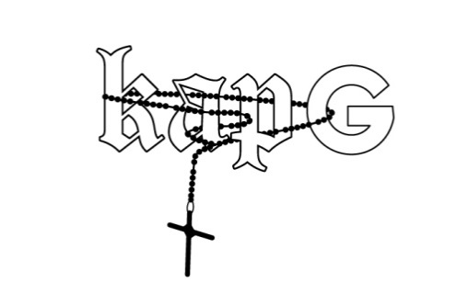
“Esperar lo inesperado.”
In English, those three words translate to the phrase—“Expect the unexpected”—and you most definitely should when it comes to Kap G. The gold-certified bilingual 23-year-old Atlanta rapper consistently surprises at every turn by unapologetically being himself. Look no further than the cover of his critically acclaimed 2017 major label mixtape, SupaJefe [Fourtune Ent/i am OTHER/Atlantic Records], where the MC dons a mariachi outfit on top of a horse in the housing projects across from the College Park Elementary School he attended as a child. Shaking up the culture, he emerged as one the few Mexican-Americans to join XXL’s Freshman Class since its launch. With a burgeoning profile, Sprite tapped him to star in a campaign alongside Lil Yachty, D.R.A.M., Vic Mensa, Vince Staples, and Kamaiyah, and Billboard named him among its “10 Hottest MCs of Latin Descent in Hip-Hop Today.”
In terms of influences, he’s just as quick to name check Selena and the Narcocorrido, favorites of his father, as he is to mention the impact of Kanye West, T.I., OutKast, and Jeezy. Fusing hard-hitting trap, clever bars, and a shot of Latin swagger, his signature style transformed “Girlfriend” into a gold-selling smash as the triumphant “Rings” famously soundtracked the Philadelphia Eagles’ 2018 Super Bowl celebration in addition to featuring on the NBA Live 18 soundtrack.
This unshakable identity has positioned him as not only a force within hip-hop, but for the Latin community at large.
“It sounds crazy when you say it out loud, ‘A Mexican kid from Atlanta doing rap music’,” he smiles. “Musically, I mixed being from the South and being Mexican-American. In my lyricism, I want to tell people about my upbringing, how I was, and my story. Every time I do a project, I’m trying to up the sound and make it bigger. I just want everything to be different. I’m always going to come with something crazy you don’t ever expect.”
The youngest of six children, Kap can recall first discovering rap music and writing rhymes in a notebook at just eight-years-old. Though the rapper admits, “It wasn’t a lavish life,” he found support at home from mom and dad as well as his siblings. As a kid, he co-founded the rap group that would codify his name Kap—Kids At Play. By 2011, he formally entered the industry. 2016’s El Southside put him on the map fueled by fan favorites such as “Don’t Need Em” [feat. Young Thug], “Power” [feat. YFN Lucci], and, of course, “Girlfriend.” Meanwhile, SupaJefe spawned the hit “I See You” [feat. Chris Brown] as he regularly averaged over 2.7 million monthly listeners on Spotify. Along the way, he headlined his own SupaJefe Tour and supported Brown on the massive Party Tour.
2017 also saw him serve up the Mood EP. Its lead single “Marvelous Day” [feat. Lil Uzi Vert & Gunna] clocked 17 million streams and 15 million YouTube views within a few months’ time. It also set the stage for the 2018 Big Mood mixtape—which he describes as, “A simple vibe that puts you in a mood. It’s more fun and free for Kap G.”
Simultaneously, he’s preparing a one-two punch of his first full-length album and a Spanish-language record. In both, he pushes boundaries once again by going deeper than ever before.
“One of the most special moments in an artist’s career is the moment when they wake up— that moment of awareness when they know who they are and what their capabilities are. Kap G has reached that point. It’s only onwards and upwards from here," comments i am OTHER creator and music icon Pharrell Williams.
“When people hear what I’ve got coming, they’re going to know exactly who I am,” he explains. “I’m bringing something fresh to rap. I’m painting a picture of who I am. This is my vision of hip-hop and the world through my eyes.”
In the end, you can invariably expect Kap G to leave an indelible mark of his own on the game.
“I hope you can take away motivation and hope from my music, especially for Hispanic kids and minorities,” he leaves off. “Maybe they can understand when the going gets tough, it’s possible to find hope and motivation in songs—or they can have fun with them. I’d feel like I accomplished what I was going for either way.”

