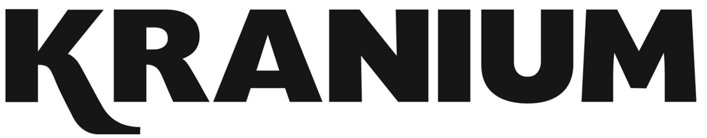
R&B Dancehall superstar Kranium drives Dancehall music and culture into the future on his own terms. Inspired by the melodies and vibes of dancehall, reggae, Afrobeats, and R&B, the internationally platinum-certified singer and songwriter fills a void we never knew we needed, yet his consistency and knack for “making a hit” have made him a global force. In 2021, he continues to push forward, infusing dancehall with soulful and scorching R&B and defining a global sound meant to make bodies move everywhere.

“2021 will be the year Kranium lives life to the fullest,” he exclaims. “We never know what tomorrow may bring, so it’s important. I’m just going to vibe, party, chill, and enjoy my family and the hard work I’ve been putting in.”

Kranium ignited 2021 and his next chapter with the aptly titled single “Life of the Party” [feat. UK-based “Don’t Rush” creators Young T & Bugsey]. On the track, organic drums and shuffling sunny production grind up against slick verses before the instantly irresistible refrain, “I’m the life of the party.” Right out of the gate, REVOLT hailed the track as “infectious,” and HotNewHipHop christened it “a summer hit” as it piled up streams. Most importantly, the song set the tone for his forthcoming second full-length album for Atlantic Records with a crucial cornerstone message.

With equal measure, VIBE and ATTITUDE perfectly define Kranium’s catalog. 2015’s “Nobody Has To Know” went Gold in the US and cemented Kranium as “the first New York-based dancehall artist to score a major international hit since Shaggy.” Ty Dolla and Major Lazer hopped on the official remix, bringing its cumulative stream count past the 200 million-mark. However, his rapid international rise didn’t stop there. “We Can” [feat. Tory Lanez] achieved a Platinum certification in Canada and clocked XX million-plus streams. On its heels, he gave us the perfect blend of Afrobeats and Dancehall with “Can’t Believe” [feat. Ty Dolla $ign & WizKid] in 2017, a hit truly ahead of its time by preceding the Afrobeats wave and asserting him as a visionary. It’s tallied 111M+ total streams (86M on the official dance video alone) and vaulted to #12 on the Billboard Reggae Chart. During 2019, he unveiled his full-length debut album, Midnight Sparks, to fan and critical adoration. The songs are still setting the world ablaze, but it’s his 2020 viral single “Gal Policy,” making a major mark on the streets and within the Dancehall culture. Even with its controversial subject matter, addressing his paramour’s man one-on-one (despite stealing his woman), it’s proving to be quite the anthem with fans singing it word for word every night along Kranium’s recent 2021 Sold Out UK Tour. Embodying the nickname of the “Melody Gad” with nearly 1 billion total streams to date worldwide. His clever wordplay, honesty, and ability to turn life experiences into smooth metaphors and bold melodies consistently distinguish him as an outlier at the highest level. He shows no signs of stopping or slowing down.

He closed out 2021 with 46 million streams in the U.S. alone and a total tally of 680 million globally. He notched two albums in the Billboard Top Reggae Albums Chart and emerged as the “2nd most streamed dancehall artist of the year.”

In the end, Kranium forever represents the future, giving not only the party, but the culture life.
2022 will find him solidifying his mark with a new project, tour, and a few other exciting and innovative moves.

BOILER
R&B Dancehall superstar Kranium drives Dancehall music and culture into the future on his own terms. 2015’s “Nobody Has To Know” went Gold in the US and cemented Kranium as “the first New York-based dancehall artist to score a major international hit since Shaggy.” Ty Dolla and Major Lazer hopped on the official remix, bringing its cumulative stream count past the 200 million-mark. However, his rapid international rise didn’t stop there. “We Can” [feat. Tory Lanez] achieved a Platinum certification in Canada and clocked XX million-plus streams. On its heels, he gave us the perfect blend of Afrobeats and Dancehall with “Can’t Believe” [feat. Ty Dolla $ign & WizKid] in 2017, a hit truly ahead of its time by preceding the Afrobeats wave and asserting him as a visionary. It’s tallied 111M+ total streams (86M on the official dance video alone) and vaulted to #12 on the Billboard Reggae Chart. During 2019, he unveiled his full-length debut album, Midnight Sparks, to fan and critical adoration. The songs are still setting the world ablaze, but it’s his 2020 viral single “Gal Policy,” making a major mark on the streets and within the Dancehall culture. Even with its controversial subject matter, addressing his paramour’s man one-on-one (despite stealing his woman), it’s proving to be quite the anthem with fans singing it word for word every night along Kranium’s recent 2021 Sold Out UK Tour. Embodying the nickname of the “Melody Gad” with nearly 1 billion total streams to date worldwide. His clever wordplay, honesty, and ability to turn life experiences into smooth metaphors and bold melodies consistently distinguish him as an outlier at the highest level. He shows no signs of stopping or slowing down.

He closed out 2021 with 46 million streams in the U.S. alone and a total tally of 680 million globally. He notched two albums in the Billboard Top Reggae Albums Chart and emerged as the “2nd most streamed dancehall artist of the year.”

After clocking nearly 1 billion streams and receiving acclaim from Pitchfork, The FADER, and more, he ignites his next chapter and 2022 with a new project, tour, and a few other exciting and innovative moves.

