BIRDY REVEALS NEW TRACK “SECOND HAND NEWS” AHEAD OF LONG-AWAITED ALBUM ‘YOUNG HEART’ - OUT APRIL 30th

LAST NIGHT SAW BIRDY HOST HER FIRST SHOW OF THE YOUNG HEART ERA - A ONE-OFF GLOBAL LIVESTREAM FROM WILTON’S MUSIC HALL

WATCH OFFICIAL VIDEO FOR “SECOND HAND NEWS”
BUY/STREAM “SECOND HAND NEWS”

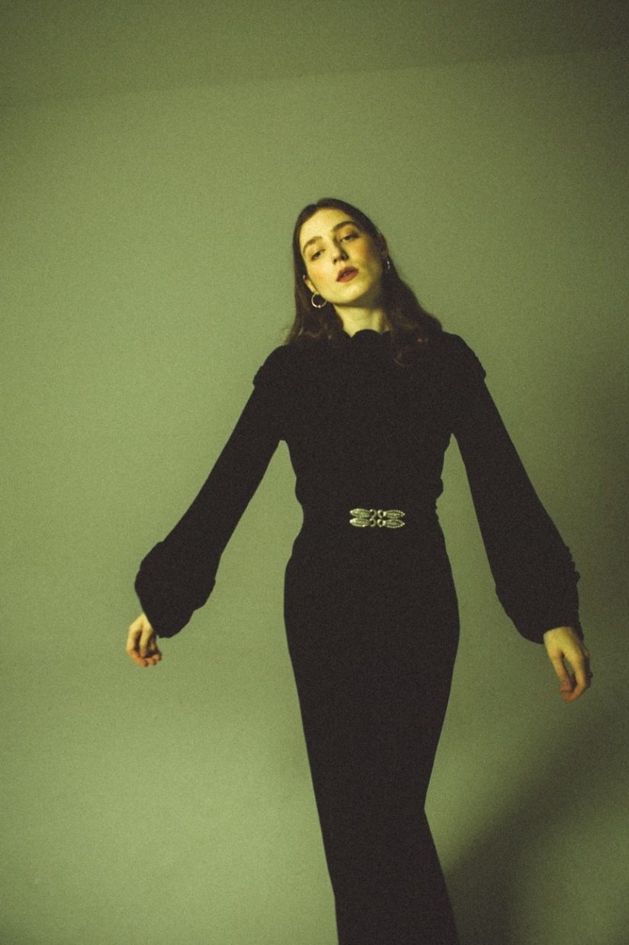

Today, Grammy-nominated, multi-platinum recording artist Birdy announces new track “Second Hand News” taken from her long-awaited fourth album, Young Heart. Following “Deepest Lonely” - ‘deeper, darker territory…authentically haunting - The Guardian’ - "Second Hand News” is a rousing piano ballad that details drifting apart from a partner based on speculation and conjecture.

Last night (April 15th), Birdy's one-off global livestream from the majestic Wilton's Music Hall - the oldest Grand Music Hall in the world - attracted ticket buyers from more than 70 countries. Shot by acclaimed director Ed Coleman and produced by Driift, the show featured a full band and eight-piece string section, with Birdy performing songs from throughout her career as well as previewing several from the new album. Images can be found HERE.
‘Young Heart’ is quite the departure from Birdy’s previous album, 2015’s dramatic ‘Beautiful Lies.’ Where Beautiful Lies was a fairy tale, Young Heart is a gritty realist portrait of the artist in pain, looking for the light. The songs on the album tussle between light and dark, between that vastness of space and the interior of home. The conflict between wanting to hide away and being compelled to go away, to new places and new experiences play out across the record.

Album opener “Voyager” is a beautifully written song about the knowledge and pain that you need to end a relationship, but the no-man’s land where your partner doesn’t know yet. From there, the record speaks of the fallout – the loneliness, the pain of missing the person one still loves, the acceptance of grief being central to love and loss, longing for travel but the pull of the familiarity of home.

Pre-order Birdy’s fourth studio album ‘Young Heart’ here: https://birdy.lnk.to/young-heart/

‘Young Heart’ Tracklisting:
- The Witching Hour – Intro
- Voyager
- Loneliness
- The Otherside
- Surrender
- Nobody Knows Me Like You Do
- River Song
- Second Hand News
- Deepest Lonely
- Lighthouse
- Chopin Waltz in A Minor – Interlude
- Evergreen
- Little Blue
- Celestial Dancers
- New Moon
- Young Heart

Birdy, discovered at the age of just 12 years old, has amassed over 1.6 billion audio streams worldwide, 1 billion YouTube views, 7.1 million monthly Spotify listeners and 4.7 million album sales to date. At the age of just 24, she has achieved 21 platinum singles worldwide, been nominated for a GRAMMY and Brit Award, and achieved number 1 albums all around the world, including in the US, UK, Australia, and more. Her passionate fanbase exceeds 8.1 million on social media and has seen her sell out venues such as The Roundhouse London, Hammersmith Apollo (twice), Sydney Opera House, Albert Hall Manchester and Shepherd’s Bush Empire and perform at the world’s largest award ceremonies including the BAFTA Awards and Paralympic London 2012 Olympics Opening Ceremony. Her brand work has seen Birdy announced as the face of REDValentino S/S 2017 and GAP’s ‘Lived In’ campaign in the US, photographed by David Sims. A highly syncable artist, Birdy has written songs for film and TV soundtracks, including The Hunger Games (2012), Disney PIXAR’s Brave (2012), The Fault in Our Stars (2014), and The Edge of Seventeen (2016).

US Press Contact: Libby Kober | Libby.Kober@atlanticrecords.com

