**BROODS NEW ALBUM**

***DON’T FEED THE POP MONSTER***

**OUT FEBRUARY 1**

**NEW SONG**

**“EVERYTHING GOES (WOW)”**

**OUT NOW**

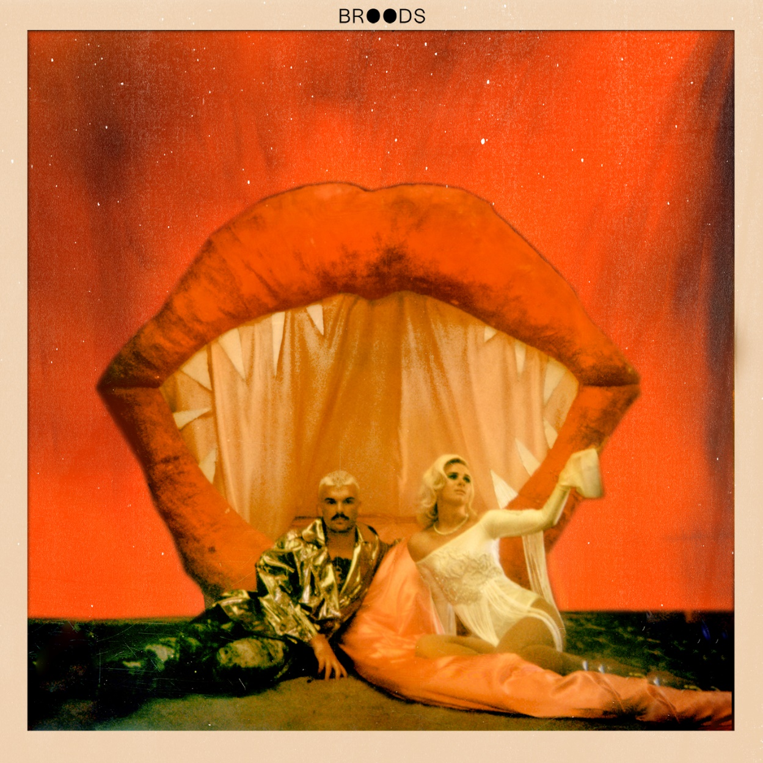

Critically acclaimed indie-pop duo Broods, comprised of siblings Georgia and Caleb Nott, will release their highly anticipated third album, *Don’t Feed The Pop Monster,* on February 1 via Neon Gold/Atlantic Records. The announcement comes in tandem with the release of “Everything Goes (Wow),” the second song Broods have shared from their forthcoming album. Listen to “Everything Goes (Wow)” here: [https://Atlantic.lnk.to/DFTPMPR](https://protect-us.mimecast.com/s/Gx9vCXDk51c1Bmrqh6XCPC)

“We wrote “Everything Goes (Wow)” in a tree house in Nicaragua,” Georgia shares, “We were there as part of a writing camp and it was one to the best experiences of our careers. It’s about accepting the mortality of everything and finding peace in that.” And on their forthcoming album, she continues, “We can’t wait to share this album with our fans and the world. We wanted to make songs that are true to us and without hiding behind any kind of façade. We made a point of just completely trusting ourselves and each other and we’re so ready for everyone to hear the album.”

Broods returned this summer with “Peach,” their first single from *Don’t Feed The Pop Monster* which has amassed nearly 10 million streams on Spotify alone. The official music video for “Peach” had ***Harper’s BAZAAR*** proclaiming, “If this is a mere glimpse at Broods' next chapter, we can't wait to see what's next.” View the official video [here](https://protect-us.mimecast.com/s/qGURCYEl52hQk5BNuG1ARZ). Fresh off supporting Taylor Swift on the Australian/New Zealand leg of the Reputation Stadium World Tour, Broods will return to ***Late Night with Seth Meyers*** on Monday (Nov. 19) for the televised US debut performance of “Peach.”

*Don’t Feed The Pop Monster* is the band’s follow up to their sophomore record, *Conscious*, which they released in June 2016 and saw lead single “Free” hit the Top 10 on Spotify’s US Viral Chart. Broods had their breakthrough with the 2014 single “Bridges” from their full-length debut *Evergreen*. Broods have played leading festivals like Coachella, Lollapalooza and Outside Lands and shared stages with artists like Ellie Goulding, Haim, Sam Smith, and CHVRCHES over the past few years.

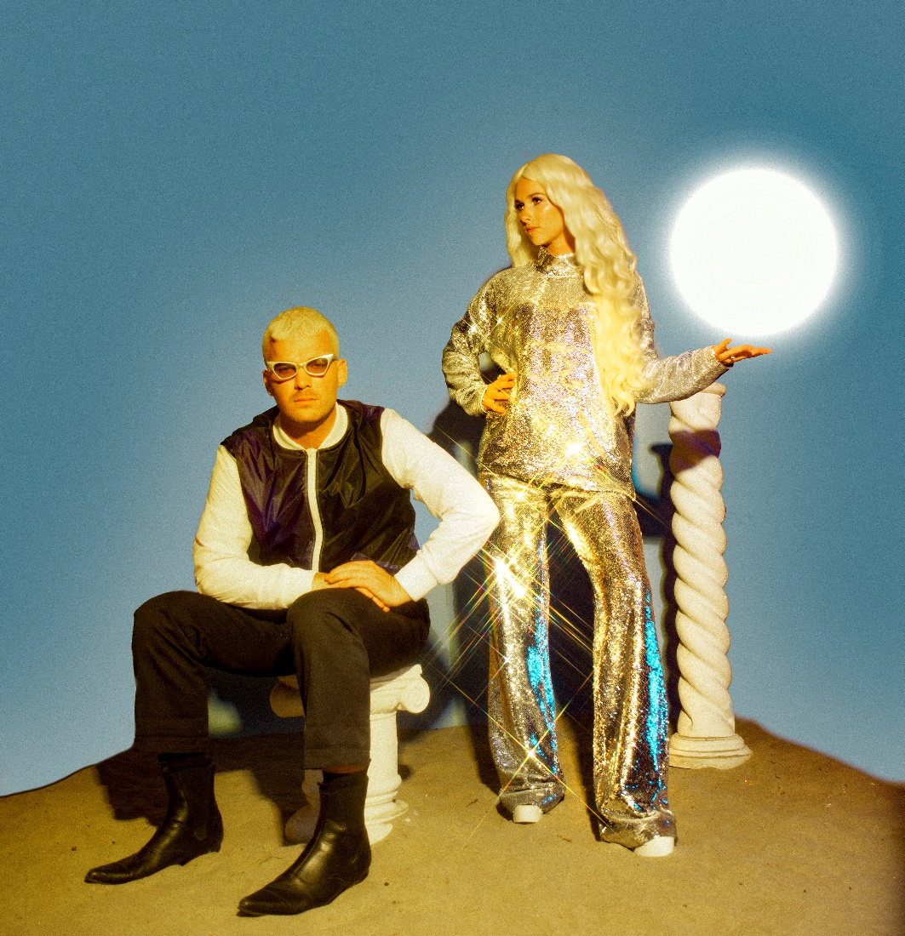

Credit: Dana Trippe

Download hi-res [here](https://protect-us.mimecast.com/s/FHguCZ6m03hEPzBDuK4ukc).

**Follow Broods:** [FACEBOOK](https://protect-us.mimecast.com/s/WpZeC1wB42f1n8WkhXNT6W) | [INSTAGRAM](https://protect-us.mimecast.com/s/FPsUC2k1W3cvK7yRU9JUp-) | [TWITTER](https://protect-us.mimecast.com/s/-AXNC31Kw4Fw7ZNGTvMcjC) | [WEBSITE](https://protect-us.mimecast.com/s/idn-C4xYL5cyYrkmIjLr9x)

**For More Information on Broods, please contact BT PR at 646.405.7010:**

Christopher Iacullo | [Chris@BTPR.biz](mailto:Chris@BTPR.biz)

Benny Tarantini | [Benny@BTPR.biz](mailto:Benny@BTPR.biz)