**BROODS NEW ALBUM**

***DON’T FEED THE POP MONSTER***

**AVAILABLE NOW**

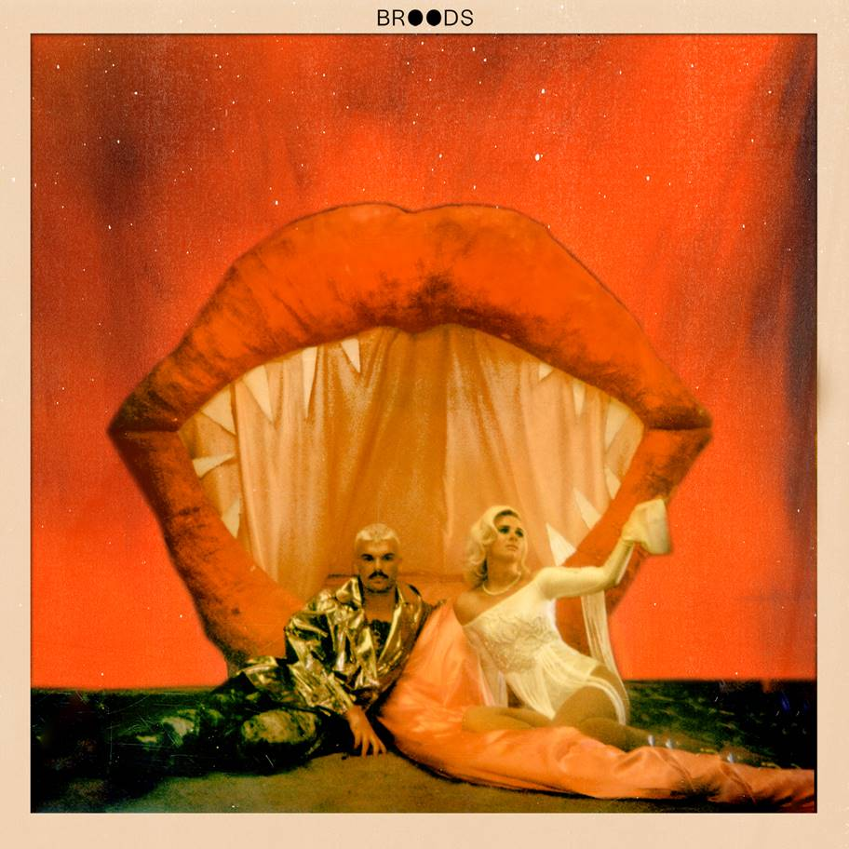

Broods’ highly anticipated third studio album, *Don’t Feed The Pop Monster*, is available today via Neon Gold/Atlantic Records. The 12-track album includes previously released tracks “Falling Apart,” “Hospitalized,” “Everything Goes (Wow),” and lead single “Peach.” With “Peach,” ***Billboard*** praised the band for the song’s “glittery production and bubbly catchphrase,” and had ***Harper’s*** ***BAZAAR*** declaring, “if this is a mere glimpse at Broods' next chapter, we can't wait to see what's next.”

For the new album, Broods’ Caleb & Georgia Nott reunited with longtime collaborator Joel Little (Lorde, Khalid), along with Swedish production duo Jack & Coke (Charli XCX, Tove Lo), Big Taste (Dua Lipa, Justin Bieber), Tommy English (Kacey Musgraves) and more to create their most personally authentic album to date. *Don’t Feed The Pop Monster* is available here: [https://Atlantic.lnk.to/DFTPMPR](https://protect-us.mimecast.com/s/xHQkCW6jqZhVvJpKu6cqK9)

“Our goal was to make songs that are true to us, without hiding behind any kind of façade.  We worked really hard and went through a thousand different emotions in the process,” says Georgia Nott, “The fact that we can feel so many different emotions and still make something that’s so true to us—to me that’s the most important part of this whole experience and we’re so excited to finally share this album with the world.”

Following album release, Broods will perform Too Proud” on ***The Late Late Show with James Corden*** on Thursday, February 7th. “Too Proud” is a stand-out new track from the album and the first Broods track to feature Caleb on lead vocals. “Too Proud” was also recently featured on the winter premiere of *Grey’s Anatomy*.

Next month, the band will embark on their North American headlining tour. Kicking off on March 26 in Santa Ana, CA, the tour will bring the band through Los Angeles, Seattle, Chicago, Boston, New York City and more (see below for a full list of dates). For tickets and more info, visit [https://www.broodsmusic.com/](https://protect-us.mimecast.com/s/WFZACXDk51cW3w6RHV_0jw)

*Don’t Feed The Pop Monster* is the band’s follow up to their sophomore record, *Conscious*, which they released in June 2016. Broods had their breakthrough with the 2014 single “Bridges” from their full-length debut *Evergreen*. Broods have played leading festivals like **Coachella, Lollapalooza** and **Outside Lands** and shared stages with artists like **Ellie Goulding**, **Haim**, **Sam Smith**, **CHVRCHES**, and most recently, **Taylor Swift**.

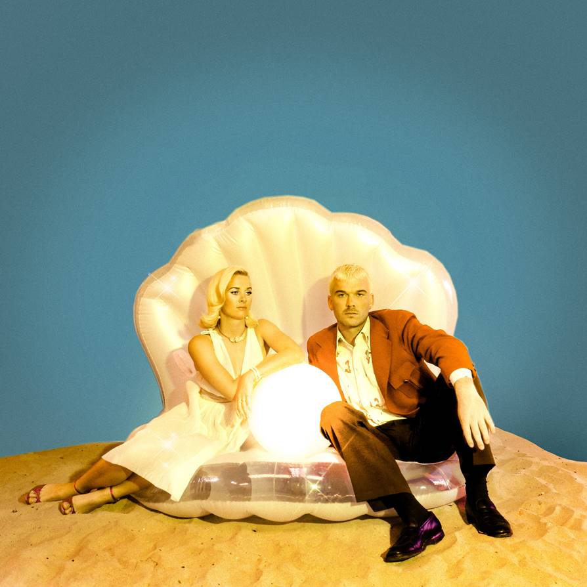

*Credit: Dana Trippe*

**Broods – *Don’t Feed The Pop Monster* Track Listing**

1. Sucker
2. Why Do You Believe Me
3. Peach
4. Falling Apart
5. Everytime You Go
6. Dust
7. Too Proud
8. To Belong
9. Old Dog
10. Hospitalized
11. Everything Goes (Wow)
12. Life After

***DON’T FEED THE POP MONSTER* SPRING 2019 TOUR NORTH AMERICAN DATES:**

03.26   Santa Ana, CA            The Observatory

03.27   Los Angeles, CA         The Fonda

03.29   San Diego, CA            The Observatory North Park

03.30   San Francisco, CA      August Hall

04.01   Seattle, WA                 Neptune Theatre

04.02   Vancouver, BC           Vogue Theatre

04.03   Portland, OR               Wonder Ballroom

04.05   Salt Lake City, UT       In The Venue

04.06   Denver, CO                 Summit

04.07   Kansas City, MO         The Truman

04.08   St Paul, MN                 Amsterdam Hall

04.10   Chicago, IL                  Metro

04.12   Toronto, ON                The Phoenix

04.13   Montreal, QC              Fairmount

04.14   Boston, MA                 Paradise

04.16   Philadelphia, PA         Union Transfer

04.18   New York, NY             Irving Plaza

04.19   Asbury Park, NJ          Asbury Lanes

04.20   Washington, DC         The Fillmore Silver Spring

**Follow Broods:** [FACEBOOK](https://protect-us.mimecast.com/s/smYGCYEl52hwPr0qU9MLPF) | [INSTAGRAM](https://protect-us.mimecast.com/s/YLAACZ6m03h0yJmLUyBUAc) | [TWITTER](https://protect-us.mimecast.com/s/mKSFC1wB42flKVjoHYN1zd) | [WEBSITE](https://protect-us.mimecast.com/s/-DRfC2k1W3cgAMxXSMdst_)

**For More Information on Broods, please contact BT PR at 646.405.7010:**

Christopher Iacullo | [Chris@BTPR.biz](mailto:Chris@BTPR.biz)

Benny Tarantini | [Benny@BTPR.biz](mailto:Benny@BTPR.biz)