**BROODS**

**“PEACH”**

**NEW SINGLE OUT NOW**

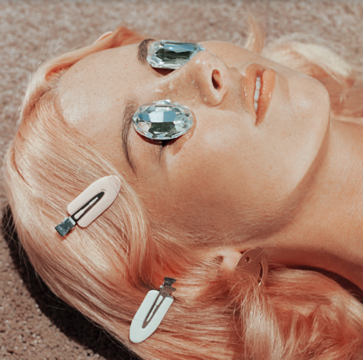

Indie-pop duo BROODS have released their new single, “Peach,” today via Neon Gold/Atlantic Records. The song’s kaleidoscopic sonic palette embraces buzzing guitar tones and choir-like harmonies along with woozy rhythms and intricate piano work while Georgia laments “I’m high and I’m low. No control. But everything looking peach now.” BROODS, comprised of Caleb and Georgia Nott, co-wrote “Peach” in Nashville with Tommy English (BØRNS, Kacey Musgraves, K. Flay). Listen to “Peach” here: [https://Atlantic.lnk.to/PeachPR](https://protect-us.mimecast.com/s/1UbOCyPJX0c9wEV7HZe3IR)

“As artists, you feel things at a much more extreme level than people who probably don’t spend most of their time inside their own heads. ‘Peach’ is about feeling all over the place all the time, and then celebrating those moments when everything feels awesome.”

“Peach” is BROODS’ first single from their third album which is expected early 2019. The band first began teasing the single last week on Instagram after announcing their new label deal with Neon Gold/Atlantic Records.

BROODS had their breakthrough with the 2014 single “Bridges” from their full-length debut *Evergreen.* BROODS released their sophomore record, *Conscious*, in June 2016 and soon saw lead single “Free” hit the top #10 on Spotify’s US Viral Chart. BROODS have played leading festivals like Coachella, Lollapalooza and Outside Lands and shared stages with artists like Ellie Goulding, Haim, Sam Smith, and CHVRCHES over the past few years.

**LISTEN TO “PEACH”**

[https://Atlantic.lnk.to/PeachPR](https://protect-us.mimecast.com/s/1UbOCyPJX0c9wEV7HZe3IR)



*Credit – Kelia Anne*

(Download hi-res image & single art [here](https://protect-us.mimecast.com/s/kFi2CzpxXRFJZvVGcXU5D7))

**FOLLOW BROODS:** [FACEBOOK](https://protect-us.mimecast.com/s/WU4bCAD91wc7XMqZC9qzCd) | [INSTAGRAM](https://protect-us.mimecast.com/s/ADHPCBBR6xTEr32DCj904A) | [TWITTER](https://protect-us.mimecast.com/s/DeSkCDkJ8zcgzQGoilr0g5) | [WEBSITE](https://protect-us.mimecast.com/s/Do9NCER6xAFR2KXlUQsq8a)

**For More Information on BROODS, please contact BT PR at 646.405.7010:**

Christopher Iacullo | [Chris@BTPR.biz](mailto:Chris@BTPR.biz)

Benny Tarantini | [Benny@BTPR.biz](mailto:Benny@BTPR.biz)