GRAMMY AWARD WINNER AND MULTI-PLATINUM SUPERSTAR
BRUNO MARS
TO BRING THE 24K MAGIC WORLD TOUR TO NORTH AMERICA AND EUROPE IN 2017

– The Magic Starts on March 28 in Antwerp, Belgium with Over 85 Shows Lined Up Across Both Continents Through The End of 2017 –

– Massive World Tour, Produced By Live Nation, To Support Release Of Bruno Mars’ New Album,
24K Magic, Set For Release On November 18 On Atlantic Records –

– Tickets Go On Sale Monday, November 21 –

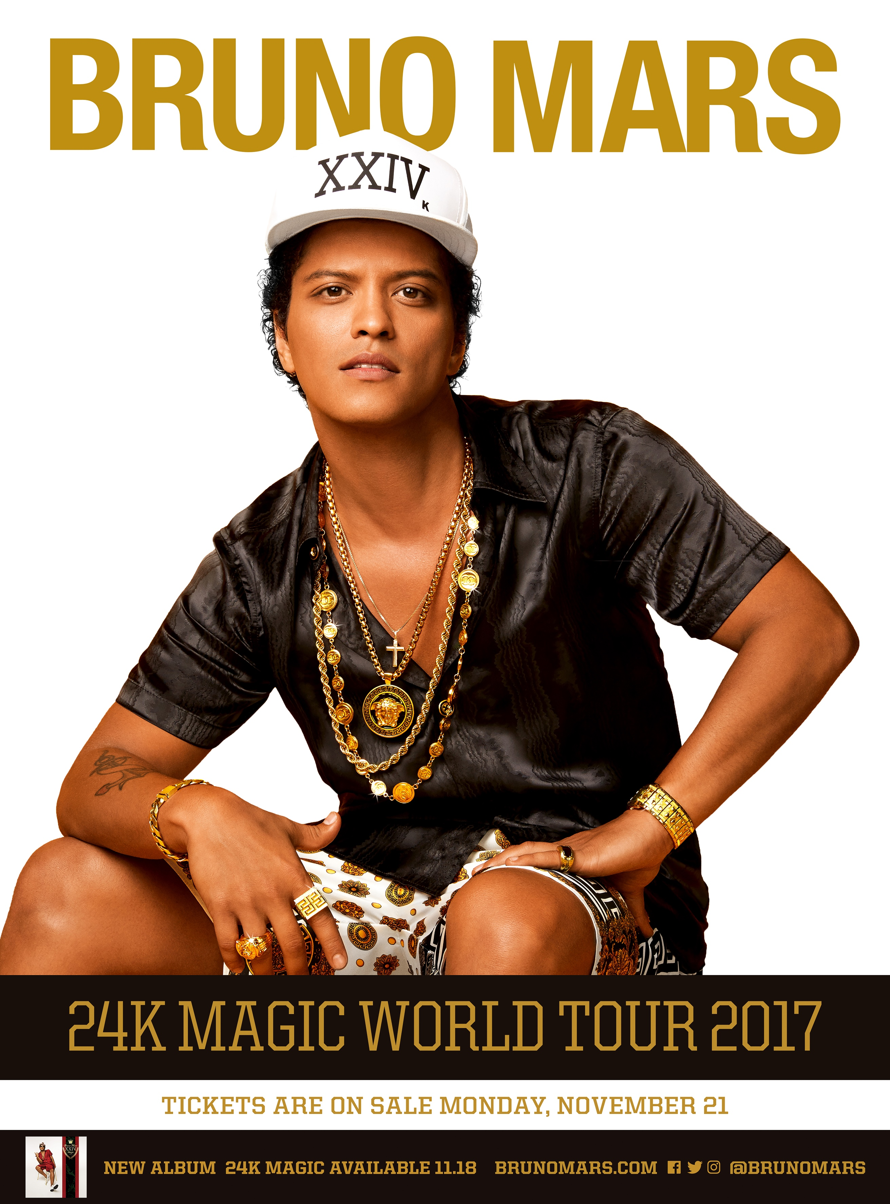

LOS ANGELES (November 15, 2016) – Grammy Award winner and world-renowned, multi-platinum singer/songwriter/producer/director/musician Bruno Mars, revealed details behind his massive upcoming global headline tour - The 24K Magic World Tour (pronounced twenty-four karat magic tour). The magic will begin March 28 at Antwerp, Belgium’s Sportpalais and will travel throughout Europe through June with shows set in London, Paris, Madrid, Zurich, Copenhagen, Berlin and more. The North American leg will follow kicking off July 15 at T-Mobile Arena in Las Vegas and then visit over 45 cities across the US and Canada before culminating with a four-night stand at The Forum in Los Angeles. A full list of dates is below. For complete details, please visit The 24K Magic World Tour official homepage. Tickets for The 24K Magic World Tour, produced by Live Nation, go on sale on Monday, November 21.

The 24K Magic World Tour celebrates Mars’ eagerly anticipated new album, 24K Magic (pronounced twenty-four karat magic), set to arrive worldwide on Friday, November 18 on Atlantic Records. Pre-orders are available now via the Bruno Mars Official Store, with all pre-orders from the store receiving early access to tickets for The 24K Magic Tour.

The 24K Magic World Tour marks Mars’ first full-length tour since 2013’s hugely successful Moonshine Jungle World Tour, an international blockbuster that sold 2 million tickets worldwide across 155 sold-out dates.

Mars – currently featured on the cover of Rolling Stone – is set for a number of high profile TV appearances, beginning with a show-opening performance at the 2016 American Music Awards, airing live Sunday, November 20th. Mars will next perform at the annual Victoria’s Secret Fashion Show, airing Monday, December 5th. The upcoming appearances follow Mars’ recent set on NBC’s Saturday Night Live, highlighted by performances of “24K Magic” and new album track, “Chunky.”

BRUNO MARS – THE 24K MAGIC WORLD TOUR
Europe
Tuesday, March 28, 2017 | Antwerp, BE | Sportpaleis
Friday, March 31, 2017 | Lille, FR | Stade Pierre Mauroy
Monday, April 3, 2017 | Madrid, ES | BarclayCard Center
Tuesday, April 4, 2017 | Lisbon, PT | MEO Arena
Friday, April 7, 2017 | Barcelona, ES | Palau Sant Jordi
Saturday, April 8, 2017 | Montpellier, FR | Montpellier Arena
Monday, April 10, 2017 | Cologne, DE | Lanxess Arena
Wednesday, April 12, 2017 | Glasgow, UK | SSE Hydro
Saturday, April 15, 2017 | Liverpool, UK | Echo Arena
Tuesday, April 18, 2017 | London, UK | O2 Arena
Wednesday, April 19, 2017 | London, UK | O2 Arena
Monday, April 24, 2017 | Birmingham, UK | BarclayCard Arena
Thursday, April 27, 2017 | Nottingham, UK | Motorpoint Arena
Saturday, April 29, 2017 | Dublin, IE | 3Arena
Tuesday, May 2, 2017 | Manchester, UK | Manchester Arena
Friday, May 5, 2017 | Leeds, UK | First Direct Arena
Saturday, May 6, 2017 | Sheffield, UK | Sheffield Arena
Tuesday, May 9, 2017 | Amsterdam, NL | Ziggo Dome
Friday, May 12, 2017 | Zurich, CH | Hallenstadion
Sunday, May 14, 2017 | Munich, DE | Olympiahalle
Wednesday, May 17, 2017 | Hamburg, DE | Barclaycard Arena
Thursday, May 18, 2017 | Copenhagen, DK | Royal Arena
Saturday, May 20, 2017 | Stockholm, SE | Ericsson Globe Arena
Monday, May 22, 2017 | Helsinki, FI | Hartwall Arena
Wednesday, May 24, 2017 | Oslo, NO | Telenor
Friday, May 26, 2017 | Berlin, DE | Mercedes Benz Arena
Thursday, June 1, 2017 | Frankfurt, DE | Festhalle
Saturday, June 3, 2017 | Vienna, AT | Stadthalle
Monday, June 5, 2017 | Paris, FR | Accorhotels Arena
Thursday, June 8, 2017 | Lyon, FR | Halle Tony Garnier
Monday, June 12, 2017 | Bologna, IT | Unipol Arena
Wednesday, June 14, 2017 | Geneva, CH | Arena Geneva
Thursday, June 15, 2017 | Milan, IT | Forum

North America
Saturday, July 15, 2017 | Las Vegas, NV | T-Mobile Arena
Tuesday, July 18, 2017 | Sacramento, CA | Golden 1 Center
Thursday, July 20, 2017 | San Jose, CA | SAP Center
Sunday, July 23, 2017 | Portland, OR | Moda Center
Monday, July 24, 2017 | Tacoma, WA | Tacoma Dome
Wednesday, July 26, 2017 | Vancouver, BC | Rogers Arena
Sunday, July 30, 2017 | Edmonton, AB | Rogers Place
Wednesday, August 2, 2017 | Winnipeg, MB | MTS Centre
Friday, August 4, 2017 | Fargo, ND | Fargo Dome
Saturday, August 5, 2017 | St. Paul, MN | Xcel Energy Center
Monday, August 7, 2017 | Lincoln, NE | Pinacle Bank Arena
Wednesday, August 9, 2017 | Kansas City, MO | Sprint Center
Saturday, August 12, 2017 | Detroit, MI | Palace of Auburn Hills
Sunday, August 13, 2017 | Indianapolis, IN | Bankers Life Fieldhouse
Tuesday, August 15, 2017 | Cleveland, OH | Quicken Loans Arena
Wednesday, August 16, 2017 | Chicago, IL | United Center
Friday, August 18, 2017 | Chicago, IL | United Center
Tuesday, August 22, 2017 | Pittsburgh, PA | PPG Paints Arena
Thursday, August 24, 2017 | Quebec City, QC | Centre Videotron
Saturday, August 26, 2017 | Toronto, ON | Air Canada Centre
Sunday, August 27, 2017 | Toronto, ON | Air Canada Centre
Tuesday, August 29, 2017 | Montreal, QC | Bell Centre
Thursday, September 14, 2017 | Charlotte, NC | Spectrum Center
Sunday, September 17, 2017 | Memphis, TN | FedEx Forum
Tuesday, September 19, 2017 | Louisville, KY | KFC Yum! Center
Wednesday, September 20, 2017 | Columbus, OH | Schottenstein Center
Friday, September 22, 2017 | New York, NY | Madison Square Garden
Tuesday, September 26, 2017 | Newark, NJ | Prudential Center
Wednesday, September 27, 2017 | Buffalo, NY | KeyBank Center
Friday, September 29, 2017 | Washington, DC | Verizon Center
Wednesday, October 04, 2017 | Brooklyn, NY | Barclays Center
Thursday, October 5, 2017 | Uniondale, NY | Nassau Coliseum
Saturday, October 7, 2017 | Boston, MA | TD Garden
Tuesday, October 10, 2017 | Philadelphia, PA | Wells Fargo Center
Thursday, October 12, 2017 | Raleigh, NC | PNC Arena
Saturday, October 14, 2017 | Orlando, FL | Amway Center
Sunday, October 15, 2017 | Ft. Lauderdale, FL | BB&T Center
Wednesday, October 18, 2017 | Miami, FL | American Airlines Arena
Thursday, October 19, 2017 | Tampa, FL | Amalie Arena
Saturday, October 21, 2017 | New Orleans, LA | Smoothie King Center
Sunday, October 22, 2017 | Little Rock, AR | Verizon Arena
Tuesday, October 24, 2017 | Houston, TX | Toyota Center
Wednesday, October 25, 2017 | San Antonio, TX | AT&T Center
Friday, October 27, 2017 | Dallas, TX | American Airlines Center
Monday, October 30, 2017 | Denver, CO | Pepsi Center
Thursday, November 2, 2017 | Fresno, CA | Save Mart Center
Friday, November 3, 2017 | Oakland, CA | Oracle Arena
Sunday, November 05, 2017 | Phoenix, AZ | Talking Stick Resort Arena
Tuesday, November 07, 2017 | Los Angeles, CA | The Forum
Wednesday, November 08, 2017 | Los Angeles, CA | The Forum
Friday, November 10, 2017 | Los Angeles, CA | The Forum
Saturday, November 11, 2017 | Los Angeles, CA | The Forum

For the latest updates on Bruno Mars:
WEBSITE
FACEBOOK
TWITTER
INSTAGRAM
YOUTUBE

About Bruno Mars:
A multiple GRAMMY® Award winner and 20 time GRAMMY® nominee, Bruno Mars has sold over 170 million singles worldwide and over 26 million albums worldwide, affirming him one of the best-selling artists of all time. The critically acclaimed singer, songwriter, producer, director, musician recently dominated charts with the worldwide smash single, “Uptown Funk.” The RIAA diamond certified smash made history as the longest-leading Billboard “Hot 100” single of the 2010s, and is only the 10th single in the chart’s 57-year history to spend at least 14 weeks at #1. “Uptown Funk” has received a number of honors, among them three 2016 GRAMMY® Awards, including the coveted “Record of the Year” award. In addition, the “Uptown Funk” companion video received the 2016 MTV Video Music Award for “Best Male Video.”

Mars returned to the Super Bowl Halftime stage this past February to perform alongside Beyoncé and Coldplay. Mars’ historic 2014 performance made NFL history as the second most watched Super Bowl Halftime Show ever, earning a record-breaking total viewership of over 115.3 million, all while being the youngest artist ever to serve as the sole Super Bowl Halftime headliner. According to Billboard, Mars scored his first five “Hot 100” #1 singles faster than any male artist since Elvis Presley. As a singer, songwriter and producer, Bruno Mars has now massed an incredible catalog of 35 “Hot 100” hits to date.

About Live Nation Entertainment
Live Nation Entertainment (NYSE: LYV) is the world’s leading live entertainment company comprised of global market leaders: Ticketmaster, Live Nation Concerts, Live Nation Media & Sponsorship and Artist Nation Management. For additional information, visit www.livenationentertainment.com.

For Bruno Mars, contact:
Chelsey Northern
chelsey.northern@atlanticrecords.com

For Bruno Mars press materials:
http://smarturl.it/24kmagic_assets

