BRYNN ELLIOTT RELEASES “WITHOUT YOU”
ANNOUNCES CAN I BE REAL? EP OUT JULY 8TH
“THE CAN I BE REAL LIVESTREAM MOMENT” CONCERT AIRS JULY 15TH
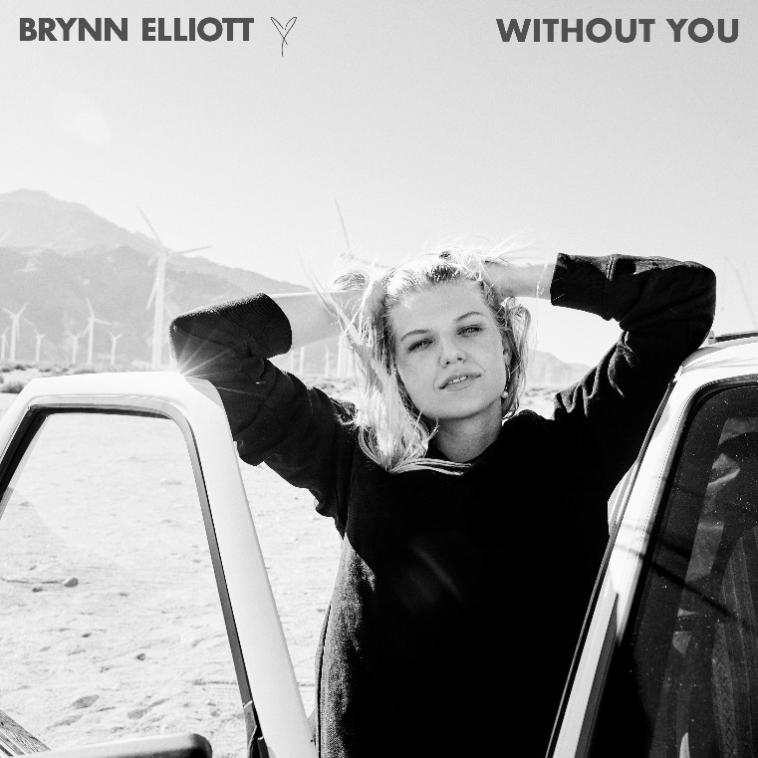
DOWNLOAD PRESS PHOTOS HERE
LISTEN / WATCH “WITHOUT YOU”
“’Without You’ plays a very important role in my forthcoming EP about honesty. It's a song about being vulnerable with someone you love, telling them that you don't want to live your life without them by your side. I think that's one of the most vulnerable things anyone could ever say to another person. It's a fun, roll down your car windows kind of song that I wanted to release right at the beginning of summer as we emerge from the pandemic and embrace our loved ones again!” – Brynn Elliott
Singer-songwriter Brynn Elliott is celebrating today’s release of “Without You,” a vulnerable track that encourages being honest about your deepest feelings. “Without You” heralds Brynn’s CAN I BE REAL? EP, available for pre-order now HERE; “Without You” is streaming now via DSPs and streaming services HERE.
Brynn Elliott’s breathtaking new EP CAN I BE REAL? is set to arrive on July 8th. Recorded in Los Angeles and produced in large part by songwriting/production duo The Monarch (Kelly Clarkson, Nicki Minaj), CAN I BE REAL? sees Elliott expanding on the thoughtful yet emotionally potent lyricism of her 2018 debut EP, TIME OF OUR LIVES.
In addition, Brynn has announced a special global livestream concert event with the premium digital live platform Moment House. She will be playing the EP live in its entirety for the first time during “The Can I Be Real Livestream Moment.” Brynn's artist career was birthed out of her love of live performance. After touring the country with acts such as Alanis Morissette, Brandi Carlile, OAR and Why Don't We, Brynn became addicted to the energy and connectivity of live music and was determined to make it her career. The Troubadour was the last venue Brynn played before the pandemic, and as a new LA resident it holds an even more special place in her heart. With the Moment House concert event, Brynn once again returns to the Troubadour to play her first live show with a full band in over a year, which will be livestreamed on July 15th for a ticketed event. Get tickets and more details at momenthouse.com/brynnelliott.
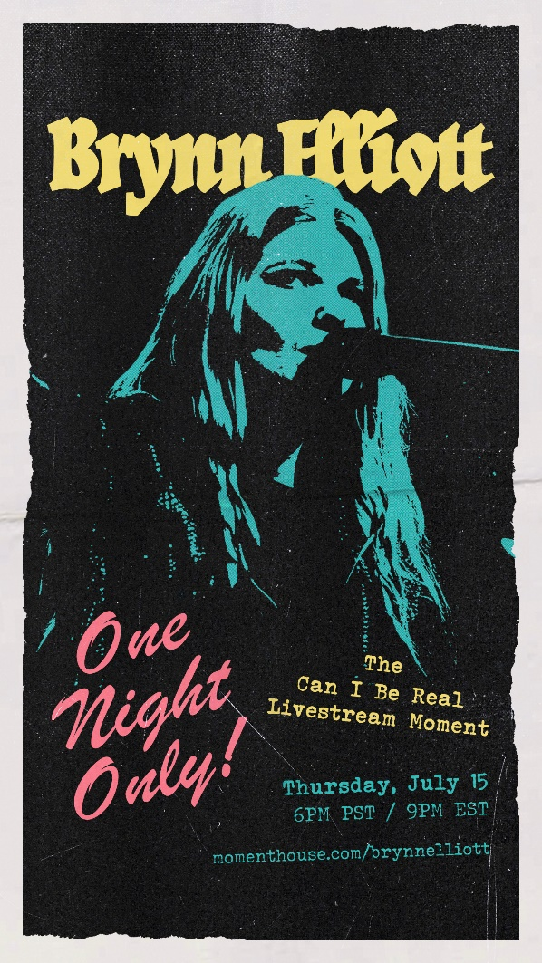
“Without You” follows Brynn’s heartfelt “Letter To A Girl,” a song that was inspired by her time on the road with Why Don’t We and a sort of sister track to “Tell Me I’m Pretty.” “Tell Me I’m Pretty” is an empowering anthem that pulls from stories of superficiality- a concept that dates back in history, from corsets to Instagram filters. The track which reached the Top 25 of Hot AC radio, is co-written with songwriter Michelle Buzz (Katy Perry, Kylie Minogue), and is joined by an official music video filmed at a palatial estate on the Hudson River Palisades, directed by Los Angeles-based photographer, creative director, and director Lauren Dunn (The Weeknd, G-Eazy) – streaming HERE now following its exclusive broadcast premiere via MTV and NickMusic. “Tell Me I’m Pretty” premiered online via Idolator, who describes the track as “a feel-good bop with a powerful message.”
BRYNN ELLIOTT – CAN I BE REAL?
July 8th
(ATLANTIC RECORDS)
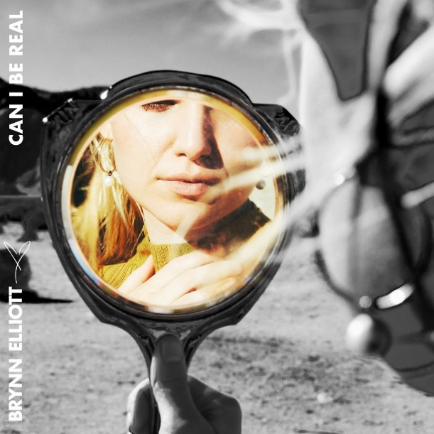

CONNECT WITH BRYNN ELLIOTT
BRYNNELLIOTT.COM
FACEBOOK
TWITTER
INSTAGRAM
YOUTUBE
ATLANTICRECORDS.COM

PRESS CONTACT
CHRISTINA KOTSAMANIDIS | CHRISTINA.KOTSAMANIDIS@ATLANTICRECORDS.COM

