**BURNA BOY UNLEASHES TRIUMPHANT NEW SINGLE**

**“B. D’OR” FEATURING WIZKID**

**[LISTEN HERE](https://burna.lnk.to/BDOR)**

**PRESALE FOR BURNA BOY’S ONE-NIGHT-ONLY SHOW AT NEW YORK’S**

**MADISON SQUARE GARDEN STARTS 12/15; PUBLIC ONSALE BEGINS 12/17**

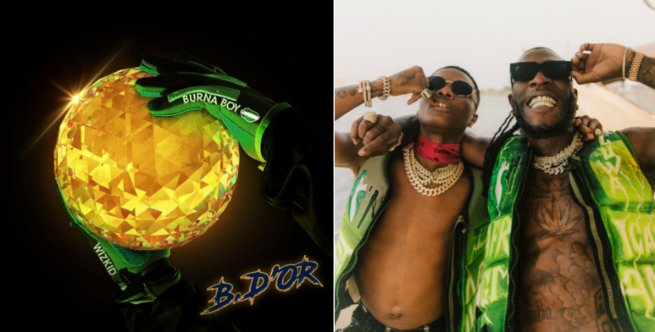

[DL art](https://warnermusicgroup.box.com/s/n0a0en6k802g0465yhjaw9c7arqs8opn) // [DL press photo](https://warnermusicgroup.box.com/s/2jcm6ygqr4f3shea6s4nb3eq78d6mmbm) (Photo credit: Yusuf Sanni)

The global giant, **Burna Boy,** has unleashed his latest single “B. D’OR featuring **Wizkid.** The song was produced by Nigerian British producer P2j and is inspired by the Ballon d’Or, one of the most prestigious trophies given to professional soccer players. The recipient is regarded as the best male football player in the world.Download/stream “B. D’OR” now [HERE.](https://burna.lnk.to/BDOR)

Just in time for the holidays, the upbeat, feel-good record arrives after Burna recently announced [One Night In Space](https://youtu.be/8UzewSuQDko%20%5Byoutu.be%5D), his history-making debut appearance at Madison Square Garden on April 28th, 2022. He will be the first Nigerian artist to headline a concert at the iconic venue. The official presale is running **Wednesday, December 15th** at **12pm ET** to **Thursday, December 16th** at **10pm ET**. Citi is the official credit card of Burna Boy Presents One Night In Space. Citi card members will have access to presale tickets beginning **Tuesday, December 14th** at **12pm** local time to **Thursday, December 16th** at **10pm** local time through the Citi Entertainment program. For complete presale details visit www.[citientertainment.com](https://citientertainment.com/). Tickets will go on sale to the general public at **12pm ET on Friday, December 17th** at [Ticketmaster.com.](https://www.ticketmaster.com/)

One Night In Space follows Burna Boy’s sold out debut at LA’s The Hollywood Bowl, electrifying performances at 2021 Global Citizen Festival and The Governor’s Ball, as well as sold out international shows at London’s O2 Arena, Paris’ Accor Arena, Amsterdam’s Ziggo Dome and more venues around the globe, as part of his 2021 Space Drift tour.

The groundbreaking Afro-Fusion artist’s 2020 fifth studio album [TWICE AS TALL](https://burna.lnk.to/TwiceAsTall) proved an immediate sensation, earning more than **5M** worldwide streams within its first hour of release. The project debuted at **#1** on Billboard’s “US World Albums” chart while receiving unprecedented worldwide critical acclaim. Among its countless accolades, TWICE AS TALL received the **2021 GRAMMY® Award** for “**Best Global Music Album**,” having already made history as the first time a Nigerian artist received back-to-back nominations in the category (following 2019’s GRAMMY® Award-nominated AFRICAN GIANT).

2021 has seen Burna Boy join forces with diverse fellow artists for collaborations such as "I Feel It (Feat. Burna Boy)" with Jon Bellion; “Want It All” featuring Polo G, “Question” ft Don Jazzy, and Becky G x Burna Boy’s “[Rotate](https://smarturl.it/xRotate),” featured in Pepsi’s global football campaign “[Music Keeps Us Fizzing](https://youtu.be/EMjHEukGL7M).” The African Giant also allied with Justin Bieber on the 8x GRAMMY® nominated album Justice and with 9x GRAMMY® Award-nominee Sia for “Hey Boy”. He is currently nominated for the 64th GRAMMY® awards alongside the multiple GRAMMY-award winning Angelique Kidjo for Best Global Performance on “Do Yourself.”

[OFFICIAL PRESS IMAGE](https://nam04.safelinks.protection.outlook.com/?url=https%3A%2F%2Fpress.atlanticrecords.com%2Fburna-boy%2F&data=04%7C01%7CSelam.Belay%40atlanticrecords.com%7Ce0d6aeacb0a34d2b541f08d9bbf0e819%7C8367939002ec4ba1ad3d69da3fdd637e%7C0%7C0%7C637747465664836590%7CUnknown%7CTWFpbGZsb3d8eyJWIjoiMC4wLjAwMDAiLCJQIjoiV2luMzIiLCJBTiI6Ik1haWwiLCJXVCI6Mn0%3D%7C3000&sdata=du89DqWtK48w7cIfnKXYY8BkLOfh5lHu4Gz0UJnsMsA%3D&reserved=0)

**CONNECT WITH BURNA BOY**

[TWITTER](https://nam04.safelinks.protection.outlook.com/?url=https%3A%2F%2Ftwitter.com%2Fburnaboy&data=04%7C01%7Cgabrielle.reese%40atlanticrecords.com%7C647e36bbd0964ce6a5de08d8ee258757%7C8367939002ec4ba1ad3d69da3fdd637e%7C0%7C0%7C637521192243242932%7CUnknown%7CTWFpbGZsb3d8eyJWIjoiMC4wLjAwMDAiLCJQIjoiV2luMzIiLCJBTiI6Ik1haWwiLCJXVCI6Mn0%3D%7C1000&sdata=3f3gkz4Wz3Ysgj9sd%2FQcA4Coq6I7SQNXqjZMLBIPCp4%3D&reserved=0) | [FACEBOOK](https://nam04.safelinks.protection.outlook.com/?url=https%3A%2F%2Ffacebook.com%2FOfficialburnaboy&data=04%7C01%7Cgabrielle.reese%40atlanticrecords.com%7C647e36bbd0964ce6a5de08d8ee258757%7C8367939002ec4ba1ad3d69da3fdd637e%7C0%7C0%7C637521192243252887%7CUnknown%7CTWFpbGZsb3d8eyJWIjoiMC4wLjAwMDAiLCJQIjoiV2luMzIiLCJBTiI6Ik1haWwiLCJXVCI6Mn0%3D%7C1000&sdata=06aKUpddr6TNVjvfJxizv%2FRG1Ws%2FAeAN3BYBmVc8OnA%3D&reserved=0) | [INSTAGRAM](https://nam04.safelinks.protection.outlook.com/?url=https%3A%2F%2Finstagram.com%2Fburnaboygram&data=04%7C01%7Cgabrielle.reese%40atlanticrecords.com%7C647e36bbd0964ce6a5de08d8ee258757%7C8367939002ec4ba1ad3d69da3fdd637e%7C0%7C0%7C637521192243252887%7CUnknown%7CTWFpbGZsb3d8eyJWIjoiMC4wLjAwMDAiLCJQIjoiV2luMzIiLCJBTiI6Ik1haWwiLCJXVCI6Mn0%3D%7C1000&sdata=MZWLABoK4UtpQCds0AKGSjddCE0qW8FtbgHN4bUCWeQ%3D&reserved=0) | [YOUTUBE](https://nam04.safelinks.protection.outlook.com/?url=https%3A%2F%2Fwww.youtube.com%2Fchannel%2FUCEzDdNqNkT-7rSfSGSr1hWg%2Ffeatured&data=04%7C01%7Cgabrielle.reese%40atlanticrecords.com%7C647e36bbd0964ce6a5de08d8ee258757%7C8367939002ec4ba1ad3d69da3fdd637e%7C0%7C0%7C637521192243262843%7CUnknown%7CTWFpbGZsb3d8eyJWIjoiMC4wLjAwMDAiLCJQIjoiV2luMzIiLCJBTiI6Ik1haWwiLCJXVCI6Mn0%3D%7C1000&sdata=41k2XTlboLf92%2Feyj14e4YaacV0IAg5H5qTxDtdI14E%3D&reserved=0)

**PRESS CONTACTS**

Corey Brewer | [Corey.Brewer@atlanticrecords.com](mailto:Corey.Brewer@atlanticrecords.com)

Selam Belay | [Selam.Belay@atlanticrecords.com](mailto:Selam.Belay@atlanticrecords.com)