BURNA BOY ANNOUNCES ONE-NIGHT-ONLY SHOW AT
NEW YORK’S MADISON SQUARE GARDEN, APRIL 28TH, 2022

FIRST-EVER NIGERIAN ARTIST TO HEADLINE THE ICONIC VENUE

PUBLIC ON SALE FRIDAY 12/17 AT 12 PM ET

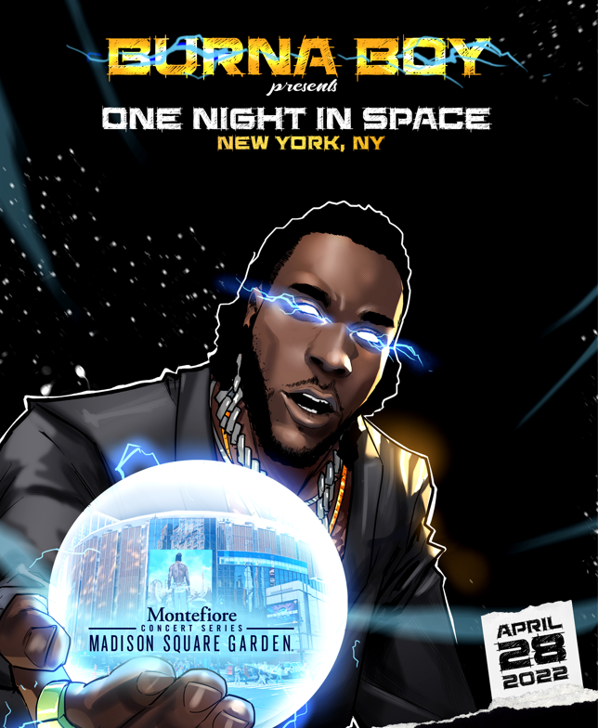
GRAMMY Award-winning artist Burna Boy announces One Night In Space, a special Burna Boy concert, to take place at New York’s iconic Madison Square Garden on April 28th, 2022. Burna Boy will be the first Nigerian artist to headline a concert at the iconic venue. Watch Burna’s show announcement video, which can also be seen at Madison Square Garden, HERE.
Fans can register now to receive early presale access to tickets and exclusive information from Burna Boy HERE, with the presale running Wednesday, December 15th at 12pm ET to Thursday, December 16th at 10pm ET. Citi is the official credit card of Burna Boy Presents One Night In Space. Citi card members will have access to presale tickets beginning Tuesday, December 14th at 12pm local time to Thursday, December 16th at 10pm local time through the Citi Entertainment program. For complete presale details visit www.citientertainment.com. Tickets will go on sale to the general public at 12pm ET on Friday, December 17th at Ticketmaster.com.
One Night In Space follows Burna Boy’s sold out debut at LA’s The Hollywood Bowl, electrifying performances at 2021 Global Citizen Festival and The Governor’s Ball, as well as sold out international shows at London’s O2 Arena, Paris’ Accor Arena, Amsterdam’s Ziggo Dome and more venues around the globe, as part of his 2021 Space Drift tour.
Burna Boy’s GRAMMY-Award Winning ‘Twice As Tall’ album is available on exclusive ruby red gatefold vinyl worldwide here. Multiple merch capsules are also still available now: The Secret Flame comic book and comic inspired merch, African Giant collection, Twice as Tall collection, Monsters You Made collection and King collection. Get your gear now ahead of the show here.
The groundbreaking Afro-Fusion artist’s 2020 fifth studio album TWICE AS TALL proved an immediate sensation, earning more than 5M worldwide streams within its first hour of release. Fueled by such singles as “Wonderful,” “Monsters You Made (Feat. Chris Martin), “Real Life (Feat. Stormzy),” and “23,” TWICE AS TALL – which features additional collaborations with Youssou N’Dour, Sauti Sol, and Naughty by Nature – debuted at #1 on Billboard’s “US World Albums” chart while receiving unprecedented worldwide critical acclaim. Among its countless accolades, TWICE AS TALL received the 2021 GRAMMY® Award for “Best Global Music Album,” having already made history as the first time a Nigerian artist received back-to-back nominations in the category (following 2019’s GRAMMY® Award-nominated AFRICAN GIANT). TWICE AS TALL was also named among 2020’s very best by a wide span of global publications, including The New York Times, The FADER, Consequence of Sound, British GQ, NME, Pitchfork, Vice, and Uproxx, to name but a few.
2021 has seen Burna Boy join forces with diverse fellow artists for collaborations such as "I Feel It (Feat. Burna Boy)" with Jon Bellion; “Want It All” featuring Polo G, “Question” ft Don Jazzy, and Becky G x Burna Boy’s “Rotate,” featured in Pepsi’s global football campaign “Music Keeps Us Fizzing.” The African Giant also allied with Justin Bieber on the 8x GRAMMY® nominated album Justice and with 9x GRAMMY® Award-nominee Sia for “Hey Boy (Feat. Burna Boy);” available now via Monkey Puzzle/Atlantic HERE; which arrived alongside an eye-popping animated video, directed by Rafatoon (Katy Perry, Deftones, Savage X Fenty) and now boasting over 19M individual views at YouTube HERE.
He is currently nominated for the 64th GRAMMY® awards alongside multiple Grammy award winning Angelique Kidjo for Best Global Performance on Do Urself.

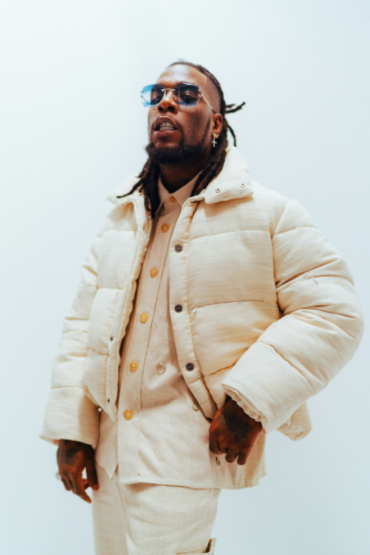
OFFICIAL PRESS IMAGE

CONNECT WITH BURNA BOY
TWITTER | FACEBOOK | INSTAGRAM | YOUTUBE

PRESS CONTACTS
Corey Brewer | Corey.Brewer@atlanticrecords.com
Selam Belay | Selam.Belay@atlanticrecords.com

