BURNA BOY REMINDS US OF OUR FAVORITE WEST AFRICAN LOVE STORIES IN HOT NEW VIDEO FOR 'ONYEKA'

GRAMMY-NOMINATED ALBUM TWICE AS TALL MARKS HIS SECOND CONSECUTIVE GRAMMY NOMINATION FOR BEST GLOBAL MUSIC ALBUM

WATCH THE VIDEO HERE

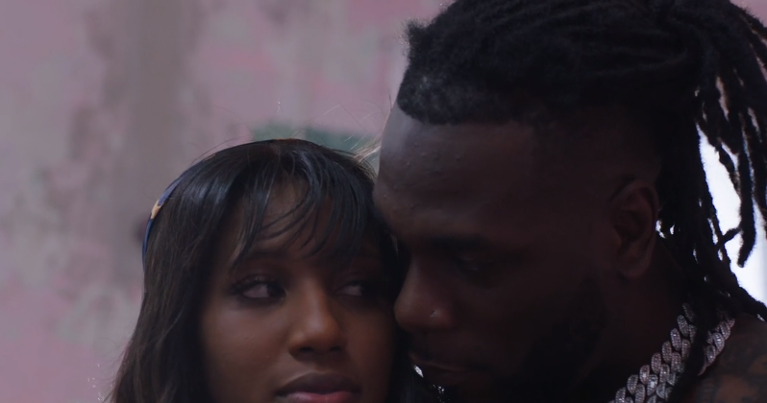
DOWNLOAD HI-RES ARTWORK
DOWNLOAD PUBLICITY IMAGES HERE

"More than his ability to smoothly navigate and naturally fuse genres through his voice, Burna Boy’s opus reflects a rare magnanimity of vision that is also simply irrefutable..." -PITCHFORK

“Burna Boy is a leader amid a bounty of new African pop that has been increasingly welcomed in the West. . . [He] hasn’t diluted his African heritage to reach his global audience. Instead, he has placed an unmistakably African stamp on music drawn from all around Africa and from across the African diaspora." -THE NEW YORK TIMES

“…on his latest full-length, Twice as Tall, he goes deeper, taking direct aim at systemic racism, poverty and rampant miseducation…Burna Boy's songs are reframing the global view of Africa.” -NPR

International award-winning music superstar Burna Boy wastes no time in releasing the highly anticipated visuals to 'Onyeka' off his Twice As Tall album, released in August 2020. Watch HERE. The 'Onyeka' video marks the fifth video release from the internationally acclaimed album, falling in line with previous videos for “Wonderful”, “Monsters You Made',” “Real Life featuring Stormzy" and “Way Too Big.”

Produced by Telz, one of the 'Wonderboyz' of the Spaceship Collective, 'Onyeka' fuses elements like the saxophone and drums into the melody, creating an indelible harmony. The Afrofusion pioneer Burna Boy serves swag, body and angles in this easily relatable video full of retro West African vibes. He teams up with a familiar love interest to take us back to simpler days of uncomplicated romance in good old-fashioned West African style.

Shot in Ghana, 'Onyeka' is a celebration of modern-day highlife, which is the basis of this visual, with good vibes and authenticity that is uniquely West African. This video is sure to put a smile on your face and warm your heart, as once again Burna outdoes himself. It is unscripted and undiluted, creating a storyline that is awesome to watch and pleasing to the soul. Everything is natural in this visual; from the popular West African modes of travel - 'okadas', buses and bicycles, to children playing outside and lovers in the streets, these elements make this video a sensational work of art.

This classic and fan favorite song also holds a special place in black women's hearts, celebrating black queens everywhere. Burna is truly gifted in creating something incandescent; showing that his music continues to evolve, and that it takes someone who is Twice as Tall to put the melodies together to create this cannonball of a masterpiece called 'Onyeka'.

The Afro-fusion pioneer, who now stands TWICE AS TALL after being nominated a second time for the GRAMMY’s Best Global Music Album and in six categories in the forthcoming Headies Awards 2020 (to be held Friday, February 12, 2021), took home the 'Best International Act' at the 2020 Music of Black Origin (MOBO) Awards and 'Best World Album' at the 2020 Dutch Edison Awards for his 2019 ‘African Giant’ album.

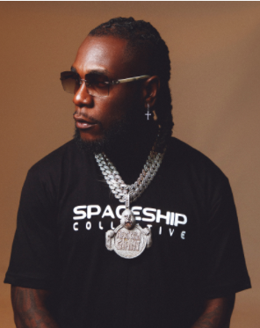
DOWNLOAD PUBLICITY IMAGES HERE

CONNECT WITH BURNA BOY
TWITTER | FACEBOOK | INSTAGRAM | YOUTUBE

PRESS CONTACTS
Corey Brewer | Corey.Brewer@atlanticrecords.com
Selam Belay | Selam.Belay@atlanticrecords.com

