FOR IMMEDIATE RELEASE
FEBRUARY 21ST, 2020

BURNA BOY ANNOUNCES TWICE AS TALL WORLD TOUR

TICKETS AVAILABLE NOW VIA WWW.ONASPACESHIP.COM

SET TO ALSO PERFORM AT WASHINGTON, D.C.’S BROCCOLI CITY FESTIVAL, PHILADELPHIA’S ROOTS PICNIC, PARIS’ LOLLAPALOOZA AND MONTREAL’S OSHEAGA FESTIVAL

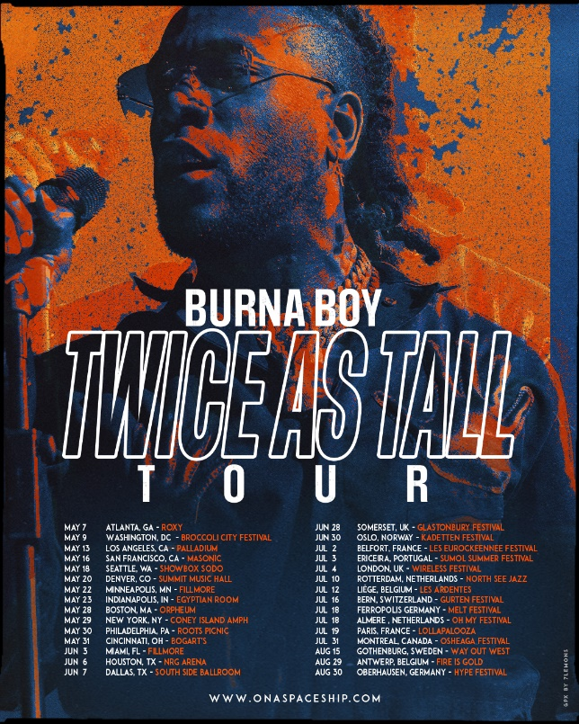

GRAMMY/BRITs-nominated and winner of Best International Act at the 2019 BET Awards, BURNA BOY, has returned to officially announce his TWICE AS TALL World Tour which is set to kick off Thursday, May 7th in Atlanta, GA at the Roxy and will continue to Los Angeles, New York, and Miami before the U.S. leg wraps in Dallas, TX on Sunday, June 7th at the South Side Ballroom (full tour routing below). Tickets are now available for purchase. He’s also set to appear at a string of festivals including Broccoli City Festival on May 9th in Washington, D.C., Roots Picnic on May 30th in Philadelphia, PA, Lollapalooza on July 19th in Paris, France and Osheaga Festival on July 31st in Montreal, Canada. For more information please visit www.onaspaceship.com.

Burna Boy continues into the new year after wrapping an extremely successful 2019. He made his U.S. late night television debut on Jimmy Kimmel Live!, along with an appearance on The Daily Show with Trevor Noah and his most recent performance on The Tonight Show Starring Jimmy Fallon. Watch Burna Boy discuss his international success on the Rap Radar Podcast exclusively on Tidal. The Nigerian star also recently performed on NPR’s Tiny Desk, performing four live songs including his global hit “Ye.”

The TWICE AS TALL tour announce arrives after the his most recent visual for “Secret” from the Grammy-nominated album (Best World Music Album), AFRICAN GIANT. The album saw incredible critical acclaim at its release and now adorns a galore of ‘best of’ lists – including Pitchfork’s 50 Best Albums of 2019, NPR’s Best Albums of 2019, Billboard’s 50 Best Albums of 2019, Rolling Stone’s 50 Best Albums of 2019, Complex’s Best Albums of 2019, and many more. He was also named Apple Music's Up Next Artist for the month of July.

At the 2019 BET Awards Burna Boy won Best International Artist in addition to receiving an in-depth profile piece with the Wall Street Journal which explores how the Nigerian star is finding success on his own terms in the United States. He also had an extensive year of live performances, travelling across North America on his The African Giant Returns Tour with sold-out stops in Toronto, New York, and LA through September, spending an additional two months for its European leg from Paris through Leicester, and had two fiery live sets at both weekends of Coachella.

ABOUT BURNA BOY
Burna Boy was born in Port Harcourt City and started producing music when he was ten years old. After graduating from school, Burna relocated to London for university. After two years, he dropped out and moved back to Nigeria to pursue his passion. A creative by the name of LeriQ allocated studio space for Burna to record and produce. His father always listened to dancehall and reggae music, an early influence and integral part of his musical style. Burna's grandfather managed Fela Kuti for the first 15 years of his career, a relationship that would come to shape Burna's sound and his understanding of himself as an artist that represents Nigeria, and more broadly Africa, to the world. Burna Boy classifies his own music as Afro-fusion, a genre he coined.
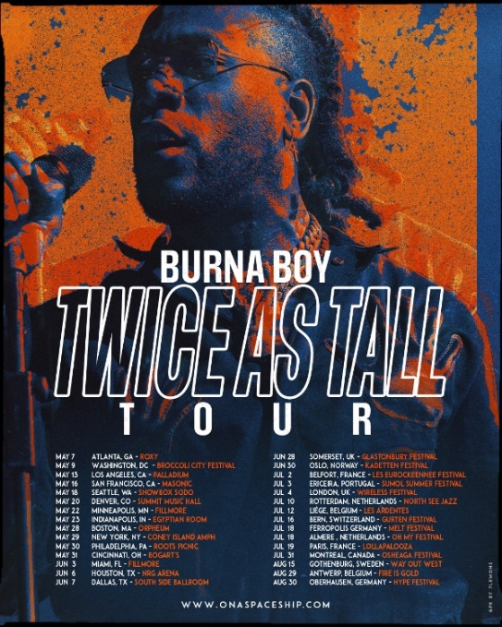
BURNA BOY
TWICE AS TALL WORLD TOUR

May 7th – Atlanta, GA – Roxy
May 9th – Washington, DC – Broccoli City Festival*
May 13th – Los Angeles, CA – Palladium
May 16th – San Francisco, CA – Masonic
May 18th – Seattle, WA – Showbox SoDo
May 20th – Denver, CO – Summit
May 22nd – Minneapolis, MN – The Fillmore
May 23rd – Indianapolis, MN – Egyptian Room
May 28th – Boston, MA – Orpheum Theatre
May 29th – New York, NY – Coney Island Amphitheater
May 30th – Philadelphia, PA – Roots Picnic*
May 31st – Cincinnati, OH – Bogart’s
June 3rd – Miami, FL – Fillmore
June 6th – Houston, TX – NRG Arena
June 7th – Dallas, TX – South Side Ballroom
---
June 28th - Somerset, UK – Glastonbury Festival
June 30th - Oslo, Norway – Kadetten Festival
July 2nd - Belfort, France – Les Eurockeennee Festival
July 3rd - Ericeira, Portugal – Sumol Summer Festival
July 4th - London, UK – Wireless Festival
July 10th - Rotterdam, Netherlands – North See Jazz
July 12th - Liege, Belgium – Les Aredentes
July 16th - Bern, Switzerland – Gurten Festival
July 18th - Ferropolis, Germany – Melt Festival
July 18th - Almere, Netherlands – Oh My Festival
July 19th - Paris, France – Lollapalooza
July 31st - Montreal, Canada – Osheaga Festival
August 15th - Gothenburg, Sweden – Way Out West
August 29th - Antwerp, Belgium – Fire Is Gold
August 30th - Oberhausen, Germany – Hype Festival

CONNECT WITH BURNA BOY
TWITTER | FACEBOOK | INSTAGRAM | YOUTUBE

For additional press assets, visit press.atlanticrecords.com/burna-boy

PRESS CONTACTS
Corey Brewer | Corey.Brewer@atlanticrecords.com
Selam Belay | Selam.Belay@atlanticrecords.com

