BURNA BOY RELEASES INTROSPECTIVE SINGLE “WANT IT ALL” FEATURING POLO G

ACCOMPANIED BY AN OFFICIAL VISUAL AVAILABLE NOW

DOWNLOAD/STREAM
WATCH/SHARE

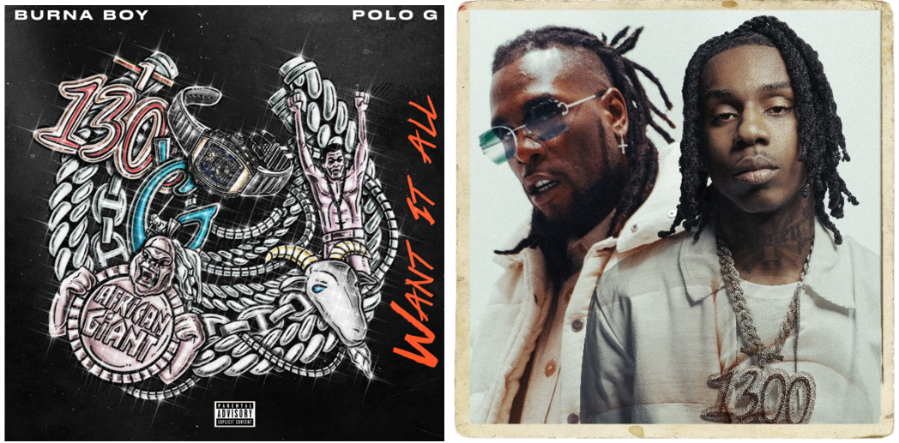
HI-RES ARTWORK | OFFICIAL PRESS IMAGE| LYRICS
GRAMMY Award-winning artist Burna Boy releases the introspective “Want It All,” featuring Polo G. The single also comes with a music video featuring both artists available now. On the collaboration Burna Boy says, “I’ve been watching him for some time, and I just knew this had to get done, but it had to get done in the perfect way where the whole world gets to feel the reality of both of us.”
After shutting down the O2 Arena and notable appearances at the 2021 Global Citizen Festival and The Governor’s Ball, Burna is currently preparing for his debut Hollywood Bowl performance. It was recently announced that Queen Naija, UMI and Donavan’s Sound Club will join him on Friday, Oct. 8, 2021. The show is a part of his global Space Drift Arena Tour. Tickets are on sale now at https://www.onaspaceship.com/tour.
Burna Boy’s GRAMMY-Award Winning ‘Twice As Tall’ album is available on exclusive ruby red gatefold vinyl worldwide here. Multiple merch capsules are also still available now: The Secret Flame comic book and comic inspired merch, African Giant collection, Twice as Tall collection, Monsters You Made collection and King collection. Get your gear now ahead of the show here.
The groundbreaking Afro-Fusion artist’s 2020 fifth studio album TWICE AS TALL proved an immediate sensation, earning more than 5M worldwide streams within its first hour of release. Fueled by such singles as “Wonderful,” “Monsters You Made (Feat. Chris Martin), “Real Life (Feat. Stormzy),” and “23,” TWICE AS TALL – which features additional collaborations with Youssou N’Dour, Sauti Sol, and Naughty by Nature – debuted at #1 on Billboard’s “US World Albums” chart while receiving unprecedented worldwide critical acclaim. Among its countless accolades, TWICE AS TALL received the 2021 GRAMMY® Award for “Best Global Music Album,” having already made history as the first time a Nigerian artist received back-to-back nominations in the category (following 2019’s GRAMMY® Award-nominated AFRICAN GIANT). TWICE AS TALL was also named among 2020’s very best by a wide span of global publications, including The New York Times, The FADER, Consequence of Sound, British GQ, NME, Pitchfork, Vice, and Uproxx, to name but a few.
2021 has already seen Burna Boy join forces with diverse fellow artists for collaborations as Becky G x Burna Boy’s “Rotate,” featured in Pepsi’s global football campaign, “Music Keeps Us Fizzing.” The African Giant also allied with 9x GRAMMY® Award-nominee Sia for “Hey Boy (Feat. Burna Boy);” available now via Monkey Puzzle/Atlantic HERE; which arrived alongside an eye-popping animated video, directed by Rafatoon (Katy Perry, Deftones, Savage X Fenty) and now boasting over 17M individual views at YouTube HERE.

CONNECT WITH BURNA BOY
TWITTER | FACEBOOK | INSTAGRAM | YOUTUBE

PRESS CONTACTS
Corey Brewer | Corey.Brewer@atlanticrecords.com
Selam Belay | Selam.Belay@atlanticrecords.com

