**BURNA BOY RELEASES ELECTRIFYING VIDEO FOR SINGLE “WAY TOO BIG,”**

**FROM GRAMMY-NOMINATED ALBUM** [**TWICE AS TALL**](https://nam04.safelinks.protection.outlook.com/?url=https%3A%2F%2Fburna.lnk.to%2FTwiceAsTall&data=04%7C01%7CGabrielle.Reese%40atlanticrecords.com%7C790cffefdd5a4d162f2808d8a1228379%7C8367939002ec4ba1ad3d69da3fdd637e%7C0%7C0%7C637436516894438214%7CUnknown%7CTWFpbGZsb3d8eyJWIjoiMC4wLjAwMDAiLCJQIjoiV2luMzIiLCJBTiI6Ik1haWwiLCJXVCI6Mn0%3D%7C1000&sdata=oOwXDR0UjvjTr3Amji%2Bgo6eX6RnRAkhlVOw8zSw%2B7Uc%3D&reserved=0)

**HIS SECOND CONSECUTIVE GRAMMY NOMINATION**

**FOR BEST GLOBAL MUSIC ALBUM AT THE 63rd ANNUAL GRAMMY AWARDS**

**WATCH THE VIDEO** [**HERE**](http://burna.lnk.to/WayTooBigVideo)

“*Always been too heavy for the elevator, steady taking the stairs to Greatness.”* – **BURNA BOY**

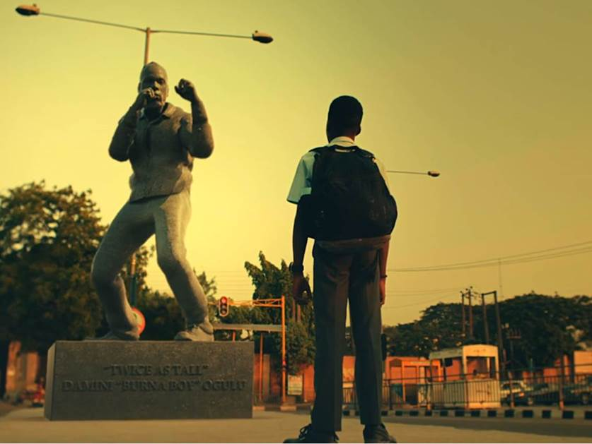

[**DOWNLOAD HI-RES ARTWORK**](https://nam04.safelinks.protection.outlook.com/?url=https%3A%2F%2Fwarnermusicgroup.box.com%2Fs%2Ffhvai5gafvfmukoxu0t0yzbfju5etbrk&data=04%7C01%7CGabrielle.Reese%40atlanticrecords.com%7C790cffefdd5a4d162f2808d8a1228379%7C8367939002ec4ba1ad3d69da3fdd637e%7C0%7C0%7C637436516894448165%7CUnknown%7CTWFpbGZsb3d8eyJWIjoiMC4wLjAwMDAiLCJQIjoiV2luMzIiLCJBTiI6Ik1haWwiLCJXVCI6Mn0%3D%7C1000&sdata=YULkwp%2FiJPH8kDKhU8ad4wHZQC8VkmNHeRdip2w4pJM%3D&reserved=0)

[**DOWNLOAD PUBLICITY IMAGES HERE**](https://nam04.safelinks.protection.outlook.com/?url=https%3A%2F%2Fwarnermusicgroup.box.com%2Fs%2F43x7dnfk7xcmi4xcjdp1whpn665q2akm&data=04%7C01%7CGabrielle.Reese%40atlanticrecords.com%7C790cffefdd5a4d162f2808d8a1228379%7C8367939002ec4ba1ad3d69da3fdd637e%7C0%7C0%7C637436516894448165%7CUnknown%7CTWFpbGZsb3d8eyJWIjoiMC4wLjAwMDAiLCJQIjoiV2luMzIiLCJBTiI6Ik1haWwiLCJXVCI6Mn0%3D%7C1000&sdata=7Q7ANLuLTJxtJvBYvULHMJ2UjUy5TagWdCeTpXxgg5U%3D&reserved=0)

*"More than his ability to smoothly navigate and naturally fuse genres through his voice, Burna Boy’s opus reflects a rare magnanimity of vision that is also simply irrefutable..."* -**PITCHFORK**

*“Burna Boy is a leader amid a bounty of new African pop that has been increasingly welcomed in the West. . . [He] hasn’t diluted his African heritage to reach his global audience. Instead, he has placed an unmistakably African stamp on music drawn from all around Africa and from across the African diaspora."* -**THE NEW YORK TIMES**

*“…on his latest full-length, Twice as Tall, he goes deeper, taking direct aim at systemic racism, poverty and rampant miseducation…Burna Boy's songs are reframing the global view of Africa.”* -**NPR**

Since dropping his internationally acclaimed *Twice As Tall* album in August 2020, Spaceship Records' Burna Boy has enjoyed tremendous success, achieving over **400M** streams on all platforms. Following the visual release of singles “[Wonderfu](https://nam04.safelinks.protection.outlook.com/?url=https%3A%2F%2Fyoutu.be%2Fk33o1IgtUEM&data=04%7C01%7CGabrielle.Reese%40atlanticrecords.com%7C790cffefdd5a4d162f2808d8a1228379%7C8367939002ec4ba1ad3d69da3fdd637e%7C0%7C0%7C637436516894458129%7CUnknown%7CTWFpbGZsb3d8eyJWIjoiMC4wLjAwMDAiLCJQIjoiV2luMzIiLCJBTiI6Ik1haWwiLCJXVCI6Mn0%3D%7C1000&sdata=r36%2F%2F3zW1KRk7dYYhh27UJcLE9Hci7WULL2KjIxhJRk%3D&reserved=0)l”, [“Monsters You Made](https://nam04.safelinks.protection.outlook.com/?url=https%3A%2F%2Fyoutu.be%2FlRpBLAwIbeA&data=04%7C01%7CGabrielle.Reese%40atlanticrecords.com%7C790cffefdd5a4d162f2808d8a1228379%7C8367939002ec4ba1ad3d69da3fdd637e%7C0%7C0%7C637436516894458129%7CUnknown%7CTWFpbGZsb3d8eyJWIjoiMC4wLjAwMDAiLCJQIjoiV2luMzIiLCJBTiI6Ik1haWwiLCJXVCI6Mn0%3D%7C1000&sdata=ZO6Fh%2FVhdh8d4xiE1VSNvI8pkp8AzHjk5nyYXNA68D4%3D&reserved=0)'' and [“Real Life featuring Stormzy"](https://nam04.safelinks.protection.outlook.com/?url=https%3A%2F%2Fyoutu.be%2FdXeOBkKdiAg&data=04%7C01%7CGabrielle.Reese%40atlanticrecords.com%7C790cffefdd5a4d162f2808d8a1228379%7C8367939002ec4ba1ad3d69da3fdd637e%7C0%7C0%7C637436516894468085%7CUnknown%7CTWFpbGZsb3d8eyJWIjoiMC4wLjAwMDAiLCJQIjoiV2luMzIiLCJBTiI6Ik1haWwiLCJXVCI6Mn0%3D%7C1000&sdata=2RW7FYFZfoyc%2FBhNF4rU1q56YZnGPdWJo1%2BtyuLnVg4%3D&reserved=0), this phenomenal Afrofusion singer releases the fourth video from *TWICE AS TALL*. Watch “Way Too Big” [here](http://burna.lnk.to/WayTooBigVideo).

Directed by Meji Alabi of JM films and shot in Lagos and London, Burna Boy chronicles his life events and brings together the elements that ground him as an artist as part of the scenes for this golden visual, making the 'Way Too Big' video everything one could ever imagine it to be.

With Burna Boy always pushing the creative envelope, 'Way too Big' plays with a lot of different themes; we see Burna Boy - the businessman, the artist, the fighter and the chilled, suave, talented singer; including his brand ambassadorship for Star Lager beer. From perfect lighting to flawless costumes, 'Way Too Big' jumps on the buzz around the extremely relaxed African Giant who takes no prisoners in this visual. He is completely in his element and brings his famous energy, vibe, swag and tough-as-nails attitude to the screen.

The Afro-fusion pioneer, who now stands *TWICE AS TALL* after recently being nominated a second time for the GRAMMY’s Best Global Music Album and in six categories in the forthcoming Headies Awards 2020, took home the 'Best International Act' at the just concluded 2020 Music of Black Origin (MOBO) Awards and 'Best World Album' at the 2020 Dutch Edison Awards for his 2019 ‘African Giant’ album.

For one who has always been too heavy for the elevator, the African giant has been steady taking the stairs to greatness. Watch the ''Way too Big'' video [here](https://youtu.be/wy_j--ljb9w) and on all digital platforms.

[DOWNLOAD PUBLICITY IMAGES HERE](https://nam04.safelinks.protection.outlook.com/?url=https%3A%2F%2Fwarnermusicgroup.box.com%2Fs%2F43x7dnfk7xcmi4xcjdp1whpn665q2akm&data=04%7C01%7CGabrielle.Reese%40atlanticrecords.com%7C790cffefdd5a4d162f2808d8a1228379%7C8367939002ec4ba1ad3d69da3fdd637e%7C0%7C0%7C637436516894468085%7CUnknown%7CTWFpbGZsb3d8eyJWIjoiMC4wLjAwMDAiLCJQIjoiV2luMzIiLCJBTiI6Ik1haWwiLCJXVCI6Mn0%3D%7C1000&sdata=95Cw9wWQcXOedoYWLYjFVrO0nt0V5E7oysr6a8ULDVY%3D&reserved=0)

**CONNECT WITH BURNA BOY**

[TWITTER](https://nam04.safelinks.protection.outlook.com/?url=https%3A%2F%2Ftwitter.com%2Fburnaboy&data=04%7C01%7CGabrielle.Reese%40atlanticrecords.com%7C790cffefdd5a4d162f2808d8a1228379%7C8367939002ec4ba1ad3d69da3fdd637e%7C0%7C0%7C637436516894468085%7CUnknown%7CTWFpbGZsb3d8eyJWIjoiMC4wLjAwMDAiLCJQIjoiV2luMzIiLCJBTiI6Ik1haWwiLCJXVCI6Mn0%3D%7C1000&sdata=Fo%2B2lYTkYD3WQ6l8%2BVf6D23uj9xNCicM9c657tjUDQg%3D&reserved=0) | [FACEBOOK](https://nam04.safelinks.protection.outlook.com/?url=https%3A%2F%2Ffacebook.com%2FOfficialburnaboy&data=04%7C01%7CGabrielle.Reese%40atlanticrecords.com%7C790cffefdd5a4d162f2808d8a1228379%7C8367939002ec4ba1ad3d69da3fdd637e%7C0%7C0%7C637436516894478040%7CUnknown%7CTWFpbGZsb3d8eyJWIjoiMC4wLjAwMDAiLCJQIjoiV2luMzIiLCJBTiI6Ik1haWwiLCJXVCI6Mn0%3D%7C1000&sdata=GWk3g0tySMlOXCLbUgTVISHGL3uUcFJF9AHj2ZkyaD8%3D&reserved=0) | [INSTAGRAM](https://nam04.safelinks.protection.outlook.com/?url=https%3A%2F%2Finstagram.com%2Fburnaboygram&data=04%7C01%7CGabrielle.Reese%40atlanticrecords.com%7C790cffefdd5a4d162f2808d8a1228379%7C8367939002ec4ba1ad3d69da3fdd637e%7C0%7C0%7C637436516894478040%7CUnknown%7CTWFpbGZsb3d8eyJWIjoiMC4wLjAwMDAiLCJQIjoiV2luMzIiLCJBTiI6Ik1haWwiLCJXVCI6Mn0%3D%7C1000&sdata=FKKfkItvVw9QboMscRzT75VBiLlyE%2BXK6WFHDKKF%2FeM%3D&reserved=0) | [YOUTUBE](https://nam04.safelinks.protection.outlook.com/?url=https%3A%2F%2Fwww.youtube.com%2Fchannel%2FUCEzDdNqNkT-7rSfSGSr1hWg%2Ffeatured&data=04%7C01%7CGabrielle.Reese%40atlanticrecords.com%7C790cffefdd5a4d162f2808d8a1228379%7C8367939002ec4ba1ad3d69da3fdd637e%7C0%7C0%7C637436516894487999%7CUnknown%7CTWFpbGZsb3d8eyJWIjoiMC4wLjAwMDAiLCJQIjoiV2luMzIiLCJBTiI6Ik1haWwiLCJXVCI6Mn0%3D%7C1000&sdata=7esGPVp00iu3i2UzuVcoB9NNfCopW0rd5xEFQnqOORc%3D&reserved=0)

**PRESS CONTACTS**

Corey Brewer | [Corey.Brewer@atlanticrecords.com](mailto:Corey.Brewer@atlanticrecords.com)

Selam Belay | [Selam.Belay@atlanticrecords.com](mailto:Selam.Belay@atlanticrecords.com)