GRAMMY & BET AWARD WINNER BURNA BOY TEAMS UP WITH DON JAZZY
ON NEW SINGLE: “QUESTION”

LISTEN/WATCH THE MUSIC VIDEO HERE

BURNA TO PLAY NY’S GOV BALL, HEADLINE HOLLYWOOD BOWL & MORE
TICKETS ON SALE NOW HERE

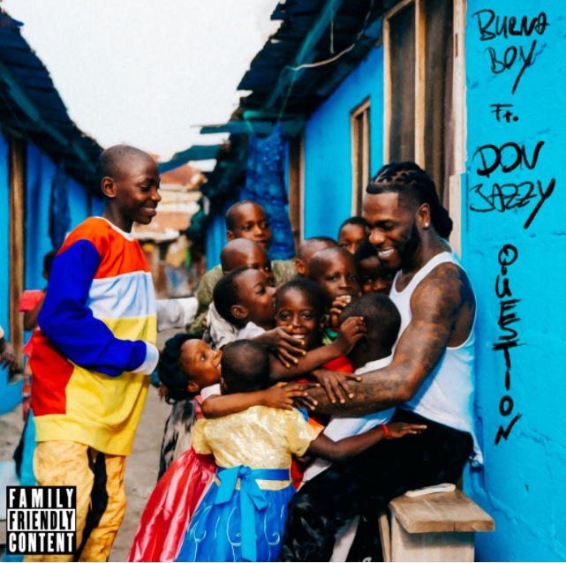
DOWNLOAD PHOTOS HERE
GRAMMY and three-time BET award-winning Afrofusion superstar, Burna Boy, reinvents himself yet again with his new track, “Question.” Produced by and featuring the legendary hitmaker, Don Jazzy, “Question” is the African Giant’s second release of the year following “Kilometre” in April. Listen/watch the music video HERE

The music video, directed by TG Omori and shot in Lagos, Nigeria, begins with an endearing interaction in Pidgin English between Burna Boy and a group of children, before diving into a unique visual, different from Burna’s classics.

With lyrics that are relatable and straight to the point, Burna Boy’s charm is evident when he sings: “Question but dem no get answer. Anything wey you wish, that be your portion. Na by the grace of God and insha Allah we dey move am.” Sung in a medley of English, Pidgin English and Yoruba, Burna Boy’s “Question” evokes nostalgia, taking us all back to easier times. Burna’s new vibe, filled with grassroots authenticity, showcases the talented singer's heritage. Not only does he have the uncanny ability to turn every sound he touches into gold, he also has the unblemished ability to introduce a freshness to his visuals.

Burna recently announced that Queen Naija, UMI and Donavan’s Sound Club will join him at his debut Hollywood Bowl concert on Friday, Oct. 8, 2021. The show is a part of his Space Drift Arena Tour, which includes performances at London’s O2 Area (8/27), New York’s The Governor’s Ball (9/26) and more. Tickets are on sale now at https://www.onaspaceship.com/tour.

Burna Boy’s GRAMMY-Award Winning ‘Twice As Tall’ album is now available on exclusive ruby red gatefold vinyl worldwide here. Multiple merch capsules are also still available now: The Secret Flame comic book and comic inspired merch, African Giant collection, Twice as Tall collection, Monsters You Made collection and King collection. Get your gear now ahead of the show here.

The groundbreaking Afro-Fusion artist’s 2020 fifth studio album TWICE AS TALL proved an immediate sensation, earning more than 5M worldwide streams within its first hour of release. Fueled by such singles as “Wonderful,” “Monsters You Made (Feat. Chris Martin), “ Real Life (Feat. Stormzy),” and “23,” TWICE AS TALL – which features additional collaborations with Youssou N’Dour, Sauti Sol, and Naughty by Nature – debuted at #1 on Billboard’s “US World Albums” chart while receiving unprecedented worldwide critical acclaim. Among its countless accolades, TWICE AS TALL received the 2021 GRAMMY® Award for “Best Global Music Album,” having already made history as the first time a Nigerian artist received back-to-back nominations in the category (following 2019’s GRAMMY® Award-nominated AFRICAN GIANT). What’s more, TWICE AS TALL was named among 2020’s very best by a wide span of global publications, including The New York Times, The FADER, Consequence of Sound, British GQ, NME, Pitchfork, Vice, and Uproxx, to name but a few.

2021 has already seen Burna Boy join forces with diverse fellow artists for collaborations as Becky G x Burna Boy’s “Rotate,” featured in Pepsi’s global football campaign, “Music Keeps Us Fizzing.” The African Giant also allied with 9x GRAMMY® Award-nominee Sia for “Hey Boy (Feat. Burna Boy);” available now via Monkey Puzzle/Atlantic HERE; which arrived alongside an eye-popping animated video, directed by Rafatoon (Katy Perry, Deftones, Savage X Fenty) and now boasting over 17M individual views at YouTube HERE.
CONNECT WITH BURNA BOY
TWITTER | FACEBOOK | INSTAGRAM | YOUTUBE
PRESS CONTACTS
Corey Brewer | Corey.Brewer@atlanticrecords.com
Selam Belay | Selam.Belay@atlanticrecords.com

