**CARYS RELEASES OFFICIAL VIDEO**

**FOR VIRAL SMASH “PRINCESSES DON’T CRY”**

**WATCH HERE:** [https://youtu.be/2tJjplMngFE](https://nam04.safelinks.protection.outlook.com/?url=https%3A%2F%2Fyoutu.be%2F2tJjplMngFE&data=02%7C01%7CPaige.Rosoff%40atlanticrecords.com%7C32c66c1eb7b2430bcf3f08d767af3d31%7C8367939002ec4ba1ad3d69da3fdd637e%7C0%7C0%7C637091874646282707&sdata=iy91J7W9qd15CeNAeS22f5MyfvjlqElN82fVB3L9LpU%3D&reserved=0)

**LISTEN HERE:** [https://CARYS.lnk.to/PrincessesDontCry](https://nam04.safelinks.protection.outlook.com/?url=https%3A%2F%2FCARYS.lnk.to%2FPrincessesDontCry&data=02%7C01%7CPaige.Rosoff%40atlanticrecords.com%7C32c66c1eb7b2430bcf3f08d767af3d31%7C8367939002ec4ba1ad3d69da3fdd637e%7C0%7C0%7C637091874646272715&sdata=Kwjh4QKs33oiPZHBOCEWXtGnb%2Bkyv44MvmhEqmgDbds%3D&reserved=0)

[](https://nam04.safelinks.protection.outlook.com/?url=https%3A%2F%2Fyoutu.be%2F2tJjplMngFE&data=02%7C01%7CPaige.Rosoff%40atlanticrecords.com%7C32c66c1eb7b2430bcf3f08d767af3d31%7C8367939002ec4ba1ad3d69da3fdd637e%7C0%7C0%7C637091874646272715&sdata=LjVqO3xMd%2BNjpVlqagzS27PrBlETk4iWe5Ihex4PzWc%3D&reserved=0) 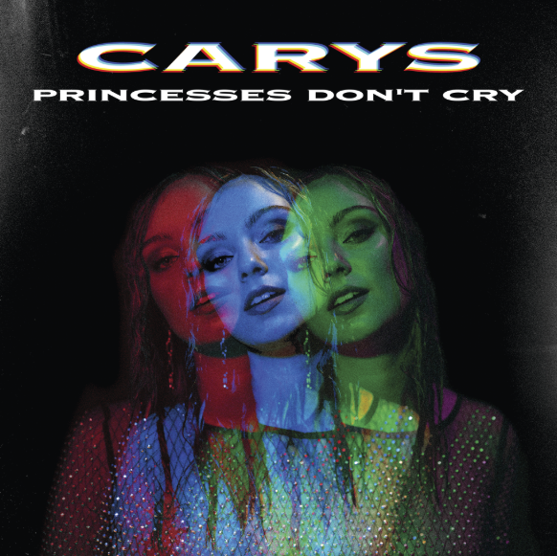

Today the Atlantic Records/Warner Music Canada recording artist **CARYS** has released the official video for her viral smash hit “Princesses Don’t Cry”.  The song has exploded on TikTok where **850k videos have been created using the song, amassing over 17 million views**.  Propelled by her dark, moody pop hits that she describes as “a vessel for her unfiltered emotions,” the Toronto native has partnered with award winning producer **Gavin Brown** (Metric, Mother Mother) on her forthcoming 2020 EP.  Fans can watch the official video, directed by Ryan Faist (bülow, Dizzy) [here](https://nam04.safelinks.protection.outlook.com/?url=https%3A%2F%2Fyoutu.be%2F2tJjplMngFE&data=02%7C01%7CPaige.Rosoff%40atlanticrecords.com%7C32c66c1eb7b2430bcf3f08d767af3d31%7C8367939002ec4ba1ad3d69da3fdd637e%7C0%7C0%7C637091874646282707&sdata=iy91J7W9qd15CeNAeS22f5MyfvjlqElN82fVB3L9LpU%3D&reserved=0).

Of the video, CARYS says “I wanted the video to be about owning your emotions. Feelings of heartbreak can be overwhelming. But bottling them up is what hurts the most. I want to show that it’s powerful and freeing to allow hurt to exist within us without resistance.”

**Press materials**: <https://press.atlanticrecords.com/carys/>

**Connect with CARYS:**

[Instagram](https://nam04.safelinks.protection.outlook.com/?url=https%3A%2F%2Fwww.instagram.com%2Fcarysofficial%2F&data=02%7C01%7CPaige.Rosoff%40atlanticrecords.com%7C32c66c1eb7b2430bcf3f08d767af3d31%7C8367939002ec4ba1ad3d69da3fdd637e%7C0%7C0%7C637091874646292700&sdata=uYkJ%2BEF2Qjd5lE2z1LDmZVHCYmDbwZtmY3MlXEI5WwY%3D&reserved=0)

[YouTube](https://nam04.safelinks.protection.outlook.com/?url=https%3A%2F%2Fwww.youtube.com%2Fchannel%2FUCtHoTrH0GgJ9fBrzmTqk7Pg&data=02%7C01%7CPaige.Rosoff%40atlanticrecords.com%7C32c66c1eb7b2430bcf3f08d767af3d31%7C8367939002ec4ba1ad3d69da3fdd637e%7C0%7C0%7C637091874646292700&sdata=jzeEF1qjff2aWs%2BonWq3q%2FeJ%2FimtrFNVkV%2FLaf2%2BTFU%3D&reserved=0)

[Facebook](https://nam04.safelinks.protection.outlook.com/?url=http%3A%2F%2Fwww.facebook.com%2Fcarysofficial&data=02%7C01%7CPaige.Rosoff%40atlanticrecords.com%7C32c66c1eb7b2430bcf3f08d767af3d31%7C8367939002ec4ba1ad3d69da3fdd637e%7C0%7C0%7C637091874646302697&sdata=uDreEfg%2BT3FK3m6bIqOWyTKXgjsMnkGUmm%2BvlaBpJOs%3D&reserved=0)

[Twitter](https://nam04.safelinks.protection.outlook.com/?url=http%3A%2F%2Fwww.twitter.com%2Fcarysofficial&data=02%7C01%7CPaige.Rosoff%40atlanticrecords.com%7C32c66c1eb7b2430bcf3f08d767af3d31%7C8367939002ec4ba1ad3d69da3fdd637e%7C0%7C0%7C637091874646302697&sdata=ZzM3wSpsLIaMY2YVHAX91bIC%2BXWANIU2OZHzZnLBY38%3D&reserved=0)

**For more information contact:**

[Paige.Rosoff@AtlanticRecords.com](mailto:Paige.Rosoff@AtlanticRecords.com)