FOR IMMEDIATE RELEASE
DECEMBER 18, 2017

CHARLIE PUTH UNVEILS “THE VOICENOTES TOUR”

WORLDWIDE POP SUPERSTAR ANNOUNCES BIGGEST EVER HEADLINE TREK
WITH SPECIAL GUEST HAILEE STEINFELD

TICKETS ON SALE TO GENERAL PUBLIC DECEMBER 22 AT LIVENATION.COM;
NORTH AMERICAN RUN BEGINS JULY 11

PUTH’S CURRENT SINGLE “HOW LONG” PROVES ANOTHER INTERNATIONAL SMASH WITH LIVE PERFORMANCES SET FOR TOMORROW NIGHT’S SEASON FINALE OF NBC’S THE VOICE
AND DICK CLARK’S NEW YEAR’S ROCKIN’ EVE 2018 ON DECEMBER 31ST

HUGELY ANTICIPATED NEW ALBUM VOICENOTES DUE NEXT YEAR

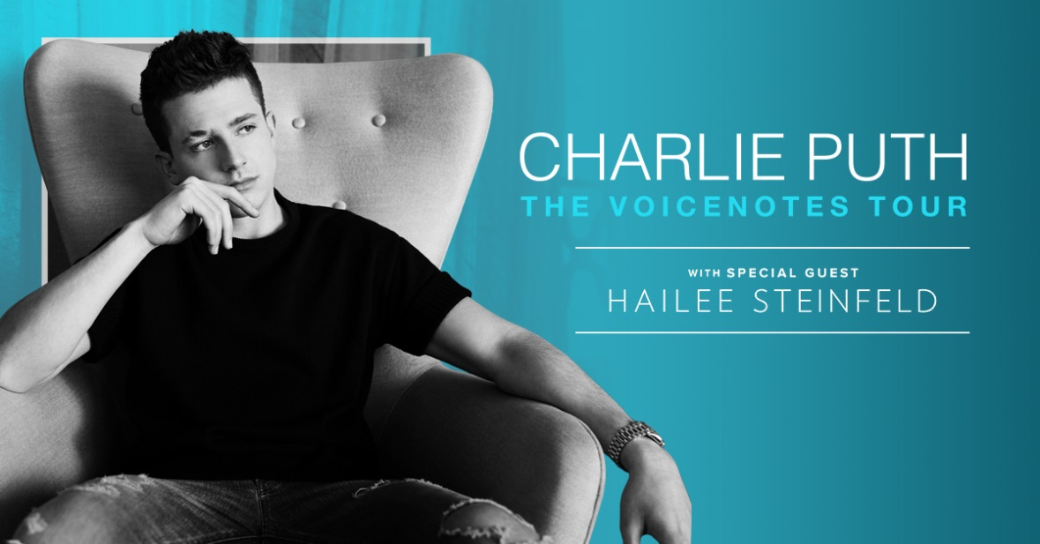

Multi-Platinum artist/musician/producer Charlie Puth has announced plans for his biggest North American headline tour to date. Produced by Live Nation, “The Voicenotes Tour” officially gets underway July 11 at Toronto, ON’s Budweiser Stage and travels the continent through the summer (see attached itinerary). Highlights include dates at New York City’s world-famous Radio City Music Hall (July 16) and the renowned Greek Theatre in Los Angeles (August 14). Multi-Platinum recording artist Hailee Steinfeld will be main support on all dates. Pre-sales begin Tuesday, December 19; tickets will go on sale to the general public starting Friday, December 22. For complete details, and ticket information, please visit www.charlieputh.com/tour or LiveNation.com.

Citi® is the official presale credit card for “The Voicenotes Tour.” As such, Citi® cardmembers have access to purchase U.S. presale tickets, which are available beginning Tuesday, December 19 at 10am local time until Thursday, December 21st at 10pm local time through Citi’s Private Pass® program. For complete presale details visit www.citiprivatepass.com.

“The Voicenotes Tour” will celebrate Puth’s hugely anticipated new album, “VOICENOTES,” due next year from Atlantic Records – pre-orders are available now HERE. The album is preceded by the current smash single, “How Long,” available now at all DSPs and streaming services HERE. Now with close to 300 million streams worldwide, the single has proven yet another popular favorite both here and abroad, reaching #1 on innumerable iTunes “Global Singles” charts and Mexico’s “Ingles Airplay” while earning both gold certification in Australia and silver certification in the United Kingdom. Named by Vanity Fair as one of “The 17 Best Pop Songs of 2017,” “How Long” is joined by an even more popular companion visual, currently boasting over 160 million views via YouTube alone – HERE.

Puth marked the release of “How Long” with high-profile TV performances on CBS’ The Late Late Show With James Corden (watch HERE) and ABC’s Good Morning America (watch HERE), soon to be followed by an eagerly anticipated performance on tomorrow night’s season finale of NBC’s The Voice. He’ll then perform both “How Long” and “Attention” on Dick Clark’s New Year’s Rockin’ Eve 2018, to be broadcast live on ABC on December 31st (check local listings). In addition, Puth will perform “How Long” on upcoming episodes of the nationally syndicated Ellen DeGeneres Show and CBS’ The Talk, both set to air in early January.

“How Long” arrived hot on the heels of Puth’s summer’s blockbuster, “Attention,” available at all DSPs and streaming services HERE. The RIAA platinum certified single – which marked Puth’s first new music since 2016’s RIAA platinum certified debut album, “NINE TRACK MIND” – reached #5 on Billboard’s “Hot 100,” his third consecutive top 10 hit and highest charting solo track to date. What’s more, “Attention” topped the multi-format “Radio Songs” chart for four straight weeks while also ascending to the #1 spot on Billboard’s “Dance Mix Show Airplay” tally – Puth’s first time atop that chart as a solo artist. “Attention” also proved an international favorite, reaching #1 in such far-flung lands as Russia, Venezuela, Ukraine, Israel, Latvia, and Mexico, while earning diamond certification in France, 3x platinum in Australia and Italy, 2x platinum in Spain, and platinum in Belgium, Denmark, Germany, New Zealand, and the United Kingdom. Of course, the “Attention” companion visual – directed by Emil Nava (Ed Sheeran, Calvin Harris Feat. Rihanna) – proved yet another record-shattering video sensation for Puth, now with over 638 million YouTube views and counting – HERE.

Hailed around the world as an energetic and electrifying live performer, Puth has spent much of the early winter stealing the show on the just-concluded iHeartRadio Jingle Ball tour. Puth received ecstatic notices for his show-stopping performances on the annual multi-artist holiday trek, with Pennsylvania’s The Morning Call enthusing, “(Puth) condensed his best material into an offering that showed just how good he is, and the growth he’s undergoing…’Attention,’ which has more of an R&B groove than his previous hits, shows he is moving from a Billy Joel-piano-rocker to more of a Timberlake vibe... ‘One Call Away’ had the whole crowd singing – because it’s good and catchy… And, of course, his closing song ‘See You Again,’ his 9x platinum hit from 2015, will be Puth’s forever can’t-miss song. Its opening still brings chills, and its choral ending still has power.” Puth “put across genuine charm and daffy enthusiasm,” raved the Los Angeles Times while Billboard applauded his “surprisingly raw performance” of hits including “Attention” and “See You Again.” “The piano-playing crooner Charlie Puth provided a few more plot twists,” declared the New York Times, “his songs refused the blandishments of an ex who only wanted ‘Attention’ and tried desperately to apologize for straying in ‘How Long.’”

Along with his worldwide popularity, Puth is among the most honored new artists in recent memory, among his many accolades a Teen Choice Award, two Billboard Music Awards, a Nickelodeon Kids Choice Award, and myriad nominations including a GRAMMY® nod for “Song of the Year” and a prestigious Golden Globe nomination for “Best Original Song.”

A gifted and charismatic live performer, Puth has proven a hugely popular concert attraction, with 2016’s “Nine Track Mind Tour” selling out nearly every date within 30 minutes of its announcement. As if that weren’t enough, Puth has made any number of show-stopping TV appearances, including FOX’s 2016 Teen Choice Awards, NBC’s TODAY and The Voice, CBS’ The Late Late Show with James Corden, ABC’s Jimmy Kimmel Live! and 2015 American Music Awards, and both the nationally syndicated Ellen DeGeneres Show and LIVE with Kelly and Michael, not to mention a guest cameo on CBS’ highly rated Life In Pieces.

“The Voicenotes Tour” special guest and Republic Records recording artist Hailee Steinfeld has quickly cemented herself as a rising force in pop music with a series of hits under her belt, including her 2015 platinum certified debut single “Love Myself,” double platinum selling smash “Starving” with Grey [feat. Zedd] and platinum selling summer anthem “Most Girls.” To date, the multi-platinum selling artist has amassed a total of nearly 2 billion streams globally. This year, Steinfeld won “Best Push Artist” at the MTV EMAs, Musical.ly’s “Top Covered Artist” award at the 2017 Billboard Music Awards and was honored by Variety with the “Crossover Artist” award at their inaugural Hitmakers event. She also garnered three Teen Choice Award nominations for her work in both film and music.Most recently, Steinfeld released her new single “Let Me Go.” Produced by Grammy nominated DJ and producer Alesso and critically acclaimed producer, songwriter and artist watt, “Let Me Go” pairs Steinfeld with one of country music’s best-selling acts Florida Georgia Line. Performed for the first time ever on this year’s American Music Awards, the song has amassed 150 million streams on Spotify where it is currently Top 20 on their Global Top 50 chart and climbing.

For news, music, and additional information, please visit www.charlieputh.com, www.facebook.com/charlieputh, twitter.com/charlieputh, instagram.com/charlieputh, www.youtube.com/user/CharliePuth, and www.atlanticrecords.com.

Press contacts:
Chelsey Northern (national) | Chelsey.Northern@atlanticrecords.com
Ted Sullivan (online/tour) | Ted.Sullivan@atlanticrecords.com
CHARLIE PUTH
THE VOICENOTES TOUR 2018
HAILEE STEINFELD TO OPEN ALL DATES

JULY
11 – Toronto, ON – Budweiser Stage
13 – Boston, MA – Blue Hills Bank Pavilion
16 – New York, NY – Radio City Music Hall
19 – Uncasville, CT – Mohegan Sun
21 – Gilford, NH – Bank of New Hampshire Pavilion
22 – Saratoga Springs, NY – Saratoga Performing Arts Center
24 – Camden, NJ – BB&T Pavilion
25 – Vienna, VA – Wolf Trap Center For The Performing Arts
27 – Charlotte, NC – PNC Music Pavilion
28 – Raleigh, NC – Coastal Credit Union Music Park @ Walnut Creek Amphitheatre
31 – Chicago, IL – Huntington Bank Pavilion

AUGUST
2 – Clarkston, MI – DTE Energy Music Theatre
3 – Cincinnati, OH – Riverbend Music Center
5 – Noblesville, IN – Ruoff Home Mortgage Music Center
6 – Maryland Heights, MO – Hollywood Casino Amphitheatre
8 – St. Paul, MN – Xcel Energy Center
9 – Kansas City, MO – Starlight Theatre
11 – Albuquerque, NM – Isleta Amphitheater
12 – Las Vegas, NV – The Pearl Concert Theater
14 – Los Angeles, CA – Greek Theatre
15 – Irvine, CA – FivePoint Amphitheatre
17 – Mountain View, CA – Shoreline Amphitheatre
18 – Stateline, NV – Lake Tahoe Harvey’s Outdoor Arena
20 – Chula Vista, CA – Mattress Firm Amphitheatre
21 – Phoenix, AZ – Ak-Chin Pavilion
23 – Irving, TX – The Pavilion @ Irving Music Factory
24 – The Woodlands, TX – Cynthia Woods Mitchell Pavilion
26 – Rogers, AR – Walmart Arkansas Music Pavilion
28 – Nashville, TN – Ascend Amphitheater
29 – Alpharetta, GA – Verizon Amphitheater
31 – Tampa, FL – MidFlorida Credit Union Amphitheatre

SEPTEMBER
1 – West Palm Beach, FL – Perfect Vodka Amphitheatre

www.charlieputh.com/tour

# # #

