CHARLOTTE CARDIN PREPARES RELEASE OF “MAIN GIRL” EP

ACCLAIMED MONTREAL-BASED SINGER-SONGWRITER TO MAKE U.S. DEBUT
WITH EP “MAIN GIRL” VIA ATLANTIC RECORDS

U.S. TOUR ALONGSIDE NICK MURPHY BEGINS SEPTEMBER 10TH IN WASHINGTON, DC

WATCH THE LIVE VIDEO FOR "DIRTY DIRTY" HERE

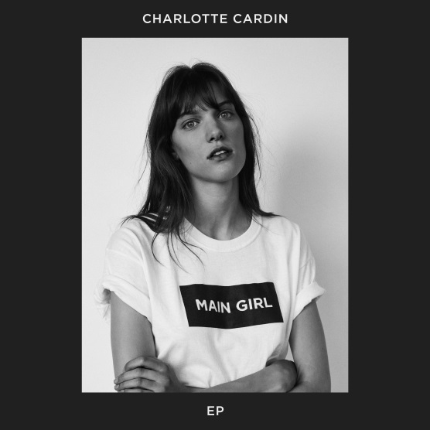

Today, with the release of her new live video for "Dirty Dirty,” Montreal songstress – Charlotte Cardin – is excited to officially announce her signing with Atlantic Records. The singer-songwriter will debut her EP, “Main Girl,” due to arrive at all DSPs and streaming services on Friday, September 8th.

“Main Girl” will include three songs featured on last year’s Canadian EP release, “Big Boy” – including “Big Boy,” “Dirty Dirty,” and “Like It Doesn’t Hurt (Feat. Husser)” – along with a trio of new tracks, among them the upcoming title track, “Main Girl.” The EP is preceded by the debut of a brand new live video accompanying “Dirty Dirty,” watch here.

Cardin will celebrate “Main Girl” with her biggest North American tour to date. The trek – headlined by Nick Murphy – begins September 10th and 11th with a two-night-stand at Washington, DC’s 9:30 Club and then continues through late October (see attached itinerary). For complete details, please see www.charlottecardin.com.

2016 saw the arrival of her “BIG BOY” EP (via Cult Nation), highlighted by the sultry, electro-jazz title track as well as such equally potent original songs as “Dirty Dirty” and “Like It Doesn’t Hurt (Feat. Husser).” The EP proved a phenomenon for the multitalented vocalist, musician, and songwriter, reaching #1 on Canada’s iTunes Store while earning over 10 million streams on Spotify alone.

Cardin amassed ecstatic critical attention here in the US from her 2016 “Big Boy” EP with Interview hailing “the smoky, jazz-tinged alto's vocal sophistication and adept wordplay…Cardin puts musicianship at the forefront; she sings confidently in both English and French over minimalist R&B productions and minor piano tickling.” The FADER applauded “Like It Doesn’t Hurt” as “a seriously smooth, beat-heavy track...Cardin's sultry voice carries this minimalistic song all the way through,” while NYLON praised “the sultry track” as “a dialogue about a dysfunctional love that burns with eternal passion…fueled by tons of drama that eventually leads to the extreme.” “(Cardin’s) got a voice that’ll make you stop whatever you’re doing, and listen,” raved Pigeons and Planes, noting “BIG BOY” “showcases a range of different styles. On some songs, Cardin explores a more jazzy and soulful vibe. On others, she slows things down to deliver an emotive pop ballad…Regardless of the genre, Cardin handles the track with the confidence of someone far more experienced. She knows when to let the song breath and, adversely, when to let her voice steer.” “All it takes is one listen to ‘BIG BOY’ to understand that (Cardin) has a certain je ne sais quoi,” wrote NOISEY, further praising her “remarkable control and maturity.”

Fast becoming known as a uniquely compelling live performer, Cardin has toured nearly non-stop over the past year, including countless Canadian live dates – both as headliner and support – as well as show-stealing performances at an array of North American festivals including Bonnaroo, Osheaga, and Le Festival d’Été de Québec, the latter of which saw her as special guest to Sting and Peter Gabriel.

For more, please visit
CHARLOTTECARDIN.COM
FACEBOOK
INSTAGRAM
TWITTER
YOUTUBE
ATLANTICRECORDS.COM

* * * * *

CHARLOTTE CARDIN
TOUR 2017

ALL DATES W/NICK MURPHY

AUGUST
9 New York, NY Public Arts
10 New York, NY Cooper Hewitt

SEPTEMBER
10 Washington, DC 9:30 Club
11 Washington, DC 9:30 Club
15 Philadelphia, PA Union Transfer
18 Boston, MA Royale
25 Toronto, ON Danforth Music Hall
26 Toronto, ON Danforth Music Hall
27 Detroit, MI Majestic Theatre
29 Chicago, IL Riviera Theatre

OCTOBER
9 Vancouver, BC Vogue Theatre
10 Vancouver, BC Vogue Theatre
13 Portland, OR Crystal Ballroom
14 Seattle, WA Showbox SoDo
16 Oakland, CA Fox Theater
19 Los Angeles, CA Shrine Auditorium
20 Santa Ana, CA The Observatory
21 San Diego, CA The Observatory North Park
25 Dallas, TX The Bomb Factory
26 Austin, TX Austin City Limits Live at the Moody Theater

MAIN GIRL TRACKLISTING
Main Girl
Dirty Dirty
Paradise Motion
Like It Doesn’t Hurt
Big Boy
The Kids

ADDITIONAL DATES TO BE ANNOUNCED

www.charlottecardin.com

