FOR IMMEDIATE RELEASE

JULY 19, 2019

**CHARLOTTE LAWRENCE ASKS “WHY DO YOU LOVE ME” ON NEW SINGLE**

***ACCLAIMED NEW POP SINGER-SONGWRITER UNVEILS ATLANTIC / GOLD TOOTH LABEL DEBUT***

***OFFICIAL MUSIC VIDEO OUT TODAY***

***“NAVY BLUE TOUR” GETS UNDERWAY NOVEMBER 7TH IN ATLANTA, GA***

***“WHY DO YOU LOVE ME” AVAILABLE TODAY AT ALL DSPS AND STREAMING SERVICES***

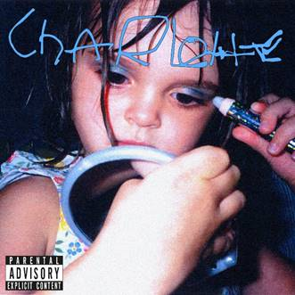

*DOWNLOAD HIGH RES COVER ART* [*HERE*](https://warnermusicgroup.box.com/s/9rgd4bgifgopupmv1q3r84wxiex9x7n3)

WATCH “WHY DO YOU LOVE ME” OFFICIAL VIDEO

<https://charlottelawrence.lnk.to/WatchWDYLMPR>

STREAM “WHY DO YOU LOVE ME”

<https://charlottelawrence.lnk.to/WDYLMPR>

Atlantic Records and Gold Tooth Records have announced the eagerly awaited label debut single from acclaimed pop singer-songwriter Charlotte Lawrence. “Why Do You Love Me” is available now via all digital music retailers and streaming services; the track is joined by a striking new companion video, directed by photographer/filmmaker Alasdair McLellan (The xx, Miu Miu) with creative direction by Marc Kalman (Travis Scott), and streaming now via YouTube [HERE](https://www.youtube.com/watch?v=mZ1FzTsIQQY).

Produced by Andrew Watt (Lana Del Rey, Cardi B), Louis Bell (Post Malone, Camila Cabello), and Charlie Puth (5 Seconds of Summer, Jason Derulo), “Why Do You Love Me” sees Los Angeles-based Lawrence exploring the space between pop and rock. Her instinctive gift for melody is now twinned with a deliciously darker aesthetic.

"I write easier about sad emotions," Lawrence says. "I think it's so cool to have an upbeat song with dark lyrics. If you tap into an emotion then you can write a whole story. No matter what you're going through it's important to take risks with music. I never want to play it safe.”

Hailed by [i-D](https://i-d.vice.com/en_us/article/kzdvw9/charlotte-lawrence-music-interview) for “smashing deeply personal lyrics into frustratingly catchy choruses,” Lawrence will celebrate “Why Do You Love Me” with a major North American concert tour. The “Navy Blue Tour” begins November 7th at Atlanta, GA’s Vinyl and then travels through the month, culminating November 23rd with an eagerly awaited homecoming performance at The Fonda Theatre in Los Angeles, CA. The newly announced dates follow recent tours of both the U.S. and Europe, runs highlighted by sold out shows in cities spanning New York and Los Angeles to Amsterdam, Manchester, and Cologne. For complete details and ticket information, please visit [charlottelawrencemusic.com](http://charlottelawrencemusic.com).

**ABOUT CHARLOTTE LAWRENCE**

Born and raised in Los Angeles, Charlotte Lawrence has already earned critical acclaim – and millions of worldwide streams – for such breakthrough hits as “[Just The Same](http://smarturl.it/justthesame)” and “[Sleep Talking](http://smarturl.it/biu7mv),” prompting [W](https://www.wmagazine.com/story/charlotte-lawrence-instagram-musician-model) to applaud her for crafting “moody bedroom pop that touches on her sometimes very personal trials with anxiety or love” in a recent cover feature. 2018 saw the release of Lawrence’s breakthrough debut EP, [YOUNG](https://charlottelawrence.lnk.to/young), acclaimed by [Atwood Magazine](http://atwoodmagazine.com/cly-young-ep-charlotte-lawrence-review/) as “a dramatic, expressive triumphant piece of work…a definite part of the ongoing pop revolution where pop songs are becoming increasingly multi-layered and wonderfully intricate.”

**CHARLOTTE LAWRENCE**

**NAVY BLUE TOUR 2019**

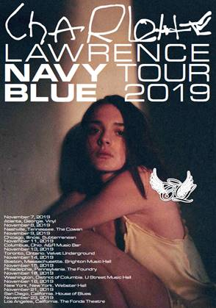

**NOVEMBER**

7 – Atlanta, GA – Vinyl

8 – Nashville, TN – The Cowan

9 – Chicago, IL – Subterranean

11 – Columbus, OH – A&R Music Bar

13 - Toronto, ON – Velvet Underground

14 – Boston, MA – Brighton Music Hall

15 – Philadelphia, PA – The Foundry

16 – Washington, DC – U Street Music Hall

18 – New York, NY – Webster Hall

21 – San Diego, CA – House of Blues - San Diego

23 – Los Angeles, CA – The Fonda Theatre

# # #

**CONNECT WITH CHARLOTTE LAWRENCE**

[OFFICIAL](http://charlottelawrencemusic.com/) | [FACEBOOK](https://www.facebook.com/CharlotteSLawrence) | [TWITTER](https://www.twitter.com/charlottelawr) | [INSTAGRAM](https://www.instagram.com/charlotteslawrence)

**PRESS CONTACT**

CARA DONATTO | [CARA.DONATTO@ATLANTICRECORDS.COM](mailto:CARA.DONATTO@ATLANTICRECORDS.COM)

TED SULLIVAN | [TED.SULLIVAN@ATLANTICRECORDS.COM](mailto:TED.SULLIVAN@ATLANTICRECORDS.COM)