FOR IMMEDIATE RELEASE
DECEMBER 8, 2021

CORDAE LIFTS THE CURTAIN ON FROM A BIRD’S EYE VIEW
2X GRAMMY® NOMINATED RAPPER UNVEILS EAGERLY AWAITED SOPHOMORE ALBUM
HIGHLIGHTS INCLUDE THE GLOBALLY ACCLAIMED NEW SINGLE,
“SINISTER (FEAT. LIL WAYNE)”
ALBUM AVAILABLE NOW FOR PREORDER HERE
FROM A BIRD’S EYE VIEW DROPS VIA ART@WAR/ATLANTIC ON FRIDAY, JANUARY 14, 2022
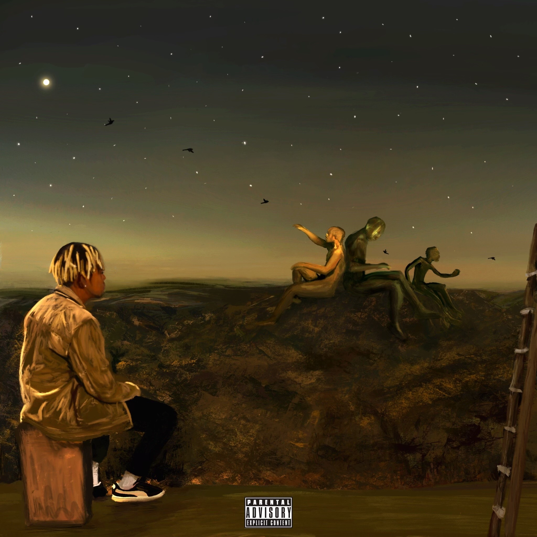
WATCH OFFICIAL ALBUM TRAILER HERE
2x GRAMMY® Award-nominated rapper Cordae is proud to announce the release of his hugely anticipated new album. From A Bird’s Eye View arrives via ART@WAR/Atlantic Records on Friday, January 14, 2022, and is available to preorder today HERE.
Deeply inspired by a life-changing trip to Africa, enduring the loss of a friend gone too soon, and evolving as an artist and a man, From A Bird’s Eye View sees Cordae telling these stories and more through technicolor imagery, nimble rhymes and fast evolving wisdom. Among its many highlights, the eagerly awaited collection includes the haunting new single, “Sinister (Feat. Lil Wayne),” available everywhere for streaming and download HERE; an official music video, directed by Edgar Esteves (French Montana, Lil Baby), is streaming via YouTube HERE. Produced by GRAMMY® Award-winning superproducer Hit-Boy (Nas, Nipsey Hussle & Roddy Ricch, Beyoncé), “Sinister” was met by instant critical applause from around the world:
“A casually excellent rhyme workout from Cordae, who reveres the complexity of the 1990s – ‘Eight months with no phone, dog/we aiming for brilliance’ – and Lil Wayne, who at his late 2000s mixtape peak, which he recalls here, turned complexity into extraterrestriality.” – THE NEW YORK TIMES
“You can find dozens of interviews and articles featuring Cordae speaking about the importance of lyricism in Hip Hop. On this latest single with Lil Wayne, both artists prove that the power of the pen isn't dead.” – HNHH
“Lyrically charged…the chorus on ‘Sinister’ hears Cordae plant his flag in the sand, proclaiming that what he does is bigger than rap and assuring listeners that will be a hip-hop mainstay for decades to come.” – NME
“The joint effort is an intriguing preview into the young rapper’s upcoming album.” – HYPEBEAST
# # #
From A Bird’s Eye View was first unveiled this fall with the powerhouse single, “Super,” available now at all DSPs and streaming services HERE. Produced by longtime collaborator Kid Culture (Justin Bieber, Ed Sheeran) and co-produced by Jenius, the track is joined by an official music video – directed by Arrad of Riveting Entertainment (Lil Wayne & Rich The Kid, Polo G) – is streaming now at YouTube HERE.
In addition, Cordae is chronicling the making of his new LP with an exclusive multi-part documentary mini-series. Episode 1 of “The Road To From A Bird’s Eye View” is already available to watch via YouTube HERE.
# # #
Cordae knows exactly what he wants to say. He chooses his words and phrases carefully. He speaks from a place of truth. That’s why the 2x GRAMMY® Award-nominated gold-selling Maryland-raised rapper has quietly become one of the modern generation’s most trusted narrators. A remarkable life has given him a lot to say. He went from trailer parks and public housing with his mom to stratospheric success. After a series of buzzing singles, he reached critical mass with his milestone 2019 debut album, The Lost Boy, available now at all DSPs and streaming services HERE. Now boasting more than 430M worldwide streams and counting, the full-length project bowed among the top 15 on the Billboard 200 and includes the RIAA gold-certified singles, “Have Mercy,” “RNP (Feat Anderson .Paak),” “Broke As F**k,” and “Kung Fu.”
Beyond unanimous praise from Billboard, Complex, High Snobiety, the New York Times, Pitchfork, and Stereogum, Cordae garnered a pair of GRAMMY® Award nominations in the categories of “Best Rap Album” for The Lost Boy and “Best Rap Song” for the RIAA gold certified lead single, “Bad Idea (Feat. Chance the Rapper).” The rare artist whose presence can be felt on-screen in a Super Bowl commercial alongside legendary Academy® Award-winning director Martin Scorsese and among XXL’s coveted “Freshman Class,” Cordae linked up with Roddy Ricch for “Gifted” as well as joining forces with Eminem for “Killer.”

# # #

CONNECT WITH CORDAE
INSTAGRAM | YOUTUBE | TWITTER | FACEBOOK

FOR PRESS INQUIRIES
SYDNEY.MARGETSON@ATLANTICRECORDS.COM
DVORA.ENGLEFIELD@LEDECOMPANY.COM
COURTNI.ASBURY@LEDECOMPANY.COM

