FOR IMMEDIATE RELEASE
APRIL 27, 2021

CORDAE UNVEILS MUSIC VIDEO FOR “DREAM IN COLOR” ON THE HEELS OF “4 PACK” PROJECT JUST UNTIL.…

JUST UNTIL… AVAILABLE NOW EVERYWHERE HERE

WATCH OFFICIAL MUSIC VIDEO FOR “DREAM IN COLOR” HERE

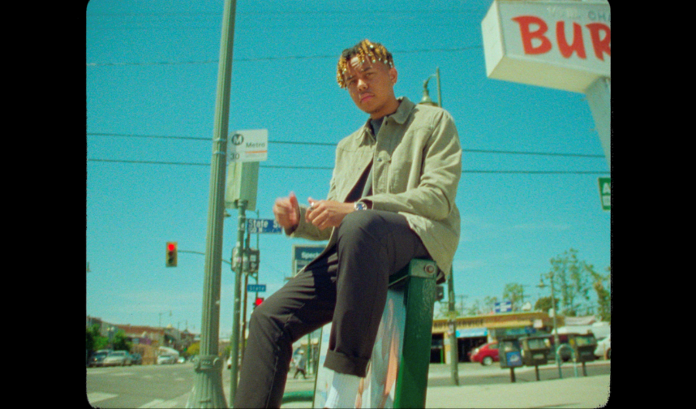
download video thumbnail here

“Impressively dexterous... Cordae specializes in thoughtful, emotionally eloquent and lyrically complex music.”
– THE NEW YORK TIMES

“Cordae raps about life with the patience of a pro”
– PITCHFORK

“Cordae dazzles as a formidable storyteller, with a knack for witty punchlines”
- BILLBOARD

2x GRAMMY® Award-nominated rapper Cordae has today unveiled the official music video for his track “Dream In Color” (watch HERE). Today’s news comes on the heels of last week the release of his eagerly anticipated new “4 pack” project – JUST UNTIL.…(listen HERE).

JUST UNTIL.… includes the mesmerizing track “Dream In Color,” with musical contributions from Raphael Saadiq and Terrace Martin. The project also includes the tracks, “More Life (Feat. Q Tip),” which premiered alongside the official music video – watch HERE, “Wassup (Feat. Young Thug),” and “Thornton Street.” Additional visuals premiering soon.

Last week’s announcement marked the long-awaited follow-up to Cordae’s milestone 2019 debut album, THE LOST BOY, available now at all DSPs and streaming services HERE. The full-length project proved a true breakthrough for the MD-based rapper, earning a GRAMMY® Award nomination for “Best Rap Album” amidst a landslide of critical acclaim from such high profile national media outlets as Billboard, Complex, Stereogum, High Snobiety, the New York Times, and more. THE LOST BOY made a top 10 debut on Billboard’s “Top R&B/Hip-Hop Albums” chart upon its initial arrival, fueled by such hit tracks as the RIAA gold-certified lead single “Have Mercy,” Cordae & Anderson .Paak’s gold-certified “RNP,” “Broke As F**k,” and “Bad Idea (Feat. Chance the Rapper),” the latter of which received a prestigious GRAMMY® nod for “Best Rap Song” and is joined by an official music video now boasting close to 8M views via YouTube HERE.

2020 saw Cordae continuing to build on his rising reputation with a number of new releases including “Gifted (Feat. Roddy Ricch),” joined by an official music video directed by Cole Bennett and streaming now at Lyrical Lemonade where it has earned close to 8M individual views thus far. The track earned widespread praise for the two GRAMMY® Award-nominated rappers, with HYPEBEAST declaring it to be “an upbeat celebration of all that the two artists have accomplished in such a short period of time while also giving thanks to their numerous blessings.”

Known for his acrobatic raps, cinematic wordplay, and nimble rhymes, Cordae has quickly risen to the vanguard of modern hip-hop. 2018 saw him make an extraordinary debut with a series of viral hit remixes and singles including “Kung Fu,” earning RIAA gold certification and more than 77M worldwide streams in less than one year. A plethora of accolades soon followed, with Cordae declared “one of music’s most promising rising stars” by the Wall Street Journal and one of the New York Times’ “10 Artists to Watch in 2019” while also being named among XXL’s star-studded “2019 Freshman Class” (alongside fellow icons like Roddy Ricch, Megan Thee Stallion, Rico Nasty, and Da Baby). In addition to his two GRAMMY® nods, 2020 saw Cordae receive a further array of global attention including rave reviews in Rolling Stone, Pitchfork, and the Financial Times, to name but a few, as well as such honors as a 2020 BET Award nomination as “Best New Artist.”

A vocal defender of justice and equality, Cordae has long been on the frontlines of Black Lives Matter protests and in July 2020, was arrested in Louisville, KY alongside other community leaders demanding justice for Breonna Taylor. Last year also saw him perform at the LeBron James Family Foundation’s “Graduate Together: America Honors the High School Class of 2020” event while Puma recently named him as the face of its new “Unity Collection” celebrating the athletic brand’s global heritage and “the power of sport uniting our world.”

Cordae is currently hard at work completing the eagerly anticipated full-length follow-up to THE LOST BOY, with additional new music slated to arrive later this year.

# # #

CONNECT WITH CORDAE
INSTAGRAM | YOUTUBE | TWITTER | FACEBOOK

FOR PRESS INQUIRIES

SYDNEY MARGETSON
SYDNEY.MARGETSON@ATLANTICRECORDS.COM

# # #

