FOR IMMEDIATE RELEASE
OCTOBER 7, 2021

CORDAE IS BACK WITH “SUPER”

2X GRAMMY® NOMINATED RAPPER HERALDS UPCOMING SECOND ALBUM
WITH POWERHOUSE NEW SINGLE

OFFICIAL MUSIC VIDEO PREMIERES TODAY AT YOUTUBE

EAGERLY AWAITED NEW ALBUM, FROM A BIRD’S EYE VIEW, DUE LATER THIS YEAR

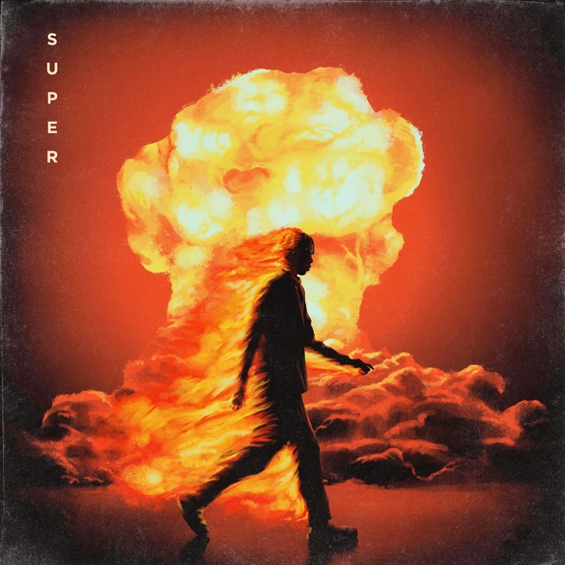

“Impressively dexterous... Cordae specializes in thoughtful, emotionally eloquent and lyrically complex music.”
– THE NEW YORK TIMES

“Cordae raps about life with the patience of a pro”
– PITCHFORK

“Cordae dazzles as a formidable storyteller, with a knack for witty punchlines”
- BILLBOARD

2x GRAMMY® Award-nominated rapper Cordae has today’s premiere of a powerhouse new single. “Super” is available now via ART@WAR/Atlantic Records at all DSPs and streaming services; an official music video – directed by Arrad of Riveting Entertainment – is streaming now at YouTube.

Produced by his longtime collaborator Kid Culture (Justin Bieber, Ed Sheeran) and co-produced by Jenius, “Super” heralds Cordae’s hugely anticipated new album, From A Bird’s Eye View, due later this year. From A Bird’s Eye View marks the long-awaited follow-up to Cordae’s milestone 2019 debut album, The Lost Boy, available now at all DSPs and streaming services HERE. Now boasting more than 430M worldwide streams and counting, the full-length project proved a true breakthrough for the MD-based rapper, earning a GRAMMY® Award nomination for “Best Rap Album” amidst a landslide of critical acclaim from such high-profile national media outlets as Billboard, Complex, Stereogum, High Snobiety, the New York Times, and more. The Lost Boy made a top 10 debut on Billboard’s “Top R&B/Hip-Hop Albums” chart upon its initial arrival, fueled by such hit tracks as the RIAA gold certified lead single “Have Mercy,” Cordae & Anderson .Paak’s gold certified “RNP,” “Broke As F**k,” and “Bad Idea (Feat. Chance the Rapper),” the latter of which received a prestigious GRAMMY® nod for “Best Rap Song” and is joined by an official music video now boasting close to 8.5M views via YouTube HERE.

2020 saw Cordae continuing to build on his rising reputation with a number of new releases including “Gifted (Feat. Roddy Ricch),” joined by an official music video directed by Cole Bennett and streaming now at Lyrical Lemonade where it has earned more than 8M individual views thus far. The track earned widespread praise for the two GRAMMY® Award-nominated rappers, with HYPEBEAST declaring it to be “an upbeat celebration of all that the two artists have accomplished in such a short period of time while also giving thanks to their numerous blessings.”

Known for his acrobatic raps, cinematic wordplay, and nimble rhymes, Cordae has quickly risen to the vanguard of modern hip-hop. 2018 saw him make an extraordinary debut with a series of viral hit remixes and singles including “Kung Fu,” earning RIAA gold certification and more than 120M worldwide streams in less than one year. A plethora of accolades soon followed, with Cordae declared “one of music’s most promising rising stars” by the Wall Street Journal and one of the New York Times’ “10 Artists to Watch in 2019” while also being named among XXL’s star-studded “2019 Freshman Class” (alongside fellow icons like Roddy Ricch, Megan Thee Stallion, Rico Nasty, and Da Baby). In addition to his two GRAMMY® nods, 2020 saw Cordae receive a further array of global attention including rave reviews in Rolling Stone, Pitchfork, and the Financial Times, to name but a few, as well as such honors as a 2020 BET Award nomination as “Best New Artist.”

A vocal defender of justice and equality, Cordae has long been on the frontlines of Black Lives Matter protests and in July 2020, was arrested in Louisville, KY alongside other community leaders demanding justice for Breonna Taylor. Last year also saw him perform at the LeBron James Family Foundation’s “Graduate Together: America Honors the High School Class of 2020” event while Puma recently named him as the face of its new “Unity Collection” celebrating the athletic brand’s global heritage and “the power of sport uniting our world.”

This year has seen Cordae continuing to make significant strides in his still-burgeoning career, including launching his own fully independent label, Hi Level, which aims to champion and empower emerging artists. Other recent highlights include a starring role in the new BAPE® x Coach campaign as well as a collaboration with Common on the just released track, “What’s Life,” featured on Liberated/Music For The Movement Vol. 3, the third installment in the critically acclaimed EP series from ESPN’s The Undefeated. As if that weren’t enough, Cordae has partnered with Disney and ESPN to help fund scholarships for HBCU students while also lending his voice to the groundbreaking Netflix series, We The People, executive produced by Barack and Michelle Obama and Kenya Barris.

# # #
CONNECT WITH CORDAE
INSTAGRAM | YOUTUBE | TWITTER | FACEBOOK

FOR PRESS INQUIRIES
SYDNEY.MARGETSON@ATLANTICRECORDS.COM

