FOR IMMEDIATE RELEASE
DECEMBER 13, 2021

CORDAE ANNOUNCES FROM A BIRD’S EYE VIEW TOUR

2X GRAMMY® NOMINATED RAPPER SETS BIGGEST NORTH AMERICAN TOUR THUS FAR

HEADLINE DATES BEGIN FEBRUARY 3 IN DALLAS, TX

ARTIST PRE-SALES BEGIN MONDAY, DECEMBER 13

SPOTIFY PRE-SALES BEGIN WEDNESDAY, DECEMBER 15

VENUE PRE-SALES BEGIN THURSDAY, DECEMBER 16
GENERAL ON-SALES BEGIN FRIDAY, DECEMBER 17 AT 10:00 AM (LOCAL)

EAGERLY AWAITED NEW ALBUM, FROM A BIRD’S EYE VIEW, ALBUM AVAILABLE FOR PREORDER HERE

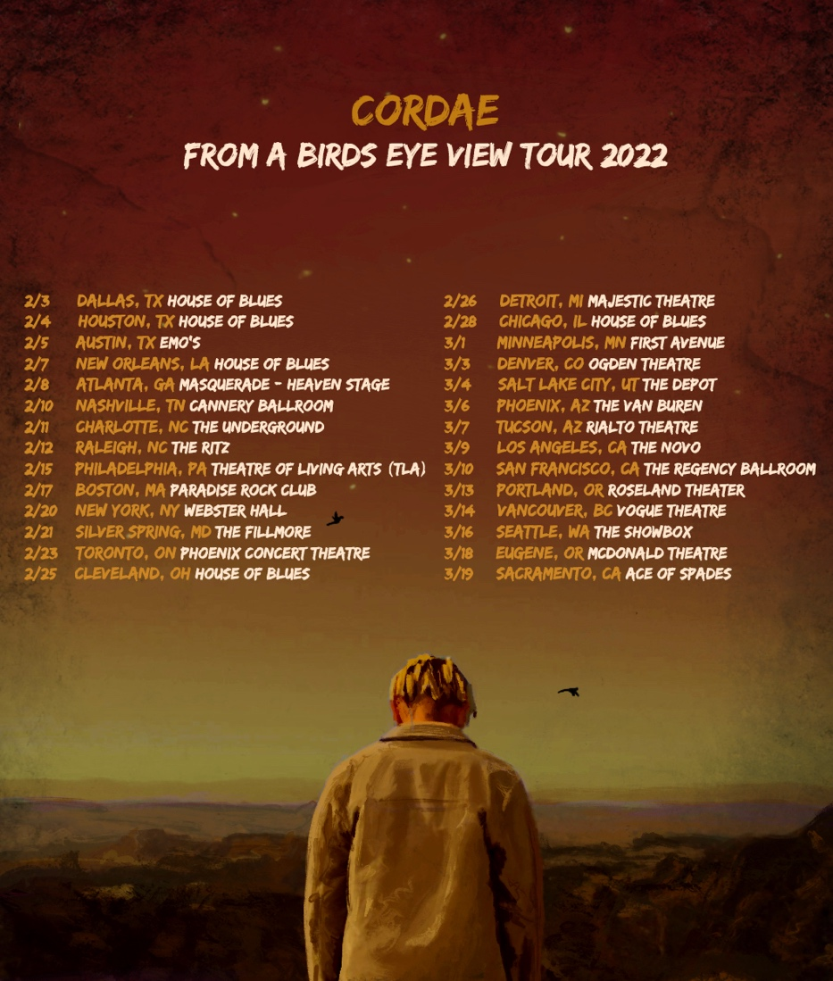

2x GRAMMY® Award-nominated rapper Cordae has announced his eagerly awaited From A Bird’s Eye View Tour. The North American headline tour begins February 3 at Dallas, TX’s House of Blues and then continues through mid-March. Additional dates and special guests will be announced soon. Artist Presale begins Monday, December 12 at 12:00 PM (local). Fans can access a unique code to preorder tickets after presaving the album. Spotify presales begin Wednesday, December 15 at 10:00 AM (local) through Thursday, December 16 at 11:59 PM (local). Local presales follow on Thursday, December 16 from 10:00 AM-10:00 PM (local). General on-sales begin Friday, December 17 at 10:00 AM (local). For complete details and ticket availability, please see www.Cordaemusic.com/tour

CORDAE
FROM A BIRD’S EYE VIEW TOUR 2022

FEBRUARY
3 - Dallas, TX - House of Blues
4 - Houston, TX - House of Blues
5 - Austin, TX - Emo's
7 - New Orleans, LA - House of Blues
8 - Atlanta, GA - The Masquerade - Heaven Stage
10 - Nashville, TN - Cannery Ballroom
11 - Charlotte, NC The Underground
12 - Raleigh, NC - The Ritz
15 - Philadelphia, PA - Theatre of Living Arts (TLA)
17 - Boston, MA - Paradise Rock Club
20 - New York, NY - Webster Hall
21 - Silver Spring, MD - The Fillmore
23 - Toronto, ON - Phoenix Concert Theatre
25 - Cleveland, OH - House of Blues
26 - Detroit, MI - Majestic Theatre
28 - Chicago, IL - House of Blues

MARCH
1 - Minneapolis, MN - First Avenue
3 - Denver, CO - Ogden Theatre
4 - Salt Lake City, UT - The Depot
6 - Phoenix, AZ - The Van Buren
7 - Tucson, AZ - Rialto Theatre
9 - Los Angeles, CA - The Novo
10 - San Francisco, CA - The Regency Ballroom
13 - Portland, OR - Roseland Theater
14 - Vancouver, BC - Vogue Theatre
16 - Seattle, WA - The Showbox
18 - Eugene, OR - McDonald Theatre
19 - Sacramento, CA - Ace of Spades

ADDITIONAL DATES TO BE ANNOUNCED

# # #

The upcoming tour heralds Cordae’s hugely anticipated new album, From A Bird’s Eye View, due via ART@WAR/Atlantic Records on Friday, January 14, 2022. Deeply inspired by a life-changing trip to Africa, enduring the loss of a friend gone too soon, and evolving as an artist and a man, the upcoming album sees Cordae telling these stories and more through technicolor imagery, nimble rhymes, and fast evolving wisdom. Recent weeks have seen the acclaimed premiere of the album’s haunting new single, “Sinister (Feat. Lil Wayne),” available everywhere for streaming and download HERE; an official music video is streaming via YouTube HERE.

From A Bird’s Eye View was first unveiled this fall with the powerhouse single, “Super,” available now at all DSPs and streaming services. Produced by longtime collaborator Kid Culture (Justin Bieber, Ed Sheeran) and co-produced by Jenius, the track is joined by an official music video – directed by Arrad of Riveting Entertainment (Lil Wayne & Rich The Kid, Polo G) – is streaming now at YouTube HERE.

Cordae knows exactly what he wants to say. He chooses his words and phrases carefully. He speaks from a place of truth. That’s why the 2x GRAMMY® Award-nominated gold-selling Maryland-raised rapper has quietly become one of the modern generation’s most trusted narrators. A remarkable life has given him a lot to say. He went from trailer parks and public housing with his mom to stratospheric success. After a series of buzzing singles, he reached critical mass with his milestone 2019 debut album, The Lost Boy, available now at all DSPs and streaming services HERE. Now boasting more than 430M worldwide streams and counting, the full-length project bowed among the top 15 on the Billboard 200 and includes the RIAA gold-certified singles, “Have Mercy,” “RNP (Feat Anderson .Paak),” “Broke As F**k,” and “Kung Fu.”

Beyond unanimous praise from Billboard, Complex, High Snobiety, the New York Times, Pitchfork, and Stereogum, Cordae garnered a pair of GRAMMY® Award nominations in the categories of “Best Rap Album” for The Lost Boy and “Best Rap Song” for the RIAA gold certified lead single, “Bad Idea (Feat. Chance the Rapper).” The rare artist whose presence can be felt on-screen in a Super Bowl commercial alongside legendary Academy® Award-winning director Martin Scorsese and among XXL’s coveted “Freshman Class,” Cordae linked up with Roddy Ricch for “Gifted” as well as joining forces with Eminem for “Killer.”

# # #
CONNECT WITH CORDAE
INSTAGRAM | YOUTUBE | TWITTER | FACEBOOK

FOR PRESS INQUIRIES
SYDNEY.MARGETSON@ATLANTICRECORDS.COM
DVORA.ENGLEFIELD@LEDECOMPANY.COM
COURTNI.ASBURY@LEDECOMPANY.COM

