FOR IMMEDIATE RELEASE
APRIL 27, 2021

CORDAE UNVEILS MUSIC VIDEO FOR “DREAM IN COLOR” ON THE HEELS OF “4 PACK” PROJECT JUST UNTIL.…

WATCH OFFICIAL MUSIC VIDEO FOR “DREAM IN COLOR” HERE

JUST UNTIL… AVAILABLE NOW EVERYWHERE HERE

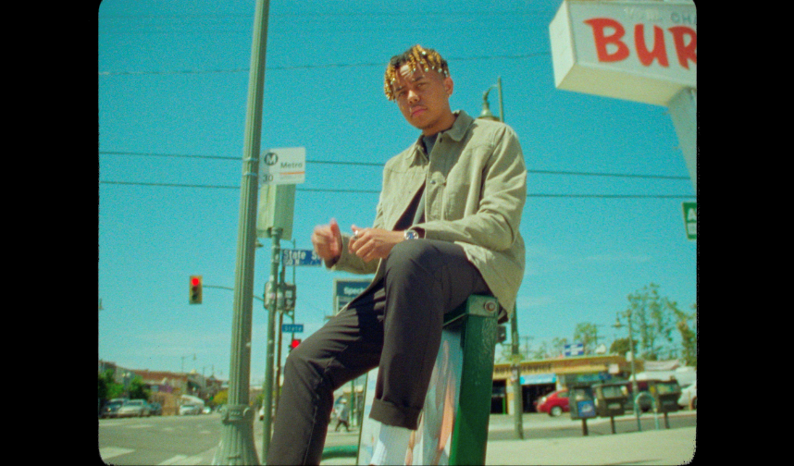
download video thumbnail here

“Impressively dexterous... Cordae specializes in thoughtful, emotionally eloquent and lyrically complex music.”
– THE NEW YORK TIMES

“Cordae raps about life with the patience of a pro”
– PITCHFORK

“Cordae dazzles as a formidable storyteller, with a knack for witty punchlines”
- BILLBOARD

2x GRAMMY® Award-nominated rapper Cordae has today unveiled the official music video for his track “Dream In Color” (watch HERE). Today’s news comes on the heels of last week’s release of his eagerly anticipated new “4 pack” project – JUST UNTIL.…(listen HERE).

JUST UNTIL.… includes the mesmerizing track “Dream In Color,” with musical contributions from Raphael Saadiq and Terrace Martin. The project also includes the tracks, “More Life (Feat. Q Tip),” which premiered alongside the official music video – watch HERE, “Wassup (Feat. Young Thug),” and “Thornton Street.” Additional visuals premiering soon.
Cordae is currently hard at work completing the eagerly anticipated full-length follow-up to THE LOST BOY, with additional new music slated to arrive later this year.

# # #

CONNECT WITH CORDAE
INSTAGRAM | YOUTUBE | TWITTER | FACEBOOK

FOR PRESS INQUIRIES

SYDNEY MARGETSON
SYDNEY.MARGETSON@ATLANTICRECORDS.COM

# # #

