FOR IMMEDIATE RELEASE JULY 9, 2020

CHARLIE PUTH SHARES OFFICIAL MUSIC VIDEO FOR “GIRLFRIEND”

“A swoon-worthy summer bop” – Billboard
“An instant hit” – E!
"Feels like the warm slice of summer that we've been longing for” – iHeart Radio

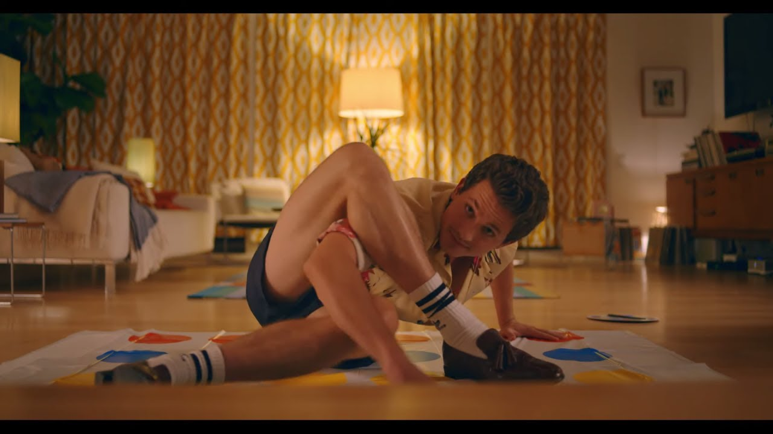

WATCH THE NEW MUSIC VIDEO HERE

STREAM/DOWNLOAD “GIRLFRIEND” HERE

Los Angeles, CA – July 9, 2020 – Multi-GRAMMY nominated and multi-platinum singer/songwriter/producer, Charlie Puth, has unveiled the official music video for “Girlfriend,” his much-anticipated first solo release of 2020. Directed by Drew Kirsch (Taylor Swift, Niall Horan, John Legend), the new visual follows Puth preparing for a dinner date that results in an unexpected turn of events.

“I’ve never released a music video that wholeheartedly showed my personality. The video for ‘Girlfriend’ is the first time I’ve truly been myself in every aspect. I can’t cook and I’m an absolute nerd. It’s also meant to visually represent what I want people to do when they hear my music and that’s to have fun in their very own way,” says Puth.

“Girlfriend” underscores why Puth is one of the industry’s most consistent hitmakers and sought-after collaborators in pop music today. In celebration of the new track, which has already garnered over eight million global streams in just two weeks, Puth was featured on Spotify’s New Music Friday billboard in Times Square and landed the cover of Amazon Music’s Pop Culture, while earning the #1 slot at Amazon Music for the week. He also debuted the performance of the new song on The Late Late Show with James Corden and recently performed “Girlfriend” on the Today Show’s Summer Concert Series.

“Girlfriend” follows Puth’s appearance on Lennon Stella’s “Summer Feelings” from SCOOB! The Album and Gabby Barrett’s “I Hope” Remix from earlier this year, in addition to his impressive trilogy of songs released in 2019 – “I Warned Myself,” “Mother,” and “Cheating On You,” which have amassed over 250 million combined worldwide streams and over 67 million video views. Puth most recently produced and co-wrote on John Legend’s “I Do,” Katy Perry’s “Small Talk” and “Harleys In Hawaii,” and 5 Seconds of Summer’s “Easier,” not to mention joining forces with Sir Elton John, revealing the two “wrote something really special.”

During the quarantine, Puth has participated in various live performances including Global Citizen & WHO’s #TogetherAtHome Concert, At Home With Apple Music, and more. He also took part in Jersey 4 Jersey Live to raise money for the pandemic relief fund in his home state, playing a cover of fellow New Jersey native Bruce Springsteen’s hit, “Growin’ Up.” In May, Puth teamed up once again with Katy Perry as a guest mentor on her team, on American Idol. Additionally, Puth's Instagram has become a destination during quarantine for its creative and funny videos, including “Baby Charlie” singing along to “Girlfriend,” a piano version of Megan Thee Stallion’s “Savage,” and “Charlie's Quarantine Song.”

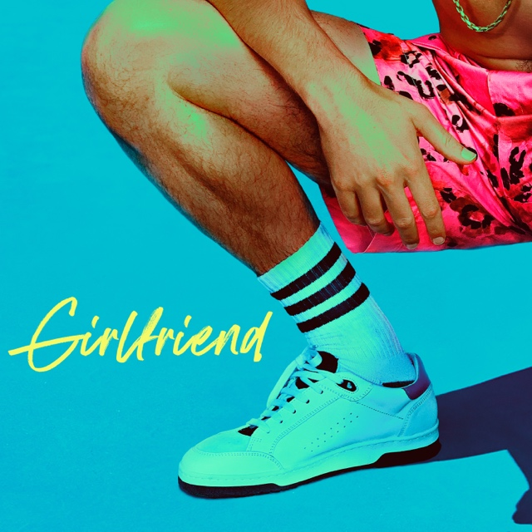
Link to Hi-Res Press Images and Cover Artwork HERE

At only 28 years old, Puth has already amassed eight multi-platinum singles, four GRAMMY nominations, two Billboard Music Awards, a Critic’s Choice Award, and a Golden Globe nomination. His 2018 GRAMMY-nominated LP, Voicenotes, was RIAA certified gold only four days after its release and has logged over 3.4 billion streams worldwide to date. Written and produced by Puth himself, Voicenotes has received universal acclaim, including The New York Times calling it “one of the year’s best pop albums.” The album features 4x platinum-certified “Attention,” 2x platinum-certified “How Long,” and platinum-certified “Done For Me.” The album was nominated for the 2019 GRAMMYs for “Best Engineered Album, Non-Classical,” and the companion Voicenotes Tour resulted in massive, sold-out headline shows across North America and Asia.

Puth exploded onto the music scene writing and recording the breakout smash “See You Again” with Wiz Khalifa, which topped the Billboard Hot 100 for 12 weeks and was the best-selling song of 2015 worldwide with over 20.9 million units sold. The track received three GRAMMY nominations including “Song of The Year” as well as a Golden Globe nomination for “Best Original Song.” The following year, Charlie released his full-length debut, the 2x platinum-certified Nine Track Mind, which spawned a remarkable three multi-platinum certified singles in “One Call Away,” “Marvin Gaye (feat. Meghan Trainor),” and “We Don’t Talk Anymore (feat. Selena Gomez).”

Connect with Charlie Puth:
Website | Facebook | Twitter | Instagram | YouTube | Media Assets

# # #

Press Contacts for Charlie Puth:
ID, Allison Elbl (aelbl@id-pr.com), Rhett Usry (rusry@id-pr.com), Nathalie Rubin (nrubin@id-pr.com)
Atlantic Records, Sheila Richman (sheila.richman@atlanticrecords.com), Ted Sullivan (ted.sullivan@atlanticrecords.com)

