**CARDI B**

**RELEASES NEW SINGLE**

**“BARTIER CARDI” FEATURING 21 SAVAGE**

[**LISTEN HERE**](https://lnk.to/BartierCardi)

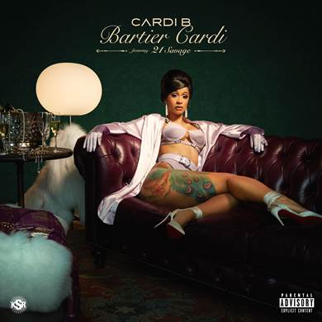

GRAMMY nominated rap superstar Cardi B rounds out an all-star 2017 by releasing her next smash single, “Bartier Cardi” featuring 21 Savage. While Cardi is currently featured on several hit tracks – G-eazy’s “No Limit” ft. A$AP Rocky, Migos’ “Motorsport” ft. Nicki Minaj, and Ozuna’s “La Modelo” – “Bartier Cardi” marks the rapper’s official second single release follow up to this year’s breakthrough smash “Bodak Yellow.”

“Bodak Yellow,” which is now certified TRIPLE platinum, had an astronomical rise this year – earning the coveted #1 spot on Billboard’s Hot 100 chart for five consecutive weeks, making Cardi B the first female rapper to reach #1 without any accompanying acts since Lauryn Hill in 1998. Additionally, Cardi B has recently become the first female rapper to land her first three Hot 100 entries in the [Top 10](https://www.billboard.com/articles/columns/chart-beat/8071032/cardi-b-hot-100-career-opening-songs-motorsport-bodak-yellow-no-limit?utm_source=Sailthru&utm_medium=email&utm_campaign=Daily&utm_term=daily_digest). Cardi B and “Bodak Yellow” have been featured on several “Best Of” lists including, Rolling Stone, New York Times, Washington Post, Time, Billboard and Vanity Fair, to name a few. Cardi was also recently named on of Forbes “30 Under 30.”

This year saw Cardi make a seemingly unstoppable series of appearances and live events including memorable performance of “Bodak Yellow” on Jimmy Kimmel Live in Brooklyn, during the [MTV Video Music Awards](http://www.mtv.com/news/3032938/cardi-b-mtv-vmas-bodak-yellow/) pre-show ceremonies, the BET Awards post show, and multiple cover features – Fader Summer Music Issue, Rolling Stone, New York Mag – and most recently, [Billboard’s “Year In Music” issue](https://www.billboard.com/articles/events/year-in-music-2017/8071047/cardi-b-hot-100-history-interview-no-1s-2017).

Cardi B has also made appearances on The Tonight Show starring Jimmy Fallon to perform “No Limit” alongside G-eazy. This past week, Cardi returned to The Tonight Show for her [first late night interview](https://www.nbc.com/the-tonight-show/video/jimmy-interviews-cardi-b/3639627).

As if that weren’t enough, Cardi B received nine BET Hip Hop Awards nominations and took home 5 wins (Single of The Year, Best New Hip Hop Artist, Hustler of the Year, Made-You –Look Award, Best Mixtape) as well as two top BET Awards nominations (for “Best New Artist” and “Best Female Hip Hop Artist”) and was among the highest profile celebrities seen at the recent New York Fashion Week, including visits to Rihanna’s Third Diamond Ball, a performance at the esteemed Alexander Wang’s WangFest party and Pat McGrath’s “Mothership” Vogue Ball.

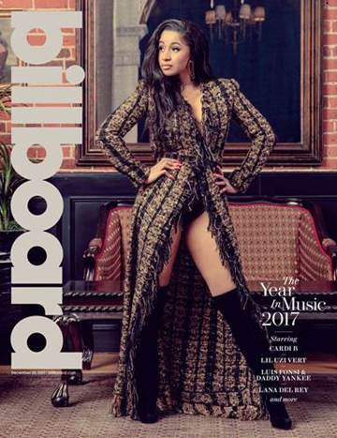

**……………………………………………………………………………………………………………………………………………………………**

***For Posting:***

**URL:** [**https://youtu.be/sXP6vliZIHI**](https://youtu.be/sXP6vliZIHI)

**EMBED: <iframe width="560" height="315" src="**[**https://www.youtube.com/embed/sXP6vliZIHI**](https://www.youtube.com/embed/sXP6vliZIHI)**" frameborder="0" gesture="media" allow="encrypted-media" allowfullscreen></iframe>**