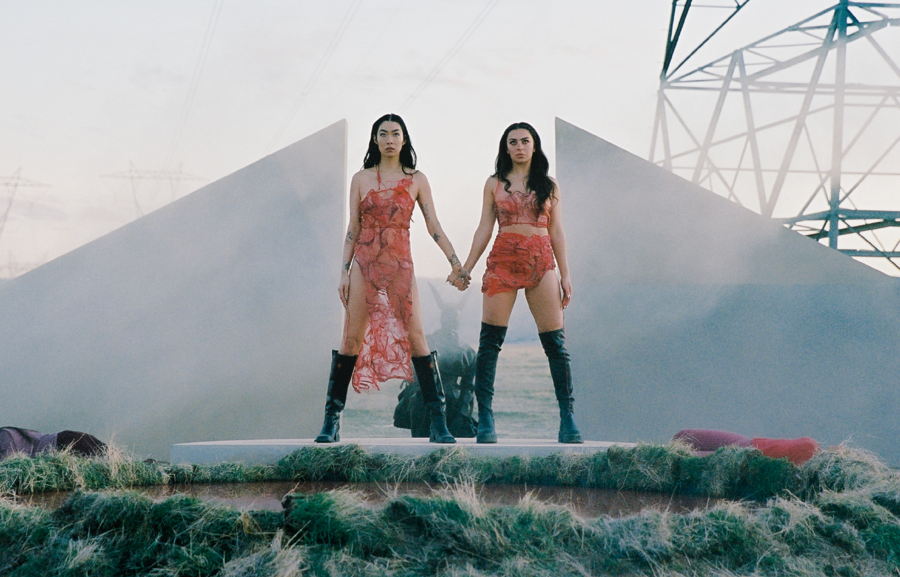

CHARLI XCX RELEASES MUSIC VIDEO FOR HER NEW TRACK, ‘BEG FOR YOU’ FEATURING RINA SAWAYAMA
WATCH THE VIDEO HERE
STREAM THE TRACK HERE

CRASH: THE ALBUM - OUT MARCH 18TH
EUROPEAN AND NORTH AMERICAN TOUR STARTS IN MARCH
PREORDER THE ALBUM + BUY YOUR TOUR TICKETS HERE

(Friday February 11th) –– Today Charli XCX, releases the music video for her latest single, ‘Beg For You’, featuring Rina Sawayama. Visually the video encapsulates cult theology within popular culture; worship of an image, obsession of a higher power, ritualistic and superstitious practices and the sacrifice for perfection. The video was directed by Nick Harwood and filmed in Lancaster, CA.

‘Beg For You’ is the first time Rina and Charli have worked together after years of friendship. The track was produced by Digital Farm Animals and features an iconic dance sample from September “Cry For You”.

Charli’s highly-anticipated forthcoming album, CRASH, will be released on March 18th and is the fifth and final album in her record deal. Charli kicks off her 21-date North American tour in Los Angeles on March 26th followed by her 17-date UK and European tour which starts in Dublin on May 13th. See full tour dates below.

North American live dates:

26th March - Fox Theatre - Oakland, CA
27th March - Fox Theatre - Oakland, CA
29th March - Crystal Ballroom - Portland, OR
1st April - The Observatory North Park - San Diego, CA
3rd April - The Greek Theatre - Los Angeles, CA
6th April - Ogden Theatre - Denver, CO
8th April - ACL Live at The Moody Theater - Austin, TX
9th April - House of Blues Houston - Houston, TX (on sale TBD)
10th April - House of Blues Dallas - Dallas, TX
12th April - Orpheum Theater - New Orleans, LA
13th April - The Eastern - Atlanta, GA
15th April - The Orange Peel - Asheville, NC
16th April - The NorVa - Norfolk, VA
18th April - The Fillmore Philadelphia - Philadelphia, PA
20th April - House of Blues Boston - Boston, MA
22nd April - Hammerstein Ballroom - New York, NY
23rd April - Hammerstein Ballroom - New York, NY
25th April - Massey Hall - Toronto, ON
26th April - Royal Oak Music Theatre - Royal Oak, MI
28th April - Palace Theatre - Saint Paul, MN
29th April - Byline Bank Aragon Ballroom - Chicago, IL

European live dates:

13th May - Olympia Theatre - Dublin, Ireland
15th May - O2 Academy - Glasgow, UK
17th May - Victoria Warehouse - Manchester, UK
18th May - O2 Academy - Birmingham, UK
19th May - Alexandra Palace - London, UK
21st May - UEA - Norwich, UK
22nd May - O2 Academy - Sheffield, UK
23rd May - Rock City - Nottingham, UK
25th May - Trianon - Paris, France*
27th May - La Madeleine - Brussels, Belgium*
28th May - TivoliVredenburg (Ronda Hall) - Utrecht, Netherlands
30th May - Astra - Berlin, Germany
31st May - Carlswerk Victoria - Cologne, Germany
2nd June - Primavera - Barcelona, Spain
4th June - Fabrique - Milan, Italy
7th June - La Riviera - Madrid, Spain
9th June - Primavera - Barcelona, Spain

Follow Charli XCX here
Download press images + artworks here
Pre-order CRASH + buy your tickets here

