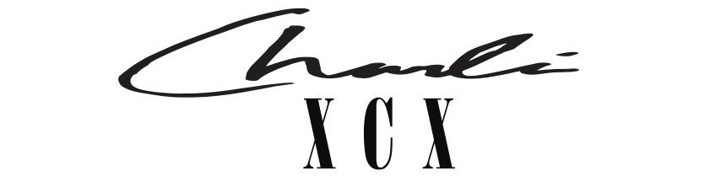

FROM THE DESK OF CHARLI XCX —
I, CHARLI XCX AM ANNOUNCING MY 5TH STUDIO ALBUM: CRASH - OUT MARCH 18TH
I AM ALSO RELEASING ONE OF THE MOST EXQUISITE TRACKS FROM THE ALBUM ALONGSIDE THE TOUR DATES - ALTHOUGH HONESTLY, ALL THE TRACKS ARE TOTALLY DIVINE.
‘NEW SHAPES’ FEATURES MY DEMONICALLY TALENTED FRIENDS CAROLINE POLACHEK AND CHRISTINE AND THE QUEENS.
I SUMMONED UP DEATON CHRIS ANTHONY AND LINUS WIKLUND FROM THE DEPTHS OF HELL TO PRODUCE IT.

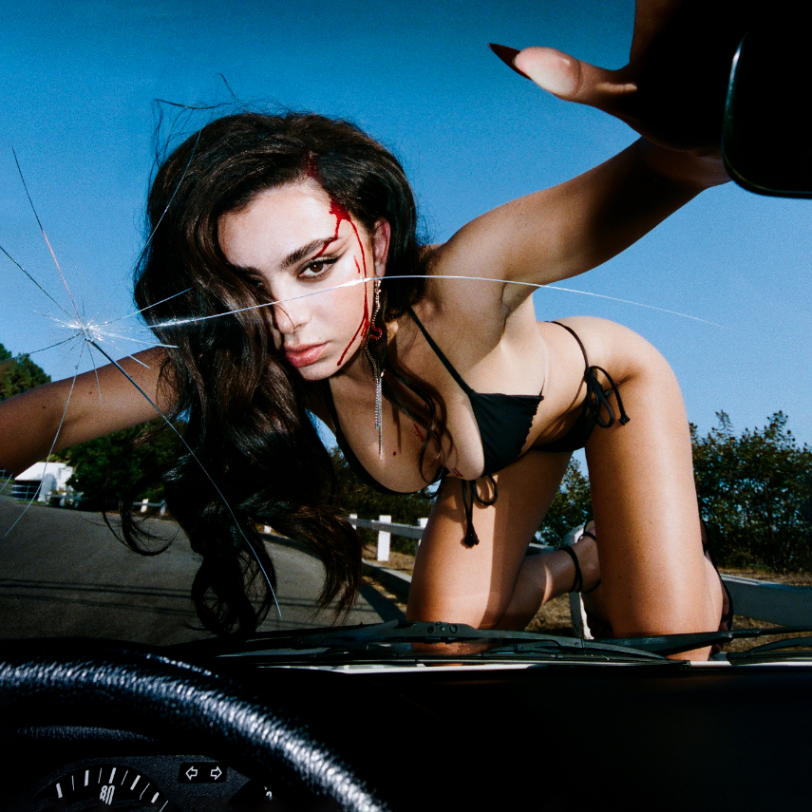

MY MOST FAST, FURIOUS, ICONIC AND DEADLY EUROPEAN AND NORTH AMERICAN TOUR STARTS NEXT YEAR WITH TICKETS AVAILABLE FOR PRE-ORDER FROM NOVEMBER 10TH

PRE-ORDER CRASH HERE
STREAM ‘NEW SHAPES’ HERE
BUY TOUR TICKETS HERE

(Thursday November 4th) –– Today I, the iconic global pop star Charli XCX, am announcing CRASH, my highly-anticipated forthcoming album, releasing March 18th 2022, available now to pre-order here. This is the fifth and final album in my record deal…

I have also released ‘New Shapes’ featuring Caroline Polachek and Christine and the Queens, and am announcing my European and North American tour, with tickets available for presale from November 10th. If you don’t stream New Shapes or purchase tickets to the tour you will most definitely burn in hell.

The announcement of CRASH follows my latest single, ‘Good Ones’, a track signaling a new chapter for me in which I embraced all that the life of a pop figurehead has to offer in today’s world - celebrity, obsession and global hits.

I was able to possess and persuade an incredible group of producers and collaborators to contribute to CRASH by using my femme fatale powers and a multitude of dark spells and curses. Some of these include A. G. Cook, George Daniel, Deaton Chris Anthony, Lotus IV, Caroline Polachek, Christine and the Queens, Oscar Holter, Digital Farm Animals, Rina Sawayama, Ian Kirkpatrik, Jason Evigan, Justin Raisen, Ariel Rechtshaid, Ilya, Oneohtrix Point Never, Jon Shave and Mike Wise. They will all remain locked in my basement forever.

In addition, I have also revealed a European and North American tour, with shows in Los Angeles, London, Paris and more. Tickets go on sale to the general public on Friday November 12th, with ticket presales beginning Wednesday November 10th at this link.

North American live dates:

March 26 - Fox Theatre - Oakland, CA
March 29 - Crystal Ballroom - Portland, OR
April 1 - The Observatory North Park - San Diego, CA
April 3 - The Greek Theatre - Los Angeles, CA
April 6 - Ogden Theatre - Denver, CO
April 8 - ACL Live at The Moody Theater - Austin, TX
April 9 - House of Blues Houston - Houston, TX
April 10 - House of Blues Dallas - Dallas, TX
April 12 - Orpheum Theater - New Orleans, LA
April 13 - The Eastern - Atlanta, GA
April 15 - The Orange Peel - Asheville, NC
April 16 - The NorVa - Norfolk, VA
April 18 - The Fillmore Philadelphia - Philadelphia, PA
April 20 - House of Blues Boston - Boston, MA
April 22 - Hammerstein Ballroom - New York, NY
April 23 - Hammerstein Ballroom - New York, NY
April 25 - Massey Hall - Toronto, ON
April 26 - Royal Oak Music Theatre - Royal Oak, MI
April 28 - Palace Theatre - Saint Paul, MN
April 29 - Byline Bank Aragon Ballroom - Chicago, IL

European live dates:

May 13 - Olympia Theatre - Dublin, Ireland
May 15 - O2 Academy - Glasgow, UK
May 17 - Victoria Warehouse - Manchester, UK
May 18 - O2 Academy - Birmingham, UK
May 19 - Alexandra Palace - London, UK
May 21 - UEA - Norwich, UK
May 22 - O2 Academy - Sheffield, UK
May 23 - Rock City - Nottingham, UK
May 25 - Trianon - Paris, France*
May 27 - La Madeleine - Brussels, Belgium*
May 28 - TivoliVredenburg (Ronda Hall) - Utrecht, Netherlands
May 30 - Astra - Berlin, Germany
May 31 - Carlswerk Victoria - Cologne, Germany
June 2 - Primavera - Barcelona, Spain
June 4 - Fabrique - Milan, Italy
June 7 - La Riviera - Madrid, Spain
June 9 - Primavera - Barcelona, Spain

*Tickets for these shows go onsale to the general public on November 10th.

Follow Charli XCX here.

PRE-ORDER CRASH HERE
STREAM ‘NEW SHAPES’ HERE
BUY TOUR TICKETS HERE
DOWNLOAD MY PHOTO + ARTWORKS

