CHARLI XCX RELEASES NEW TRACK ‘FOREVER’
FROM UPCOMING ALBUM 'how i'm feeling now'
LISTEN HERE
ALBUM TO BE WRITTEN, RECORDED AND RELEASED IN SELF-ISOLATION
TO RELEASE 15TH MAY 2020

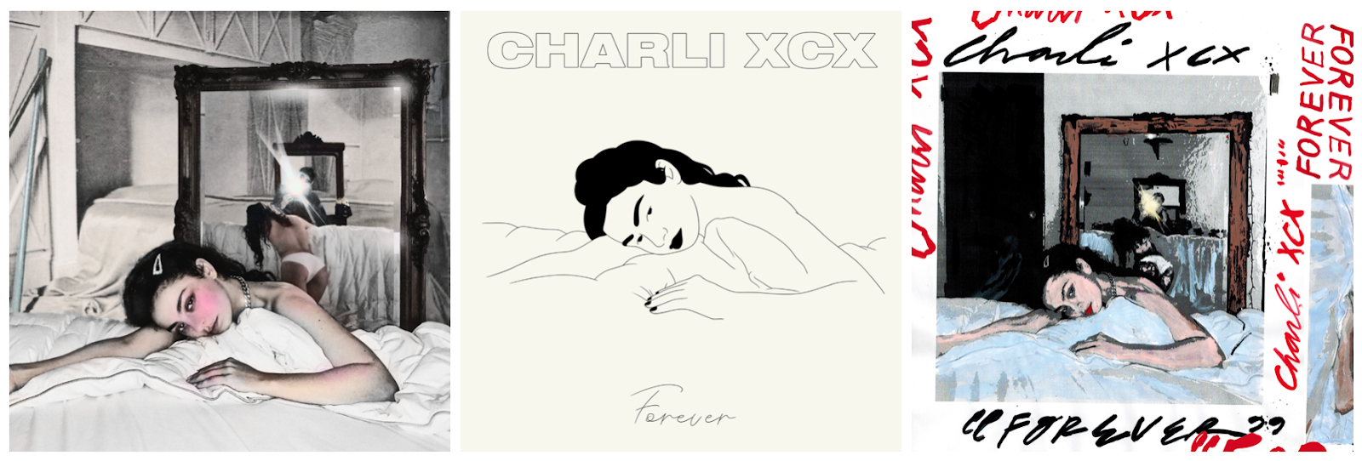
ARTWORKS HERE

Today Charli XCX releases ‘Forever’, the debut track taken from her forthcoming album ‘how i’m feeling now’.

‘Forever’ was written this week by Charli XCX and co-executive produced by Charli XCX, A. G. Cook and BJ Burton. The track was created within the last two days, with Charli teaming up with Cook and Burton via the internet while all three are in self-isolation. This is a working process that will continue throughout the album, with the entirety of the project being written, recorded, produced and released while in quarantine due to the world pandemic.

A romantic, hopeful cut of progressive pop, ‘Forever’ glows with luminous synths and cascading pixelated textures. Lo-fi in nature before slowly unfurling into something more beautiful, ‘Forever’ is a perfect touchpoint for how the upcoming project may sound; patient, forward thinking, and completely unique.

Last night Charli held her first Zoom press conference with journalists from around the world and creatives across multiple disciplines such as Maisie Williams, Rebecca Black and Jaboukie Young-White. Each guest posed questions to Charli as 1000 ecstatic fans watched on.

The three single artworks are individually created by artists Seth Bogart, Caroline Polachek and Regards Coupables. Charli personally invited each artist to create their own version of a photograph which she took at home this week.

Charli comments, “I’m such a fangirl of all three artists and to collaborate on artwork like this is a new experience for me. I like the idea that the visual language for this project can be interpreted by however someone feels towards the music. The music and the emotions that are generated guide the creative output and anything is possible.”

To coincide with the release of ‘how i’m feeling now’, Charli has announced that she will be reigniting her Beats 1 show, The Candy Shop. The new season, titled ‘Inside The Candy Shop’ will find Charli recording from home, opening out her process live on air while sharing new demos, ideas, and playing songs she loves right now alongside special guests. Charli will be joined by Caroline Polachek in episode one to talk about what’s going on in her world, as well as the artwork she has contributed for ‘Forever’. Air date to be announced soon.

Charli XCX announced her new album via Zoom this past Monday 6th April - watch the album announcement via her YouTube channel here.

To support those suffering with the effects of COVID-19 if you are in a position to, please consider donating to the following charity:
WORLD HEALTH ORGANISATION
The World Health Organisation (WHO) has launched a special fund designed to raise funds specifically for Covid-19 response. The WHO estimates it needs $675M through April for preparedness and response efforts.
The United Nations Foundation and the Swiss Philanthropy Foundation have created a fund to benefit the WHO’s effort. The fund supports the delivery of protective equipment to frontline healthcare workers, laboratory testing and accelerates research into diagnostics, treatments, and vaccine development.
To donate to the COVID-19 Solidarity Response Fund: click here
Charli XCX: Facebook | Twitter | Instagram

Hi-res press image here.

For more information please contact Huxley: anna@huxley.world / mitch@huxley.world / jemma@huxley.world

