ANNOUNCEMENT FROM THE DESK OF CHARLI` XCX…

I AM RELEASING A NEW SINGLE CALLED ‘GOOD ONES’
WITH A DEMONIC CO-DIRECTED MUSIC VIDEO MADE FOR THE ULTIMATE POPSTAR AKA: ME

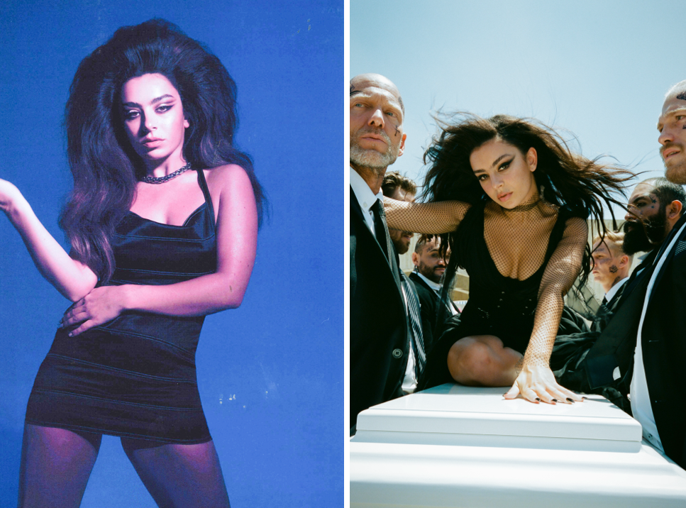

LISTEN TO ‘GOOD ONES’: https://xcx.lnk.to/Good-Ones
WATCH THE ‘GOOD ONES’ VIDEO: https://xcx.lnk.to/good-ones-video
IF YOU DON’T - YOU’LL BE CURSED FOREVER.

Today, I, the inimitable Charli XCX, am releasing a brand new single ‘Good Ones’, accompanied by a twisted, dramatic and quite frankly electrifying music video.

The first single of my new chapter embraces all that my life has to offer in today’s world - fame, glamour, inner demons and global hits. ‘Good Ones’ was produced by Oscar Holter of Max Martin’s Wolf Cousins entity, and laments my inability to keep hold of healthy relationships, instead being endlessly drawn back to the dysfunctional and toxic.

Filmed in Mexico and co-directed by my new favorite director: Hannah Lux Davis, the ‘Good Ones’ video sees me dramatically mourning the untimely loss of my partner as I battle with the realisation that once again I’ve abandoned the goodness in my life, in favour of the sinister, with a visual aesthetic that marks a new era of me: Charli XCX.

I have announced 3 special sold-out how i’m feeling now shows: September 27th @ Masonic Lodge, Los Angeles (haunted) October 1st @ Le Poisson Rouge, New York (cursed)
October 24th @ Lafayette, London (portal to another dimension)
Enter at your own risk…

This month, I launched my first standalone podcast ‘Charli XCX’s Best Song Ever’. I talk to friends and guests from around the world, to discover the songs that have been instrumental in shaping their lives. Everyone’s taste so far has been undeniable, and honestly, I’m a brilliant interviewer… there’s really nothing I can’t do… maybe I’m possessed? Listen to the podcast here.

As you already know, I am an iconic figure in the arts, and have helped expand the landscape of popular music over the last decade by seamlessly traversing the underground and the mainstream with my output. My innovative approach has opened up new possibilities within the pop sphere for both myself and others. You’re welcome.

Follow me here.
Press photo photographed by Emily Lipson here.
Video photo photographed by Terrence O’Connor here.
Listen to ‘Good Ones’ here.
Watch the ‘Good Ones’ video here.

For media enquiries contact my sacrificial sisters:
jemma@huxley.world | anna@huxley.world | rohani@huxley.world

