FOR IMMEDIATE RELEASE
NOVEMBER 12, 2021

FROM THE DESK OF CHARLI XCX —
I, CHARLI XCX AM RELEASING MY VISUAL FOR “NEW SHAPES”
FEATURING CAROLINE POLACHEK AND CHRISTINE AND THE QUEENS
IT’S THE FIRST PERFORMANCE FROM MY NEW TALK SHOW ‘TV HEAVEN’

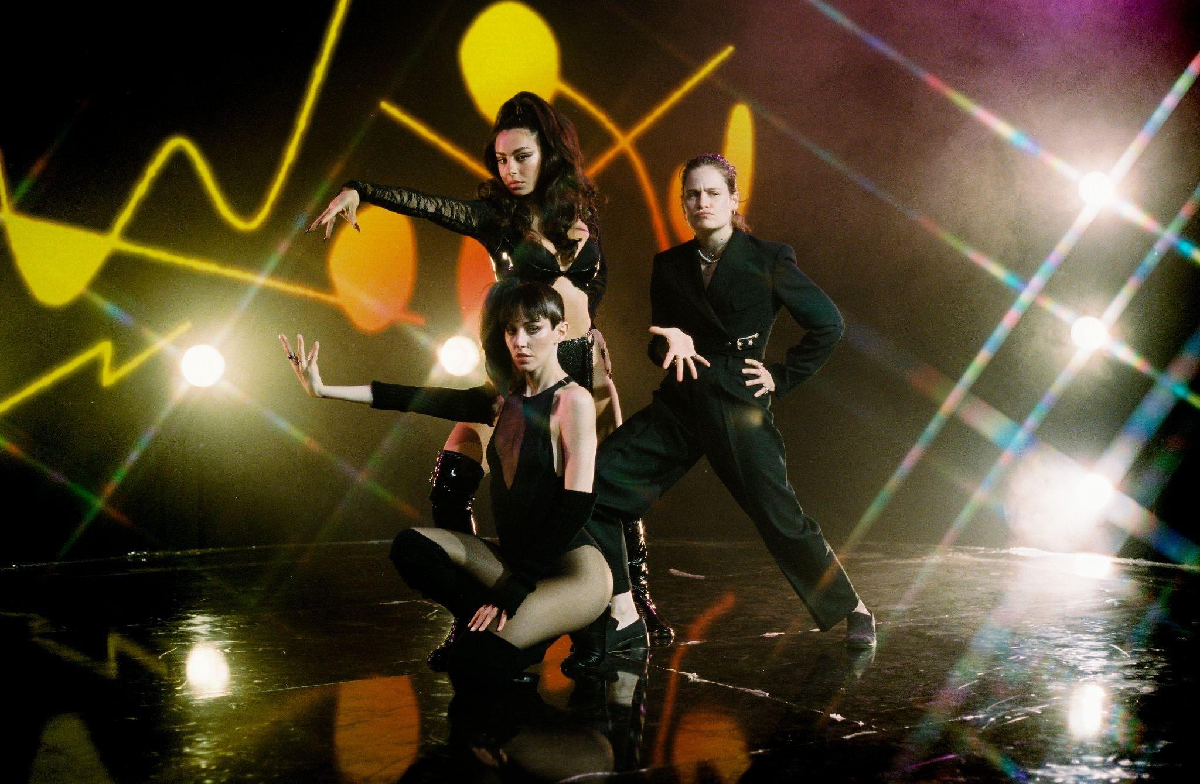

WATCH THE “NEW SHAPES” VIDEO HERE
IMAGES HERE

MY 5TH STUDIO ALBUM: CRASH - OUT MARCH 18TH
MY MOST FAST, FURIOUS, ICONIC AND DEADLY EUROPEAN AND NORTH AMERICAN TOUR STARTS NEXT YEAR WITH TICKETS AVAILABLE NOW

PRE-ORDER CRASH & BUY YOUR TOUR TICKETS HERE

Today I, the iconic global pop star Charli XCX, am releasing a visual for “New Shapes”; my track featuring my demonically talented friends Caroline Polachek and Christine and the Queens. The “New Shapes” visual is the first performance from my new talk show, TV Heaven, which will only be available to stream in full once you cross over to the afterlife. Watch a little taste here.

Last week I announced that CRASH, my highly-anticipated forthcoming album, will be released March 18, 2022. This is the fifth and final album in my record deal… Rolling Stone declared that ‘if you don’t listen to Charli XCX’s new album you will burn in hell’; I couldn’t agree more.

In addition, today my European and North American tour tickets go on sale to the general public at this link with shows in Los Angeles, London, Paris and more. See full dates below. I have no doubt it will be the best live show you’ve ever seen.

North American live dates:

26th March - Fox Theatre - Oakland, CA
27th March - Fox Theatre - Oakland, CA
29th March - Crystal Ballroom - Portland, OR
1st April - The Observatory North Park - San Diego, CA
3rd April - The Greek Theatre - Los Angeles, CA
6th April - Ogden Theatre - Denver, CO
8th April - ACL Live at The Moody Theater - Austin, TX
9th April - House of Blues Houston - Houston, TX (on sale TBD)
10th April - House of Blues Dallas - Dallas, TX
12th April - Orpheum Theater - New Orleans, LA
13th April - The Eastern - Atlanta, GA
15th April - The Orange Peel - Asheville, NC
16th April - The NorVa - Norfolk, VA
18th April - The Fillmore Philadelphia - Philadelphia, PA
20th April - House of Blues Boston - Boston, MA
22nd April - Hammerstein Ballroom - New York, NY
23rd April - Hammerstein Ballroom - New York, NY
25th April - Massey Hall - Toronto, ON
26th April - Royal Oak Music Theatre - Royal Oak, MI
28th April - Palace Theatre - Saint Paul, MN
29th April - Byline Bank Aragon Ballroom - Chicago, IL

European live dates:

13th May - Olympia Theatre - Dublin, Ireland
15th May - O2 Academy - Glasgow, UK
17th May - Victoria Warehouse - Manchester, UK
18th May - O2 Academy - Birmingham, UK
19th May - Alexandra Palace - London, UK
21st May - UEA - Norwich, UK
22nd May - O2 Academy - Sheffield, UK
23rd May - Rock City - Nottingham, UK
25th May - Trianon - Paris, France*
27th May - La Madeleine - Brussels, Belgium*
28th May - TivoliVredenburg (Ronda Hall) - Utrecht, Netherlands
30th May - Astra - Berlin, Germany
31st May - Carlswerk Victoria - Cologne, Germany
2nd June - Primavera - Barcelona, Spain
4th June - Fabrique - Milan, Italy
7th June - La Riviera - Madrid, Spain
9th June - Primavera - Barcelona, Spain

Follow me, Charli XCX here.

DOWNLOAD MY PHOTO + ARTWORKS
DOWNLOAD VIDEO STILLS HERE
WATCH THE ‘NEW SHAPES’ VIDEO HERE
PRE-ORDER CRASH & BUY YOUR TOUR TICKETS HERE

For media enquiries please contact my sacrificial sisters: jemma@huxley.world, anna@huxley.world, sophie@huxley.world

