For Immediate Release
JANUARY 13, 2021

Charlotte Cardin captivates with “Daddy”
New TRACK & music video out now!

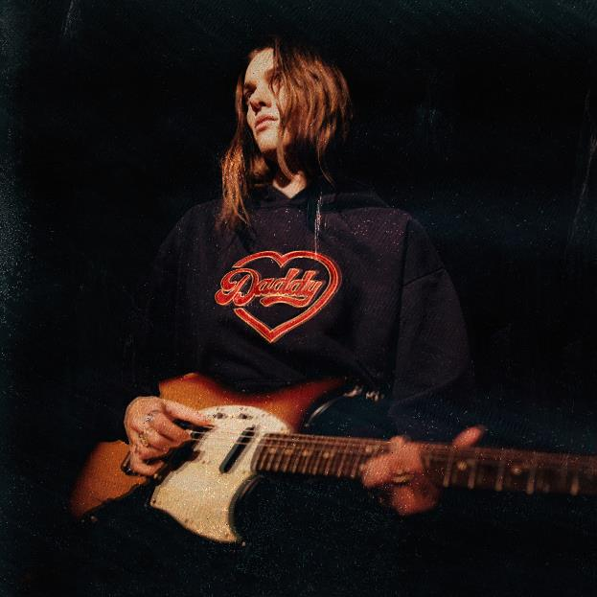
DOWNLOAD HIGH-RES IMAGES

WATCH/STREAM “DADDY”: https://CharlotteCardin.lnk.to/DaddyPR

Globally-acclaimed singer/songwriter Charlotte Cardin has kicked off 2021 with new track “Daddy” – available now via Atlantic Records. Co-penned by Cardin, Jason Brando & Mathieu Sénéchal and produced by Brando & Marc-André Gilbert (MAG), the track arrives alongside a desirously mesmerizing music video companion directed by Martin C. Pariseau. “Daddy” follows the release of “Passive Aggressive,” the first single in nearly two years from the Montreal-based artist.

“’Daddy’ is a song about kissing your crush right by the open bar,” muses Cardin. “Your crush’s other crush, standing by the shrimp buffet, sees it all. Your crush can’t choose between their two crushes, so you jump right in and choose for them. ‘Daddy’ is a song about knowingly making a bad decision and loving it.”

Guided by instinct and gifted with a seismic voice, Cardin pens personal anthems about life and love without filter. Following the success of her Big Boy EP across Canada, she made waves worldwide with her major label and US debut Main Girl EP in 2017 and has amassed over 134 million career streams worldwide. Featuring the standout title track and breakthrough “Dirty Dirty,” Main Girl quickly gained critical acclaim from the likes of The FADER, Harper’s BAZAAR, Interview, NYLON, PAPER, W Magazine & more. The release simultaneously sparked a whirlwind two-year journey around the globe that saw Cardin support the likes of Nick Murphy and BØRNS, in addition to selling out headline shows on multiple continents and gracing the stages of festivals such as Bonnaroo, Osheaga & Festival d’Été de Québec (as a special guest of Sting and Peter Gabriel).

Having spent the majority of the past two years locked in the Cult Nation studio, Cardin is primed for a rise back into the spotlight with her forthcoming full-length debut. With 2020 having seen her grace the cover of ELLE Québec for a third time and continue to serve as house ambassador for CHANEL, the celebrated chanteuse has only just begun to take flight.

CONNECT:
CHARLOTTECARDIN.COM | FACEBOOK | INSTAGRAM | TWITTER | YOUTUBE| PRESS ASSETS

CONTACT:
Ted Sullivan | ted.sullivan@atlanticrecords.com

