For Immediate Release
APRIL 23, 2021

Charlotte Cardin takes flight with Phoenix

Debut album from globally-acclaimed singer/songwriter arrives today,
alongside stunning “Anyone Who Loves Me” video

13-track collection features singles “Sad Girl,” “Daddy” & more

Tickets for “The Phoenix Experience” livestream concert event available now

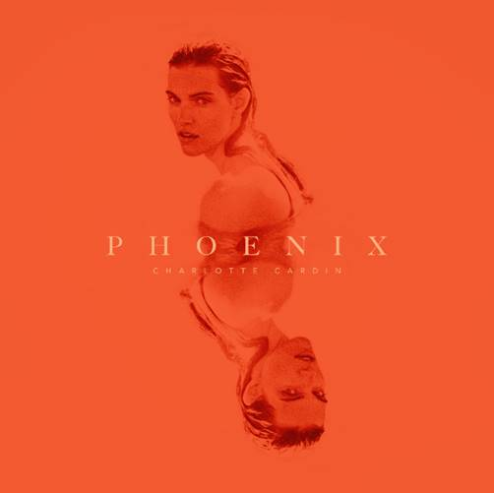
DOWNLOAD HIGH-RES IMAGES

WATCH “ANYONE WHO LOVES ME”: https://charlottecardin.lnk.to/awlmvideoPR
BUY/STREAM PHOENIX: https://CharlotteCardin.lnk.to/PhoenixPR

Globally-acclaimed singer/songwriter Charlotte Cardin takes flight on her highly anticipated debut full-length album Phoenix – available today via Atlantic Records. The 13-track collection arrives alongside a breathtakingly beautiful video for stand-out track “Anyone Who Loves Me,” directed by Jean Pierrot. A stunning body of work, Phoenix features Cardin’s most recent single “Sad Girl” along with previously released tracks “Passive Aggressive,” “Daddy” & “Meaningless” – all of which marked the first music in nearly two years from the Montreal-based artist.

“I have always been torn between my true desires and what I chose to present to the world. This conflict of will has gotten me to feel very empty at a young age and is still something I struggle with. Making this album took two years, because I started the writing process trying to keep control over what I wanted to show. It eventually became obvious, though, that I needed to embrace accessing those true impulses for my music (and my life) to make any sense whatsoever. The more I realized certain things about myself in the process, the angrier I got for not understanding them earlier. This conflicting loop of shame versus growth gave birth to ‘Phoenix.’
This was an elemental liberation for me. And if others who, like me, are torn between what is expected from them and who they really are, experience a part of this liberation through my songs, this album will have served its purpose.” – CHARLOTTE CARDIN

To celebrate the release of Phoenix, Cardin has also announced “The Phoenix Experience” livestream performance available on April 29th (North + South America) and April 30th (Europe) via Moment House. The first ever performance of her debut album will feature exclusive merchandise, while viewers are propelled into an immersive experience exploring cinematic themes that retrace the artist’s journey. For more information, please visit momenthouse.com/charlottecardin.

Guided by instinct and gifted with a seismic voice, Cardin pens personal anthems about life and love without filter. Following the success of her Big Boy EP across Canada, she made waves worldwide with her major label and US debut Main Girl EP in 2017 and has amassed over 149 million career streams worldwide. Featuring the standout title track and breakthrough “Dirty Dirty,” Main Girl quickly gained critical acclaim from the likes of The FADER, Harper’s BAZAAR, Interview, NYLON, PAPER, W Magazine & more. The release simultaneously sparked a whirlwind two-year journey around the globe that saw Cardin support the likes of Nick Murphy and BØRNS, in addition to selling out headline shows on multiple continents and gracing the stages of festivals such as Bonnaroo, Osheaga & Festival d’Été de Québec (as a special guest of Sting and Peter Gabriel).

Charlotte Cardin – Phoenix (Atlantic Records)
1. Phoenix
2. Passive Aggressive
3. Anyone Who Loves Me
4. Meaningless
5. Daddy
6. Sex To Me
7. Good Girl
8. Sad Girl
9. XOXO
10. Oceans
11. Sun Goes Down (Buddy)
12. Romeo
13. Je Quitte

CREDIT: JEAN PIERROT – DOWNLOAD HIGH-RES IMAGES

CONNECT:
CHARLOTTECARDIN.COM | FACEBOOK | INSTAGRAM | TWITTER | YOUTUBE| PRESS ASSETS

CONTACT:
Ted Sullivan | ted.sullivan@atlanticrecords.com

