FOR IMMEDIATE RELEASE

SEPTEMBER 27, 2019

**CHARLOTTE LAWRENCE EMERGES WITH “NAVY BLUE”**

**Acclaimed pop singer-songwriter releases captivating**

**new single AND VISUAL via Atlantic/Gold Tooth Records**

**WATCH THE “NAVY BLUE” VISUAL** [**HERE**](https://charlottelawrence.lnk.to/NavyBluePR/youtube)

**Headline “Navy Blue Tour” kicks off November 7th**

[DOWNLOAD HIGH-RES IMAGE](http://press.atlanticrecords.com/charlotte-lawrence/)

**STREAM “NAVY BLUE”:** [http://charlottelawrence.lnk.to/NavyBluePR](https://nam04.safelinks.protection.outlook.com/?url=http%3A%2F%2Fcharlottelawrence.lnk.to%2FNavyBluePR&data=02%7C01%7CTed.Sullivan%40atlanticrecords.com%7Ce82f8091506e4773346c08d74043b819%7C8367939002ec4ba1ad3d69da3fdd637e%7C0%7C0%7C637048531896321486&sdata=zcQykcqASwrtalOOHjc%2F8NNX1mvyHlQbxeq5sTk%2Fwsk%3D&reserved=0)

Acclaimed pop singer-songwriter **Charlotte Lawrence** has unveiled new single “**Navy Blue**” – her second release via **Atlantic/Gold Tooth Records**. Written/produced alongside **Andrew Watt**, **Ryan Tedder**, **Ali Tamposi** and **Charlie Puth**, “**Navy Blue**” meshes a mounting bassline with Lawrence’s signature captivating vocals. The sonically simplistic and intimate track continues to set the tone for Lawrence’s forthcoming sophomore EP, due later this year.

“**Navy Blue**” follows Lawrence’s major label debut single “[**Why Do You Love Me**](https://youtu.be/mZ1FzTsIQQY),” which arrived alongside a stunning **Alasdair McLellan**-directed music video. The track was praised as *“a haunting take on pop rock”* by **Billboard** upon release, while **DuJour** declared *“(Lawrence) is a force to be reckoned with”* and **Flaunt** echoed *“(Lawrence) is the latest teenage pop icon to emerge and dominate the music charts.”* Lawrence also followed with a hauntingly beautiful [stripped back version](https://youtu.be/kImCRV-fuTg) of the song and reimagined mixes by [**Hippie Sabotage**](https://charlottelawrence.lnk.to/HippieSabotageRmxPR), [**Riton**](https://charlottelawrence.lnk.to/RitonRmxPR) and [**Klingande**](https://charlottelawrence.lnk.to/KlingandeRmxPR).

Since exploding on the scene in recent years, Lawrence has seen widespread critical acclaim and millions of worldwide streams for breakthrough hits “**Just The Same**” and “**Sleep Talking**” off her 2018 debut EP ***YOUNG***. She has graced the cover of **V Magazine**’s Spring 2019 preview issue, in addition to being featured prominently via **PAPER**, **W Magazine**, **Harper’s BAZAAR**, **Wonderland**, **Teen Vogue** & more.

This fall will see Lawrence embarking on her headline **Navy Blue Tour**, kicking off November 7th in Atlanta, GA with stops at Webster Hall in New York, NY and The Fonda in Los Angeles, CA. The dates follow recent tours of both the U.S. and Europe, runs highlighted by sold out shows in cities spanning New York and Los Angeles to Amsterdam, Manchester, and Cologne. For complete details and ticket information, please visit [charlottelawrencemusic.com](http://charlottelawrencemusic.com).

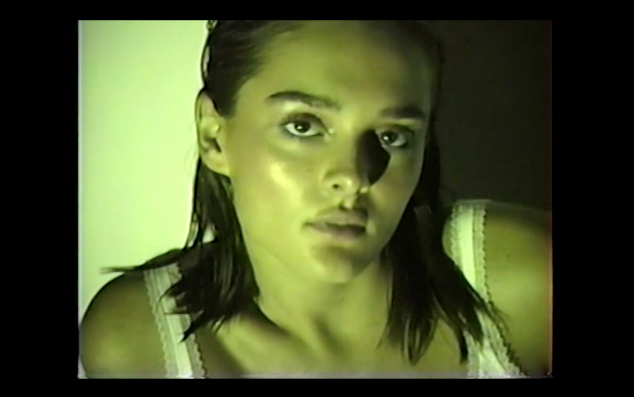

[DOWNLOAD HI-RES IMAGE](https://warnermusicgroup.box.com/s/6uv0qfh82d82kryxfy1w8afjp0rw7u0c)

**CHARLOTTE LAWRENCE: NAVY BLUE TOUR 2019**

*w/ special guest Goody Grace*

November 7 – Atlanta, GA – Vinyl

November 8 – Nashville, TN – The Cowan

November 9 – Chicago, IL – Subterranean

November 11 – Columbus, OH – A&R Music Bar

November 13 - Toronto, ON – Velvet Underground

November 14 – Boston, MA – Brighton Music Hall

November 15 – Philadelphia, PA – The Foundry

November 16 – Washington, DC – U Street Music Hall

November 18 – New York, NY – Webster Hall

November 21 – San Diego, CA – House of Blues - San Diego

November 23 – Los Angeles, CA – The Fonda Theatre

**CONNECT:**

[OFFICIAL](http://charlottelawrencemusic.com/) | [FACEBOOK](https://www.facebook.com/CharlotteSLawrence) | [TWITTER](https://www.twitter.com/charlottelawr) | [INSTAGRAM](https://www.instagram.com/charlotteslawrence) | [PRESS ASSETS](http://press.atlanticrecords.com/charlotte-lawrence/)