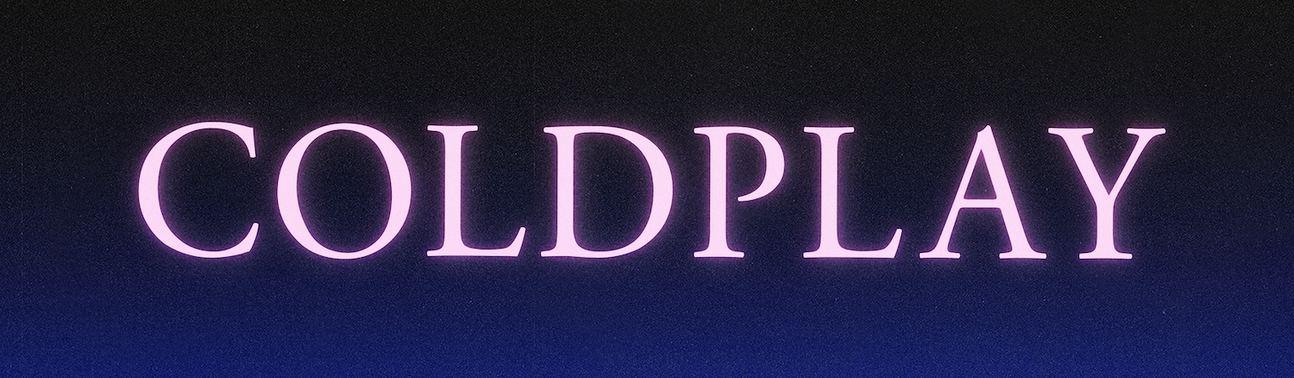
COLDPLAY PREMIERE HIGHER POWER IN SPACE
BAND LINK-UP WITH ASTRONAUT THOMAS PESQUET ON BOARD THE ISS FOR LAUNCH OF NEW SINGLE

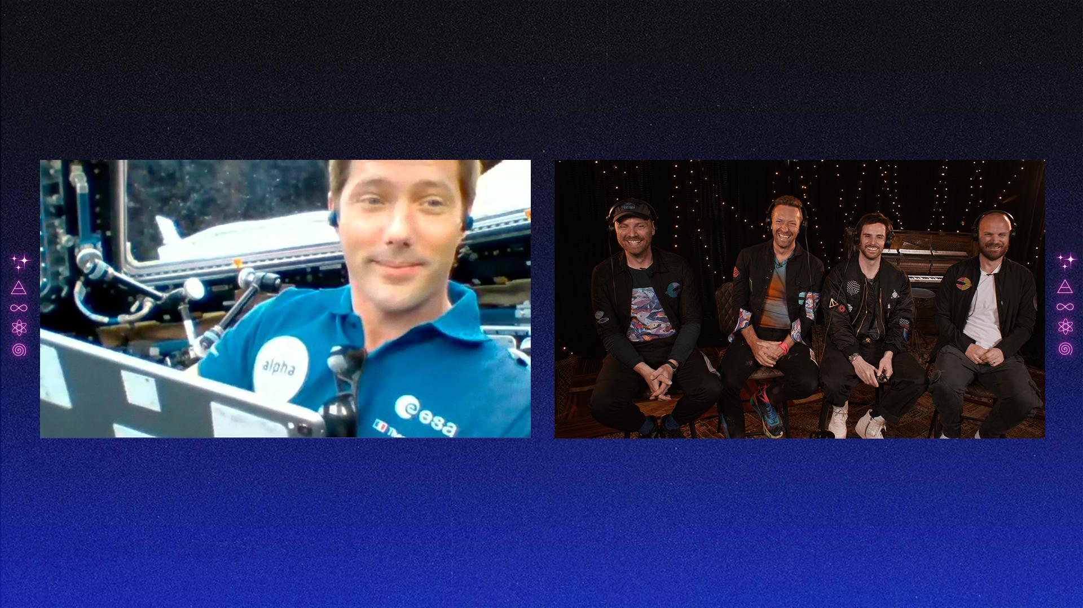

Coldplay’s new single, Higher Power, is out now via Parlophone / Atlantic. The Max Martin-produced song is available to stream / download everywhere here.

To celebrate Higher Power’s release, the band linked up for an extraterrestrial video chat with French ESA astronaut Thomas Pesquet, who is currently on board the International Space Station.

A specially-recorded performance of Higher Power - featuring dancing alien holograms - was beamed up to Pesquet, who gave the track its very first play on board the ISS.

The song’s premiere followed a conversation which took in similarities between life on tour and life on the ISS; the fragility of planet earth; and whether Pesquet has spotted any aliens.

Watch the band’s conversation with Pesquet: youtu.be/ERH7Xg4ww94

Watch the Higher Power Extraterrestrial Transmission video: youtu.be/gXgf5smLEgQ

Download clips for media use: https://bit.ly/3h5Exot

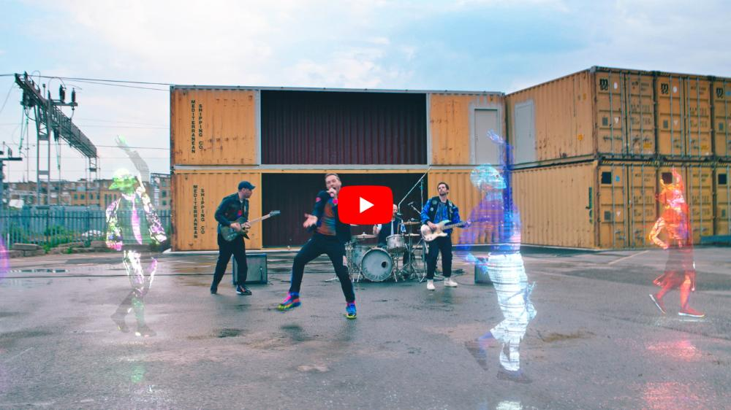

Coldplay will perform Higher Power on American Idol on Sunday (May 9) and at the BRIT Awards on Tuesday (May 11). The band will also perform a set for Glastonbury’s Live At Worthy Farm global livestream on May 22.

For more information please visit Coldplay.com or contact:
Sheila Richman (Atlantic Records) – sheila.richman@atlanticrecords.com
Ted Sullivan (Atlantic Records) – ted.sullivan@atlanticrecords.com

For more information on ESA, visit www.esa.int

Alien choreography by Ambiguous Dance Company

