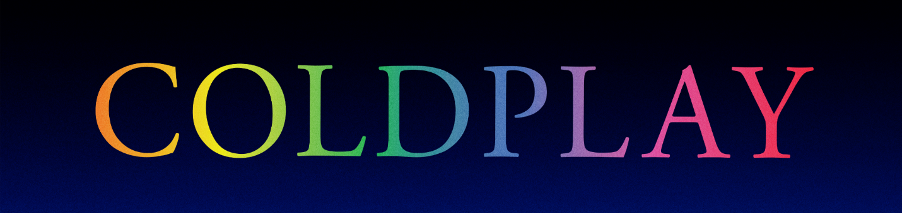

COLDPLAY’S MUSIC OF THE SPHERES ALBUM IS OUT TODAY

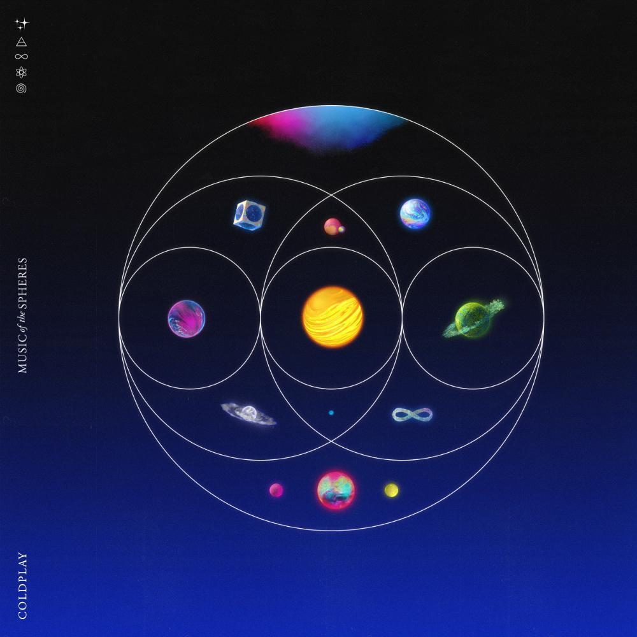

Coldplay’s much-anticipated ninth album, Music Of The Spheres is out today worldwide. Click here to download / stream now.

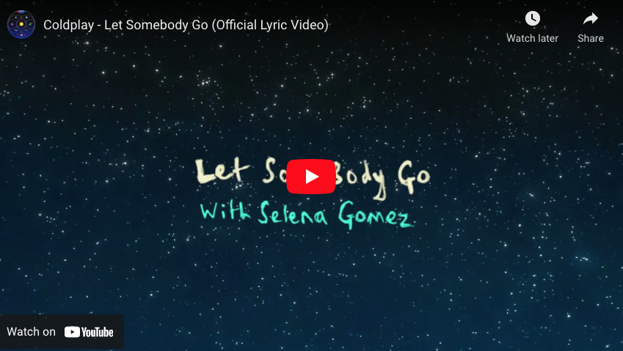

The band have also released a new lyric video for album centerpiece Let Somebody Go, featuring handwritten lyrics by Chris and guest singer, Selena Gomez. Watch the lyric video here https://youtu.be/EptPhiK_q0E.

Music Of The Spheres features the single Higher Power, which received its first play on the International Space Station by French astronaut Thomas Pesquet and quickly became a worldwide hit. Last week, Coldplay became the first British band to debut at number one on the US Hot 100 with their BTS collaboration My Universe. The song has already racked up more than 100 million views on YouTube.

The album release comes a day after the band announced a massive global stadium tour for 2022. The full list of shows for the Music Of The Spheres World Tour is available now at coldplay.com/tour.

The tour announcement was accompanied by a comprehensive set of sustainability initiatives and environmental commitments, including halving CO2 emissions and planting a tree for every ticket sold. The full list can be viewed at coldplay.com/sustainability.

The band will appear for a week-long music residency on CBS’s THE LATE LATE SHOW with JAMES CORDEN from Monday, October 18th to Thursday, October 21st to celebrate the release of Music Of The Spheres. The residency will include the television debut of Let Somebody Go with Selena Gomez as well as a special performance of ❤️ (pronounced Human Heart) with We Are KING and Jacob Collier.

On Friday, October 22, Coldplay will play the very first show at the new Climate Pledge Arena in Seattle. The performance will stream live globally for free on Amazon Music, Amazon Prime and Twitch.

For more information please visit Coldplay.com or contact:
Sheila Richman | sheila.richman@atlanticrecords.com
Ted Sullivan | ted.sullivan@atlanticrecords.com

