COLDPLAY ANNOUNCE
MUSIC OF THE SPHERES WORLD TOUR
BAND REVEAL 2022 DATES ALONGSIDE PLEDGE TO MAKE
TOUR AS SUSTAINABLE AND LOW-CARBON AS POSSIBLE

US dates go on sale Friday, October 22nd at 10am local time

Tour trailer: https://youtu.be/IxLcMz0aUQM

On the eve of their new album, Music Of The Spheres, Coldplay have today announced an accompanying global stadium tour in 2022.

The Music Of The Spheres World Tour begins on March 18, 2022 with the band’s first ever show in Costa Rica, before travelling to the Dominican Republic, Mexico, USA, Germany, Poland, France, Belgium and the UK.

The full list of shows is available below and at coldplay.com/tour. Support at the majority of shows will come from H.E.R., with London Grammar supporting at selected dates.

Tickets for the US dates will go on sale to the general public on October 22nd at 10am local time at ticketmaster.com.

To ensure tickets get into the hands of fans directly, the tour will also have a Verified Fan presale available for all U.S. dates. Registration for U.S. tour dates is available now HERE through Sunday, October 17th at 6pm PT/9pm ET via Ticketmaster’s Verified Fan program. Verified Fan presale begins Wednesday, October 20 at 10am local time through Thursday, October 21 at 10pm local time.

The band have already teased that more dates will follow soon.

SUSTAINABILITY PLAN ‘A WORK IN PROGRESS’
SHOW POWERED BY 100% RENEWABLE ENERGY
PLEDGE TO CUT TOUR EMISSIONS BY 50%
ONE TREE PLANTED FOR EVERY TICKET SOLD

In 2019, Coldplay committed to making their future tours as environmentally beneficial as possible, and today’s announcement is accompanied by a comprehensive set of sustainability initiatives and environmental commitments.

Full details can be seen at coldplay.com/sustainability, including commitments to:

- cut direct emissions by 50% compared to the band’s most recent tour (2016-17).

- power the show entirely by renewable, super-low emission energy – with solar installations at every venue, waste cooking oil, a kinetic stadium floor and kinetic bikes powered by fans. This power will be stored in the first ever mobile, rechargeable show battery (developed and made in partnership with BMW from recyclable BMW i3 batteries).

- draw down significantly more CO2 than the tour produces with a range of nature- and technology-based solutions, including planting one tree for every ticket sold.

- provide each venue with a sustainability rider requesting best environmental practices.

- encourage fans to use low carbon transport to and from shows via the official tour app built by SAP, rewarding those who do with a discount at venues.

- ensure all merchandise is sustainably and ethically sourced.

- offer free drinking water and strive to eliminate plastic bottles at every venue.

- put 10% of all earnings into a fund for environmental and socially-conscious causes, including ClientEarth, One Tree Planted and The Ocean Cleanup.

- establish a partnership with climate change experts at Imperial College London's Grantham Institute - Climate Change and the Environment to quantify the impact of the tour – both positively and negatively – on the environment

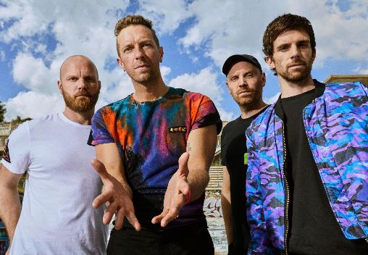
Download latest Coldplay press shot here.
Credit: James Marcus Haney

Coldplay said:

“Playing live and finding connection with people is ultimately why we exist as a band. We’ve been planning this tour for years, and we’re super excited to play songs from across our whole time together.

At the same time, we’re very conscious that the planet is facing a climate crisis. So we’ve spent the last two years consulting with environmental experts to make this tour as sustainable as possible, and, just as importantly, to harness the tour’s potential to push things forward. We won’t get everything right, but we’re committed to doing everything we can and sharing what we learn. It’s a work in progress and we’re really grateful for the help we’ve had so far.

If you'd like to come to a show and sing with us, we’re so excited to see you.”

MUSIC OF THE SPHERES WORLD TOUR 2022

MARCH
18: San Jose, CR - Estadio Nacional (Support: TBA)
22: Santo Domingo, DR - Estadio Olímpico (Support: TBA)
25: Monterrey, MX - Estadio BBVA (Support: H.E.R.)
29: Guadalajara, MX - Estadio Akron (Support: H.E.R.)

APRIL
3: Mexico City, MX - Foro Sol (Support: H.E.R.)
23: Santa Clara, CA - Levi’s Stadium (Support: H.E.R.)
26: Los Angeles, CA - SoFi Stadium (Support: H.E.R.)

MAY
3: Phoenix, AZ - State Farm Stadium (Support: H.E.R.)
6: Dallas, TX - Cotton Bowl Stadium (Support: H.E.R.)
8: Houston, TX - NRG Stadium (Support: H.E.R.)
28: Chicago, IL - Soldier Field (Support: H.E.R.)

JUNE
1: Washington, DC - FedExField (Support: H.E.R.)
4: East Rutherford, NJ - Metlife Stadium (Support: H.E.R.)
8: Philadelphia, PA - Lincoln Financial Field (Support: H.E.R.)
11: Atlanta, GA - Mercedes-Benz Stadium (Support: H.E.R.)
14: Tampa, FL - Raymond James Stadium (Support: H.E.R.)

JULY
2: Frankfurt, DE - Deutsche Bank Park (Support: H.E.R.)
3: Frankfurt, DE - Deutsche Bank Park (Support: H.E.R.)
8: Warsaw, PL - PGE Narodowy (Support: H.E.R.)
10: Berlin, DE - Olympiastadion Berlin (Support: London Grammar)
12: Berlin, DE - Olympiastadion Berlin (Support: H.E.R.)
16: Paris, FR - Stade de France (Support: H.E.R.)
17: Paris, FR - Stade de France (Support: H.E.R.)

AUGUST
5: Brussels, BE - King Baudouin Stadium (Support: H.E.R.)
6: Brussels, BE - King Baudouin Stadium (Support: H.E.R.)
12: London, UK - Wembley Stadium (Support: H.E.R.)
13: London, UK - Wembley Stadium (Support: H.E.R.)
16: London, UK - Wembley Stadium (Support: London Grammar)
23: Glasgow, UK - Hampden Park Stadium (Support: H.E.R.)

SEPTEMBER
10: Rio De Janeiro, BR - Rock in Rio Festival
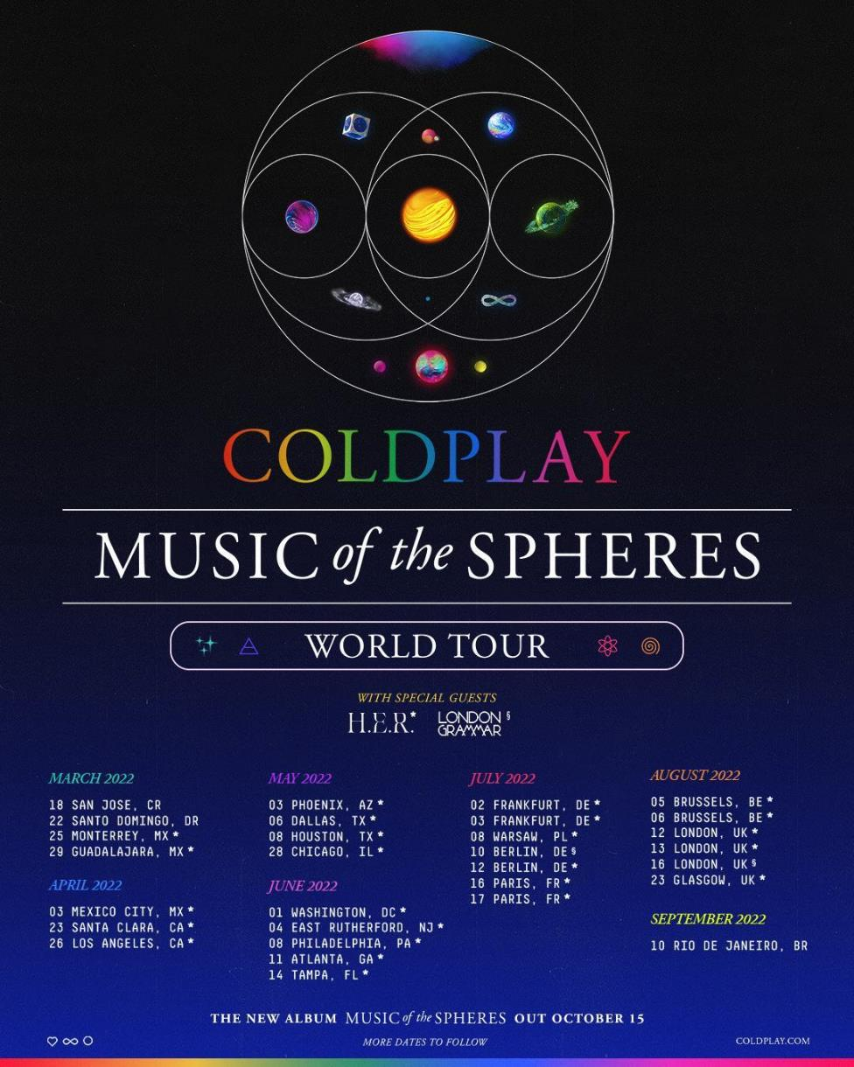
Download poster here

For more information please visit coldplay.com or contact:
Sheila Richman | Sheila.Richman@Atlanticrecords.com
Ted Sullivan | Ted.Sullivan@Atlanticrecords.com

