BTS SUGA’S REMIX OF MY UNIVERSE AVAILABLE NOW
REWORKING OF COLDPLAY X BTS TRACK OUT TODAY

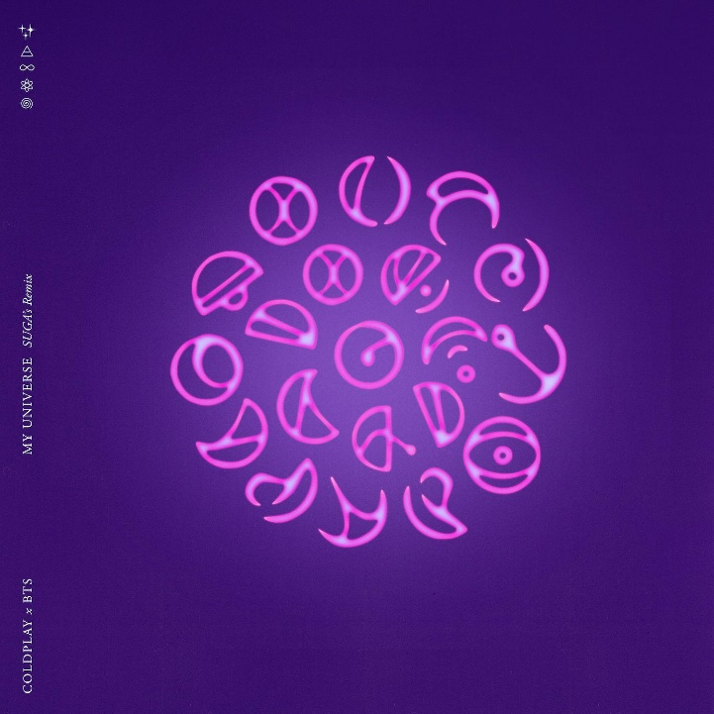

Coldplay X BTS have today released a sparkling new version of their current hit single, My Universe, remixed by 21st century pop icons BTS’ SUGA. The remix - which came about following a conversation over lunch when the two groups met up in New York recently - is available now HERE.

Said SUGA: “I'm thrilled to be able to work together with Coldplay, who I've admired since I was a kid, and honored to be a part of this remix."

My Universe has already made history as the first Billboard Hot 100 #1 by two co-billed lead groups, in addition to topping the Digital Song Sales, Hot Rock & Alternative Songs and Hot Alternative Songs charts. Coldplay also became the first British band ever to debut at #1 on the Hot 100 with the collaboration, which has racked up more than 100 million views on Youtube and more than 100 million streams on Spotify.

The single is taken from Coldplay’s Music Of The Spheres album, which was released on Friday and is available to stream / download here.

Last week, the band announced a massive global stadium tour for 2022. The full list of Music Of The Spheres World Tour shows - which go on general sale on Thursday / Friday - is available now at coldplay.com/tour. The tour announcement was accompanied by a comprehensive set of sustainability initiatives which can be seen at coldplay.com/sustainability.

On Friday, October 22, the band will play the very first show at the new Climate Pledge Arena in Seattle. The performance will stream live globally for free on Amazon Music, Amazon Prime and Twitch.

For more information please visit Coldplay.com or contact:
Sheila Richman | sheila.richman@atlanticrecords.com
Ted Sullivan | ted.sullivan@atlanticrecords.com

