COLDPLAY AND BTS PREMIERE MY UNIVERSE VIDEO
WATCH THE STUNNING DAVE MEYERS-DIRECTED CLIP NOW

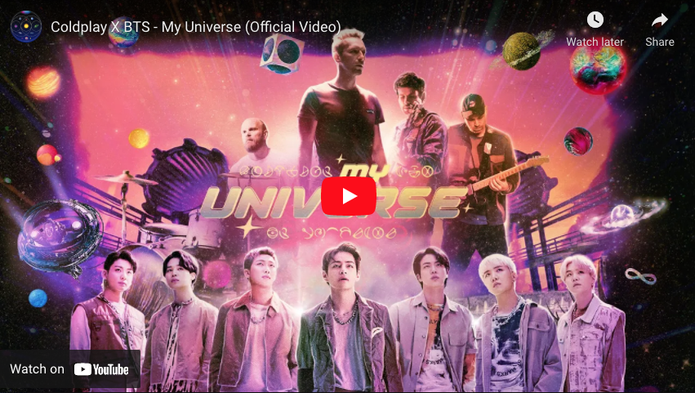

Coldplay have today premiered the out-of-this-world video for My Universe, their hit new collaboration with BTS. The video is available to watch at https://youtu.be/3YqPKLZF_WU now.

Helmed by superstar director Dave Meyers - who also directed Coldplay’s Higher Power video - the My Universe clip is set in the distant galaxy of The Spheres where music is forbidden, but BTS, Coldplay and an alien supergroup called Supernova 7 unite via hologram to defy the ban…

My Universe is taken from Coldplay’s forthcoming album Music Of The Spheres, which arrives on October 15th.

Since its release on Friday, My Universe has already been streamed more than 100 million times and topped sales and airplay charts around the world.

Download clips / stills for media use: cldp.ly/mu-assets-media

For more information please visit Coldplay.com or contact:
Sheila Richman | Sheila.Richman@Atlanticrecords.com
Ted Sullivan | Ted.Sullivan@Atlanticrecords.com

