FOR IMMEDIATE RELEASE
MARCH 12, 2020

COLDPLAY RELEASE “TROUBLE IN TOWN” VIDEO

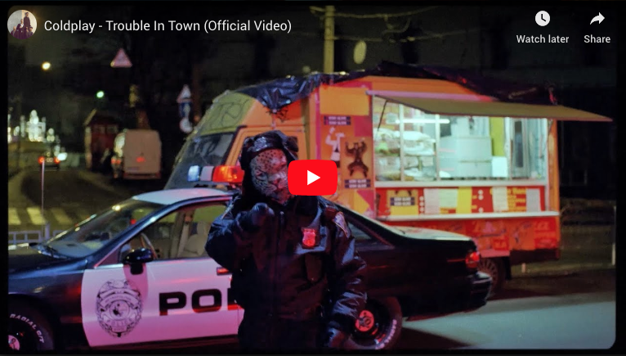

Coldplay have today released a powerful video for “Trouble In Town,” taken from their acclaimed number one album, Everyday Life. Inspired by George Orwell’s Animal Farm, the video is set in a dystopian world populated by animals, including politician pigs, street-hustling foxes and an officious snow leopard cop.

The video was directed by Aoife McCardle. You can watch it at youtu.be/aKlwJROuo-Q now.

All proceeds from the song and the video will be split between two organisations: the Innocence Project, which works to overturn wrongful convictions in the US, and ACFS, a charity for vulnerable children in South Africa, some of whom provided vocals for the original track.

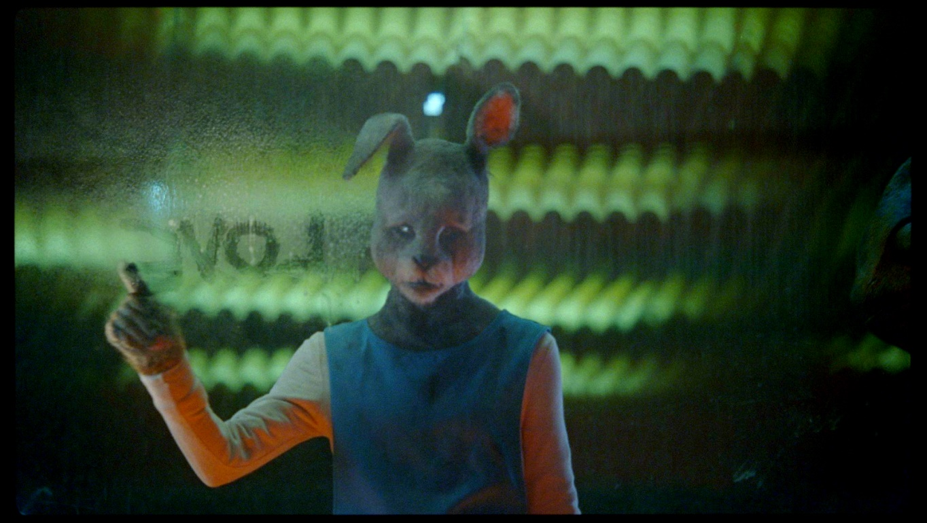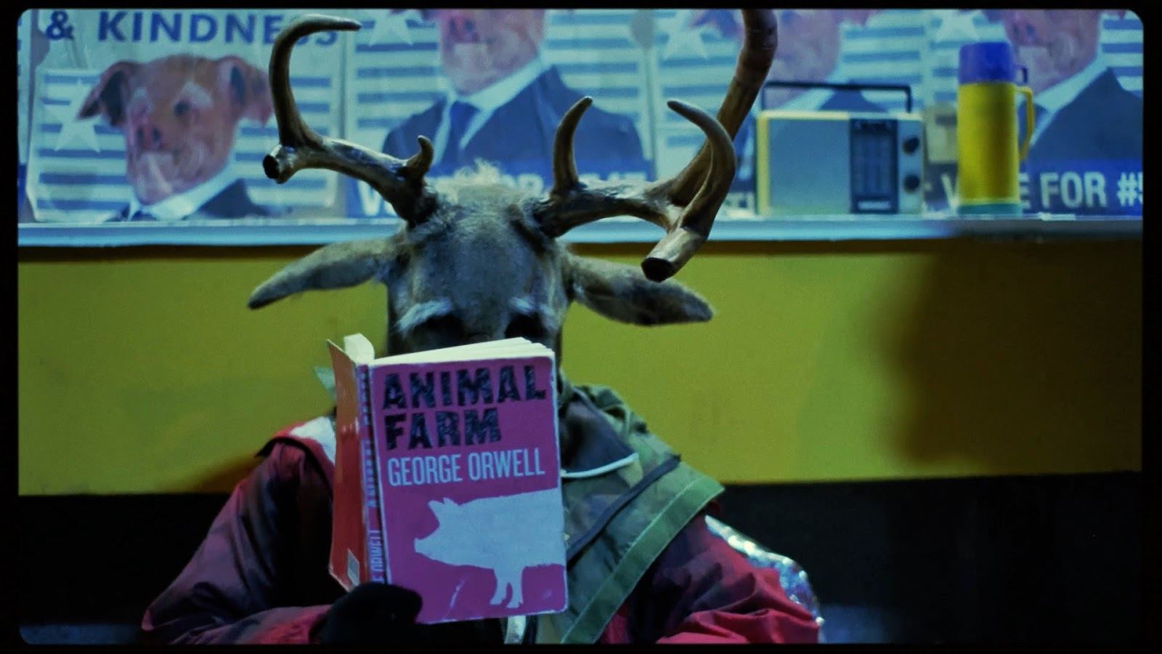
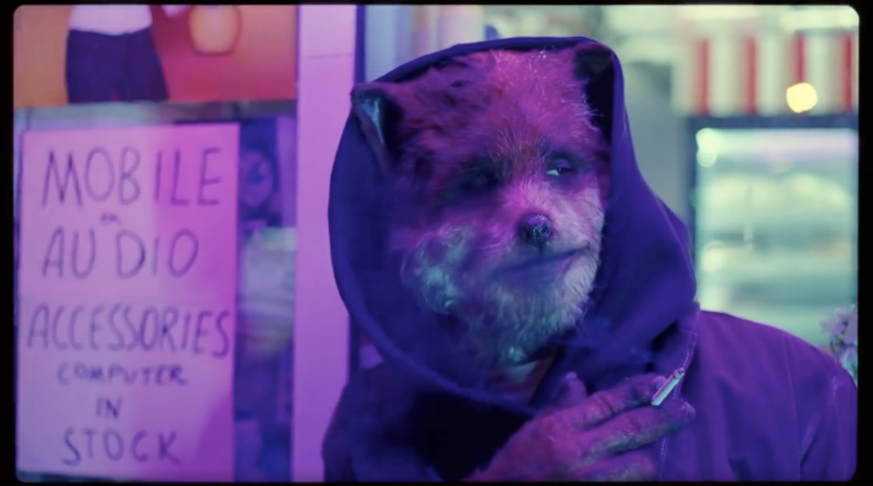

Click here to download hi-res album artwork and band photo.

For more information please visit Coldplay.com or contact:
Sheila Richman (Atlantic Records) – sheila.richman@atlanticrecords.com
Ted Sullivan (Atlantic Records) – ted.sullivan@atlanticrecords.com

