FOR IMMEDIATE RELEASE

SEPTEMBER 6, 2019

**DEATH CAB FOR CUTIE RELEASE HIGHLY ANTICIPATED** [***THE BLUE EP***](https://death-cab-for-cutie.lnk.to/BlueEPPR)

**RELEASE COMES ACCOMPANIED BY LIVE STUDIO VIDEO**

**FOR “**[**BLUE BLOODS**](https://www.youtube.com/watch?v=wKS3n5TvieM)**”**

**DEBUT TRACKS “KIDS IN ‘99” + “TO THE GROUND” RELEASED TO CRITICAL ACCLAIM FROM**

**ROLLING STONE, STEREOGUM, SPIN, BILLBOARD, PASTE,**

**CONSEQUENCE OF SOUND & MORE**

*“Two decades and nine albums into their career, indie icons Death Cab for Cutie are still going strong with their distinct brand of bittersweet melodies and emotional excavations.”*

**– LOS ANGELES TIMES**

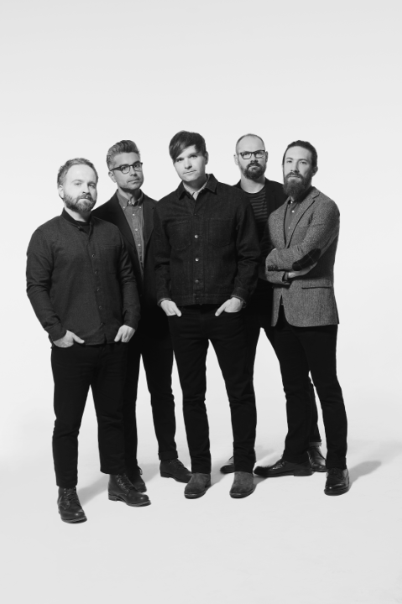

[*download hi-res press image here*](http://press.atlanticrecords.com/wp-content/uploads/2019/07/Death-Cab-for-Cutie-Credit-Eliot-Lee-Hazel-EP-1.jpg)

**WATCH “BLUE BLOODS” LIVE STUDIO VIDEO:**

[**https://www.youtube.com/watch?v=wKS3n5TvieM**](https://www.youtube.com/watch?v=wKS3n5TvieM)

**BUY/STREAM “THE BLUE EP”:**

[**https://death-cab-for-cutie.lnk.to/BlueEPPR**](https://death-cab-for-cutie.lnk.to/BlueEPPR)

8x GRAMMY® Award-nominated Atlantic recording group Death Cab for Cutie today releases their highly anticipated EP, *The Blue EP*. The release comes accompanied by a studio video for “Blue Bloods” – directed by Justin Mitchell – which features the band recording the track at producer Peter Katis’ Connecticut studio – watch [here](https://www.youtube.com/watch?v=wKS3n5TvieM). *The Blue EP* features five tracks (tracklist attached) is available now at all DSP’s, streaming services, and the band’s online store ([here](https://death-cab-for-cutie.lnk.to/BlueEPPR)).

“Blue Bloods” and “Kids in ‘99” both received production from Katis (The National, Interpol, Kurt Vile), while “To The Ground” and “Before The Bombs” were produced by Rich Costey during the recording sessions for the band’s critically acclaimed ninth studio album, [*Thank You for Today*](https://lnk.to/ThankYouforToday) and held for this planned subsequent EP. Rounding out the project, “Man in Blue” was self-produced by the band.

Tracks released thus far from the EP – “[To The Ground](https://death-cab-for-cutie.lnk.to/ToTheGroundPR)” and “[Kids in '99](https://death-cab-for-cutie.lnk.to/Kidsin99PR)” – have both been met with critical acclaim, with [SPIN](https://www.spin.com/2019/08/death-cab-for-cutie-to-the-ground-song-new-ep-listen/) declaring “To The Ground” an “ominous slow-building rocker based around an insistent blusey guitar riff.” Upon the release of “Kids in ’99” in July, [Rolling Stone](https://www.rollingstone.com/music/music-news/death-cab-for-cutie-kids-in-99-865125/) applauded the “sweet and somber song,” while [Uproxx](https://uproxx.com/indie/best-new-indie-this-week-clairo-death-cab-for-cutie/) exclaimed: “‘Kids in ‘99’ features very tight alternative production and Ben Gibbard’s signature vocal stylings.” “In most scenarios,” they continued, “any Death Cab is good Death Cab.”

The band also recently received critical acclaim for “[Do You Remember](https://open.spotify.com/track/67xBtV07CC73eFw7z5oCvU?si=dt4B9uNrR8-d-TjKANDUxw),” a track from Chance the Rapper’s highly-anticipated new album *The Big Day* on which they are featured. Upon release, [TIME](https://time.com/5635605/chance-the-rapper-the-big-day-best-songs/) highlighted the track in their “5 Best Songs of the Week,” exclaiming: “On ‘Do You Remember,’ a laid-back, nostalgic jam, rock band Death Cab for Cutie shows up to set a dreamy, throwback mood.” The track has gone on to amass tens of millions of streams across platforms, with the band even inviting Chance the Rapper out during their Lollapalooza set to perform the fan favorite with them ([watch](https://www.youtube.com/watch?v=7YH1yOimQbQ)).

Death Cab for Cutie recently wrapped the latest leg of their summer headline tour, including their first appearance at Lollapalooza since 2006, as well as performances at iconic venues from New York’s Forest Hills to LA’s Hollywood Bowl, and a sold-out show at the legendary Red Rocks Amphitheatre.The final leg of the tour will includea pair of highly anticipated homecoming shows this weekend at Washington’s Marymoor Park (with support from fellow Seattle natives Car Seat Headrest), as well as Sonoma Harvest Music Festival and other stops throughout California, Oregon, and British Columbia.

***

Death Cab for Cutie was born in 1997 when Western Washington University engineering student and budding guitarist-songwriter Benjamin Gibbard first united with guitarist-keyboardist-producer Chris Walla and bassist Nick Harmer to record a demo cassette dubbed “YOU CAN PLAY THESE SONGS WITH CHORDS.” Though Gibbard had initially conceived the tape as a solo project, the eight-song cassette proved both popular and aesthetically successful, prompting him to reconfigure Death Cab for Cutie as a full band. Death Cab for Cutie made their official live debut on November 22nd that same year, a performance recently uncovered and released as “[FIRST SHOW, ACOUSTIC AT THE PACER HOUSE, BELLINGHAM WA. 11​/​22​/​97](http://atlantic.lnk.to/DCFC_PacerHouse),” available now exclusively via [Bandcamp](http://atlantic.lnk.to/DCFC_PacerHouse); downloads begin at $4 with all of the band’s proceeds benefitting Seattle’s [The Aurora Commons](https://www.auroracommons.org/).

Immediately hailed as one of indie rock’s most compelling and creative collectives, Death Cab for Cutie’s milestone debut album, “SOMETHING ABOUT AIRPLANES,” arrived in 1998 via the Seattle-based independent label, Barsuk. The band enjoyed a long relationship with Barsuk before making their Atlantic Records debut with 2005’s fifth studio release, “PLANS.” The album proved the band’s popular breakthrough, earning RIAA platinum certification as well as spawning the chart-topping singles, “Soul Meets Body” and “I Will Follow You Into The Dark.”  The latter track was honored with a GRAMMY® nomination as “Best Pop Performance By Duo Or Group With Vocals,” with “PLANS” receiving the nod as “Best Alternative Album.”  “DIRECTIONS,” the 2006 DVD companion to “PLANS,” earned an additional GRAMMY® nod as “Best Longform Music Video.”

Now fully affirmed as an era-defining band, Death Cab for Cutie made a stunning #1 debut atop the SoundScan/Billboard 200 with 2008’s RIAA gold certified “NARROW STAIRS.” More critical acclaim and two further GRAMMY® nominations followed, including nods for “Best Alternative Album” and “Best Rock Song” (honoring the hit single, “I Will Possess Your Heart”). “THE OPEN DOOR” EP was released in 2009, earning DCFC a third consecutive GRAMMY® Award nomination for “Best Alternative Album.” “CODES AND KEYS” arrived in 2011 and made a top 3 entry on the SoundScan/Billboard 200 before receiving the band’s *fourth* straight GRAMMY® nomination for “Best Alternative Music Album.”  “You Are A Tourist,” the album’s first single, also proved a multi-format radio smash, reaching #1 at both Triple A and Modern Rock outlets nationwide – Death Cab for Cutie’s first-ever #1 at the latter format.

Death Cab for Cutie’s eighth studio album, “KINTSUGI” made a remarkable chart debut upon its March 2015 release, debuting at #1 on Billboard’s “Top Alternative Albums” and “Top Rock Albums” charts, as well as #8 on the overall SoundScan/Billboard 200. Hailed by Magnet as perhaps “the best record of (Death Cab for Cuties’s) 17-year career,” the album was honored with a “Best Rock Album” nomination for the 58th Annual GRAMMY® Awards – the iconic band’s eighth overall nod.

***

**DEATH CAB FOR CUTIE**

***The Blue EP* TRACKLISTING**

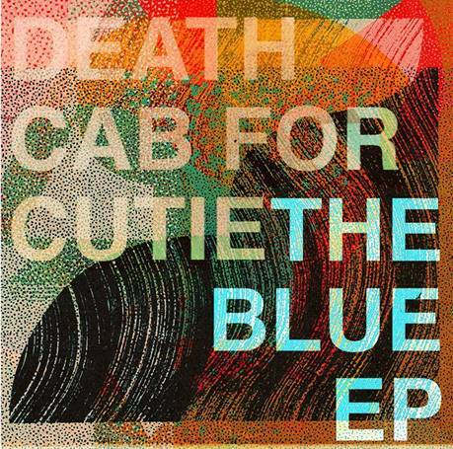

1. To The Ground
2. Kids in ’99
3. Man In Blue
4. Before The Bombs
5. Blue Bloods

###

**DEATH CAB FOR CUTIE**

**TOUR DATES 2019**

|  |  |
| --- | --- |
|  |  |

**SEPTEMBER**

6 Portland, OR Oregon Zoo Amphitheatre (w/ Car Seat Headrest) **\*SOLD OUT\***

7Redmond, WA Marymoor Park(w/ Car Seat Headrest) **\*SOLD OUT\***

8 Redmond, WA Marymoor Park(w/ Car Seat Headrest)

20 Saratoga, CA The Mountain Winery (w/ Hazel English)

21 Paso Robles, CA Vina Robles Amphitheatre (w/ Hazel English)

22 Glen Ellen, CA Sonoma Harvest Music Festival

For more news and information, please log on to [www.deathcabforcutie.com](http://www.deathcabforcutie.com).

Sheila Richman/Atlantic Records

212-707-3063 [Sheila.Richman@atlanticrecords.com](mailto:sheila.richman@atlanticrecords.com)

Libby Kober/Atlantic Records

212-707-2562 [Libby.Kober@atlanticrecords.com](mailto:Libby.Kober@atlanticrecords.com)