FOR IMMEDIATE RELEASE

AUGUST 16, 2019

**DEATH CAB FOR CUTIE RELEASE “TO THE GROUND” – SECOND TRACK FROM HIGHLY ANTICIPATED *THE BLUE EP***

***THE BLUE EP* ARRIVES EVERYWHERE ON SEPTEMBER 6TH;**

**PRE-ORDERS AVAILABLE** [**NOW**](https://death-cab-for-cutie.lnk.to/BlueEPPR)

**DEBUT TRACK “KIDS IN ‘99” RELEASED TO CRITICAL ACCLAIM FROM**

**ROLLING STONE, STEREOGUM, BILLBOARD, PASTE,**

**CONSEQUENCE OF SOUND & MORE**

*“Two decades and nine albums into their career, indie icons Death Cab for Cutie are still going strong with their distinct brand of bittersweet melodies and emotional excavations.”*

**– LOS ANGELES TIMES**

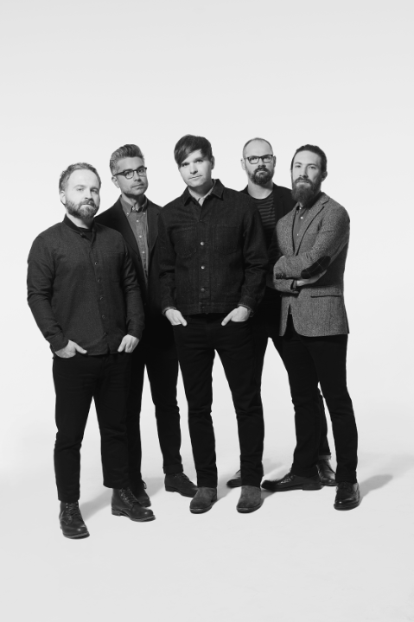

[*download hi-res press image here*](http://press.atlanticrecords.com/wp-content/uploads/2019/07/Death-Cab-for-Cutie-Credit-Eliot-Lee-Hazel-EP-1.jpg)

**LISTEN TO “TO THE GROUND”:** [**https://death-cab-for-cutie.lnk.to/ToTheGroundPR**](https://death-cab-for-cutie.lnk.to/ToTheGroundPR)

**PRE-ORDER:** [**https://death-cab-for-cutie.lnk.to/BlueEPPR**](https://death-cab-for-cutie.lnk.to/BlueEPPR)

8x GRAMMY® Award-nominated Atlantic recording group Death Cab for Cutie today releases “To The Ground” ([listen here](https://death-cab-for-cutie.lnk.to/ToTheGroundPR)), the second from their forthcoming *The Blue EP* – out everywhere Friday, September 6th (tracklist attached). “To The Ground” was produced by Rich Costey during the recording sessions for the band’s critically acclaimed ninth studio album, [*Thank You for Today*](https://lnk.to/ThankYouforToday) and held for this planned subsequent EP. *The Blue EP* is available for pre-order now at all DSP’s, streaming services, and the band’s online store ([here](https://death-cab-for-cutie.lnk.to/BlueEPPR)).

Today’s release comes on the heels of “[Kids in ’99](https://death-cab-for-cutie.lnk.to/Kidsin99PR)” – the debut track from the EP, released to critical acclaim at the end of July. [Rolling Stone](https://www.rollingstone.com/music/music-news/death-cab-for-cutie-kids-in-99-865125/) applauded the “sweet and somber song,” while [Stereogum](https://www.stereogum.com/2053028/death-cab-for-cutie-kids-in-99/music/) heralded the “slick, produced, sensitive studio-rock that Death Cab for Cutie have been making in recent years.” “‘Kids in ‘99’ features very tight alternative production and Ben Gibbard’s signature vocal stylings,” [Uproxx](https://uproxx.com/indie/best-new-indie-this-week-clairo-death-cab-for-cutie/) exclaimed, before asserting: “In most scenarios, any Death Cab is good Death Cab.”

The band also recently received critical acclaim for “Do You Remember,” a track from Chance the Rapper’s highly-anticipated new album *The Big Day* on which they are featured. Upon release, [TIME](https://time.com/5635605/chance-the-rapper-the-big-day-best-songs/) highlighted the track in their “5 Best Songs of the Week,” exclaiming: “On ‘Do You Remember,’ a laid-back, nostalgic jam, rock band Death Cab for Cutie shows up to set a dreamy, throwback mood.” The track has gone on to amass tens of millions of streams across platforms, with the band even inviting Chance the Rapper out during their Lollapalooza set to perform the fan favorite with them ([watch](https://www.youtube.com/watch?v=7YH1yOimQbQ)).

“To The Ground” and “Before The Bombs” were both produced by Costey, with “Kids in ‘99” and “Blue Bloods” receiving production from Peter Katis (The National, Interpol, Kurt Vile). Rounding out the project, “Man in Blue” was self-produced by the band.

Death Cab for Cutie recently wrapped the latest leg of their summer headline tour, including their first appearance at Lollapalooza since 2006, as well as performances at iconic venues from New York’s Forest Hills to LA’s Hollywood Bowl, and a sold-out show at the legendary Red Rocks Amphitheatre.The final leg of the tour will includea pair of highly anticipated homecoming shows at Washington’s Marymoor Park (with support from fellow Seattle natives Car Seat Headrest), as well as Sonoma Harvest Music Festival and other stops throughout California, Oregon, and British Columbia.

***

Death Cab for Cutie was born in 1997 when Western Washington University engineering student and budding guitarist-songwriter Benjamin Gibbard first united with guitarist-keyboardist-producer Chris Walla and bassist Nick Harmer to record a demo cassette dubbed “YOU CAN PLAY THESE SONGS WITH CHORDS.” Though Gibbard had initially conceived the tape as a solo project, the eight-song cassette proved both popular and aesthetically successful, prompting him to reconfigure Death Cab for Cutie as a full band. Death Cab for Cutie made their official live debut on November 22nd that same year, a performance recently uncovered and released as “[FIRST SHOW, ACOUSTIC AT THE PACER HOUSE, BELLINGHAM WA. 11​/​22​/​97](http://atlantic.lnk.to/DCFC_PacerHouse),” available now exclusively via [Bandcamp](http://atlantic.lnk.to/DCFC_PacerHouse); downloads begin at $4 with all of the band’s proceeds benefitting Seattle’s [The Aurora Commons](https://www.auroracommons.org/).

Immediately hailed as one of indie rock’s most compelling and creative collectives, Death Cab for Cutie’s milestone debut album, “SOMETHING ABOUT AIRPLANES,” arrived in 1998 via the Seattle-based independent label, Barsuk. The band enjoyed a long relationship with Barsuk before making their Atlantic Records debut with 2005’s fifth studio release, “PLANS.” The album proved the band’s popular breakthrough, earning RIAA platinum certification as well as spawning the chart-topping singles, “Soul Meets Body” and “I Will Follow You Into The Dark.”  The latter track was honored with a GRAMMY® nomination as “Best Pop Performance By Duo Or Group With Vocals,” with “PLANS” receiving the nod as “Best Alternative Album.”  “DIRECTIONS,” the 2006 DVD companion to “PLANS,” earned an additional GRAMMY® nod as “Best Longform Music Video.”

Now fully affirmed as an era-defining band, Death Cab for Cutie made a stunning #1 debut atop the SoundScan/Billboard 200 with 2008’s RIAA gold certified “NARROW STAIRS.” More critical acclaim and two further GRAMMY® nominations followed, including nods for “Best Alternative Album” and “Best Rock Song” (honoring the hit single, “I Will Possess Your Heart”). “THE OPEN DOOR” EP was released in 2009, earning DCFC a third consecutive GRAMMY® Award nomination for “Best Alternative Album.” “CODES AND KEYS” arrived in 2011 and made a top 3 entry on the SoundScan/Billboard 200 before receiving the band’s *fourth* straight GRAMMY® nomination for “Best Alternative Music Album.”  “You Are A Tourist,” the album’s first single, also proved a multi-format radio smash, reaching #1 at both Triple A and Modern Rock outlets nationwide – Death Cab for Cutie’s first-ever #1 at the latter format.

Death Cab for Cutie’s eighth studio album, “KINTSUGI” made a remarkable chart debut upon its March 2015 release, debuting at #1 on Billboard’s “Top Alternative Albums” and “Top Rock Albums” charts, as well as #8 on the overall SoundScan/Billboard 200. Hailed by Magnet as perhaps “the best record of (Death Cab for Cuties’s) 17-year career,” the album was honored with a “Best Rock Album” nomination for the 58th Annual GRAMMY® Awards – the iconic band’s eighth overall nod.

***

**DEATH CAB FOR CUTIE**

***The Blue EP***

Release Date: September 6th

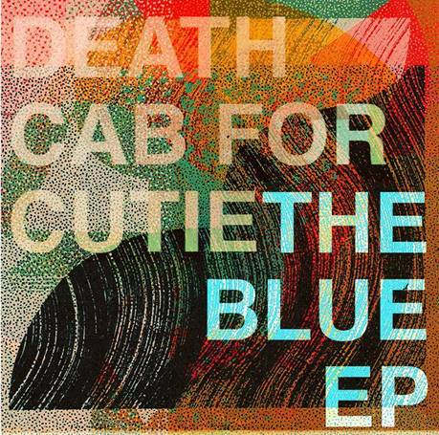

**TRACKLISTING**

1. To The Ground
2. Kids in ’99
3. Man In Blue
4. Before The Bombs
5. Blue Bloods

###

**DEATH CAB FOR CUTIE**

**TOUR DATES 2019**

|  |  |
| --- | --- |
|  |  |

**SEPTEMBER**

5 Vancouver, BC Malkin Bowl (w/ Jenn Champion)

6 Portland, OR Oregon Zoo Amphitheatre (w/ Car Seat Headrest) **\*SOLD OUT\***

7Redmond, WA Marymoor Park(w/ Car Seat Headrest) **\*SOLD OUT\***

8 Redmond, WA Marymoor Park(w/ Car Seat Headrest)

20 Saratoga, CA The Mountain Winery (w/ Hazel English)

21 Paso Robles, CA Vina Robles Amphitheatre (w/ Hazel English)

22 Glen Ellen, CA Sonoma Harvest Music Festival

For more news and information, please log on to [www.deathcabforcutie.com](http://www.deathcabforcutie.com).

Sheila Richman/Atlantic Records

212-707-3063 [Sheila.Richman@atlanticrecords.com](mailto:sheila.richman@atlanticrecords.com)

Libby Kober/Atlantic Records

212-707-2562 [Elizabeth.Kober@atlanticrecords.com](mailto:Elizabeth.Kober@atlanticrecords.com)