30 DAYS, 30 SONGS
Musicians Align Against Donald Trump
WATCH Death Cab for Cutie’s “Million Dollar Loan” - https://youtu.be/XE0nOfTA3pY

Features new and unreleased music by Death Cab for Cutie, Bhi Bhiman, R.E.M., Aimee Mann, Thao Nguyen, clipping., My Morning Jacket’s Jim James, and more!
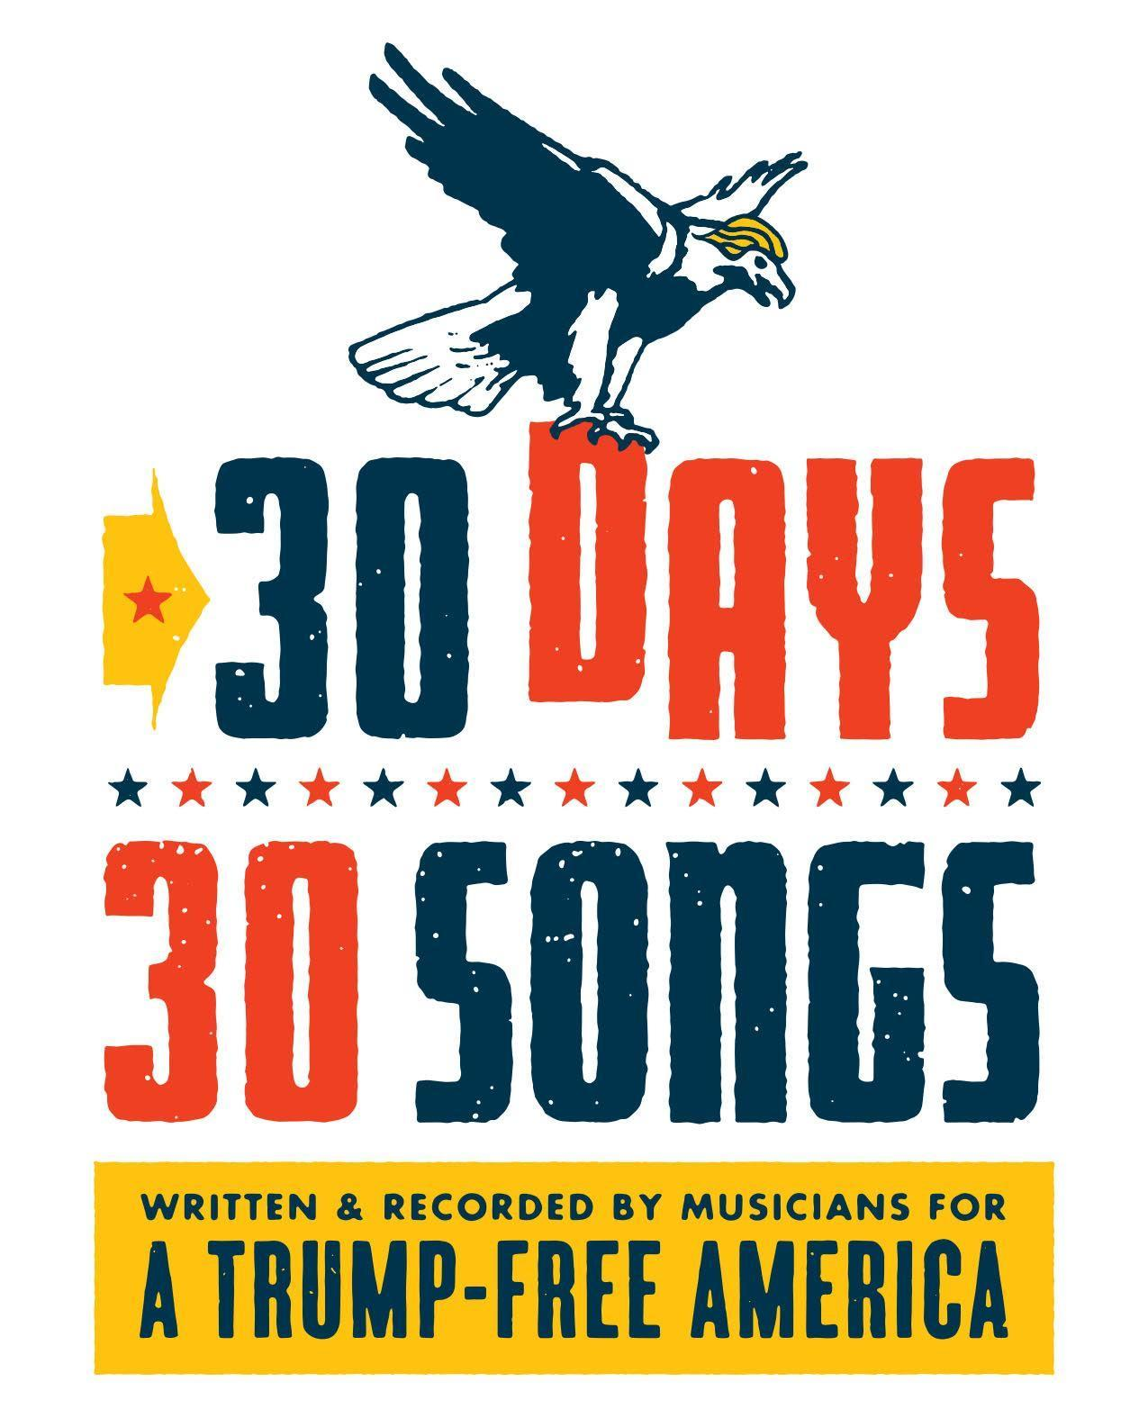
Today, we are proud to announce the launch of 30 Days, 30 Songs an independent project in support of defeating this year’s Republican presidential nominee, Donald Trump. Created by writer Dave Eggers and the team that brought you 2012’s 90 Days, 90 Reasons, 30 Days, 30 Songs is a daily, evolving playlist. It will feature a mix of new material and unheard tracks by many of our greatest independent musical voices, all of whom want a Trump-free America. (Read the project’s mission statement HERE.)

Beginning today, 30 Days, 30 Songs will release one track per day until Election Day. The collection’s first week will feature original compositions by Death Cab for Cutie, Jim James, Aimee Mann, Thao Nguyen, clipping., and Bhi Bhiman. The week also includes a never-before-released live song by R.E.M.

The project kicks off with "Million Dollar Loan," an original Death Cab for Cutie song accompanied by a lyric video directed by Simian Design. Explains DCfC frontman Ben Gibbard, “Lyrically, ‘Million Dollar Loan’ deals with a particularly tone deaf moment in Donald Trump's ascent to the Republican nomination. While campaigning in New Hampshire last year, he attempted to cast himself as a self-made man by claiming he built his fortune with just a ‘small loan of a million dollars’ from his father. Not only has this statement been proven to be wildly untrue, he was so flippant about it. It truly disgusted me. Donald Trump has repeatedly demonstrated that he is unworthy of the honor and responsibility of being President of the United States of America, and in no way, shape or form represents what this country truly stands for. He is beneath us.”

Future weeks will feature an incredible lineup of artists. Each song will go up at 9 am Pacific time daily on 30days30songs.com as well as via the following playlists:

30 DAYS, 30 SONGS SPOTIFY PLAYLIST
Apple Music playlist will be live within 24 hours

EMBED THE PLAYLIST: <iframe src="https://embed.spotify.com/?uri=spotify%3Auser%3A30days30songs%3Aplaylist%3A0GDtTmyBfSvYxMgFCS6yee" width="300" height="380" frameborder="0" allowtransparency="true"></iframe>

PURCHASE “MILLION DOLLAR LOAN” BY DEATH CAB FOR CUTIE: http://apple.co/2dfsKTh

The genesis for 30 Days, 30 Songs began after Eggers, horrified by the Trump campaign, attended a Trump rally in Sacramento for The Guardian. “While the audience was waiting for Trump to appear, I was pretty surprised to hear music by Bruce Springsteen, Elton John and Queen,” says Eggers. “None of these musicians support Trump, of course, so it occurred to me that this election would benefit from the timely resurrection of the political protest song. From Woody Guthrie to Public Enemy, we know that songs can change minds, and particularly now, we need to motivate voters to stand against bigotry, sexism, hatred and ignorance.” In the weeks that followed, dozens of songwriters were contacted, and those who had the time and inspiration wrote songs for what became 30 Days, 30 Songs.

All proceeds generated by 30 Days, 30 Songs will be donated to the Center for Popular Democracy (CDP) and their efforts to achieve Universal Voter Registration for all Americans (https://cpdaction.org/).

Many more songs – a grand total of 30, to be exact - are set for release over the next few weeks, so continue to go to 30days30songs.com for more...

#30days30songs
Website * Facebook * Twitter

