DEAR EVAN HANSEN 12” PICTURE DISC AVAILABLE TODAY
INCLUDES “WAVING THROUGH A WINDOW” AND PREVIOUSLY UNRELEASED TRACK,
“IN THE BEDROOM DOWN THE HALL”

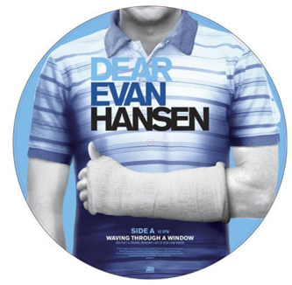

PURCHASE 12” PICTURE DISC: https://Atlantic.lnk.to/InTheBedroomDownTheHallPR

POST “IN THE BEDROOM DOWN THE HALL”:
https://www.youtube.com/watch?v=cvf1ETgCMN4

Atlantic Records today released a Dear Evan Hansen vinyl 12” picture disc pairing “Waving Through A Window,” one of the show’s most popular tracks, with a never-before-released song, “In The Bedroom Down the Hall.”

Written by Academy Award and Tony Award-winners Benj Pasek and Justin Paul and performed by Tony Award-winner Rachel Bay Jones and Tony Award nominee Jennifer Laura Thompson, “In The Bedroom Down The Hall” appeared in very early versions of the show and was cut before the show's D.C. premiere. Until today, it has never been available for fans to hear.

The Original Broadway Cast Recording of six-time Tony-winning musical Dear Evan Hansen debuted on the Billboard 200 at #8 upon its release in February – the highest charting debut position for an original cast album since 1961.

For more, visit:
www.dearevanhansen.com
www.instagram.com/dearevanhansen
www.twitter.com/dearevanhansen
www.facebook.com/DearEvanHansen

