DON Q DROPS CORNER STORIES RELOADED

CORNER STORIES TOPS 1M

STREAMS ON DATPIFF: UPDATED MIXTAPE CONTAINS 5 NEW TRACKS

"OH YOU THE PLUG" VIDEO PREMIERING TODAY ON COMPLEX AT 1PM EST; WATCH THE TRAILER NOW

OUT NOW VIA HIGH BRIDGE THE LABEL / ATLANTIC RECORDS; STREAM / PURCHASE HERE

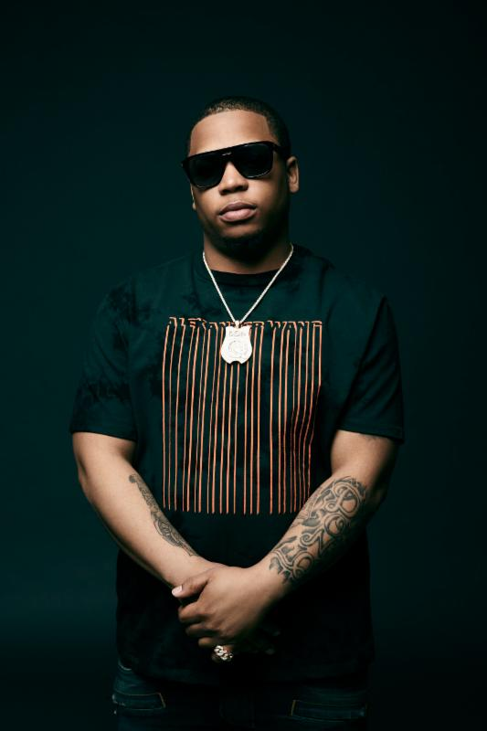
Photo credit: Jimmy Fontaine

High Bridge The Label & Atlantic Records are excited to officially share Corner Stories Reloadedtoday, the updated mixtape from Bronx rapper Don Q, featuring five new tracks that highlight Don Q's lyrical flow and are the true embodiment of East Coast rap. The mixtape is an updated version of the previously released project Corner Stories, which has now reached over 1M streams onDatPiff. The 15-track project evokes some of hip-hop's "mixtape era" icons like Lloyd Banks, Cassidy and Fabulous and features collaborations from Philly crooner PNB Rock, aforementioned veteran spitter Fabulous, longtime friend and fellow High Bridge label mate A Boogie Wit Da Hoodie, Atlanta's very own Loso Loaded, NYC's Rowdy Rebel, and Miami's Zoey Dollaz. Production by Murda Beatz (Gucci Mane, French Montana), and Scott Storch helps bestow the perfect backdrop to Q's visceral delivery and penmanship. The project provides a look into the Highbridge life and is peppered with tales of overcoming obstacles, life and death, and the hustle; all stories that befit the corner where everyday life happens in that Bronx neighborhood. "'I'm going to call it Corner Stories.' I'm going to share the story about the corner. That's what we're doing every day. That's our life."

In addition to today's mixtape release, Complex will premiere the visual for new single "Oh You The Plug" at 1pm EST. The video shows Don Q's take on the mobster lifestyle and taking revenge into your own hands with a plot twist ending. Watch the video at complex.com

Stay tuned for more updates on Don Q coming soon !

LISTEN TO / STREAM "OH YOU THE PLUG":
https://youtu.be/qhbFcW0OBqY?list=PLC4Qr-naMF1HyARGnNfgXRl7x7tzgJQ4q

WATCH "CHASING THESE BANDS" FEAT. PNB ROCK AND FABULOUS:
https://youtu.be/QK3V8HGDB-Y

PURCHASE / STREAM CORNER STORIES RELOADED:
lnk.to/CornerStoriesReloaded
https://www.youtube.com/playlist?list=PLC4Qr-naMF1HyARGnNfgXRl7x7tzgJQ4q

EARLY PRESS ON DON Q

"The New York rap hardass we need" - STEREOGUM

"Don Q is turning heads with lyrical prowess and gritty delivery." - XXL

"Don Q has brought new excitement to the Bronx's hip hop scene..." - MASS APPEAL

"New York City hip-hop is under new management. And at the heart of the revival are Highbridge The Label stars, A Boogie Wit Da Hoodie and Don Q." - RAP RADAR

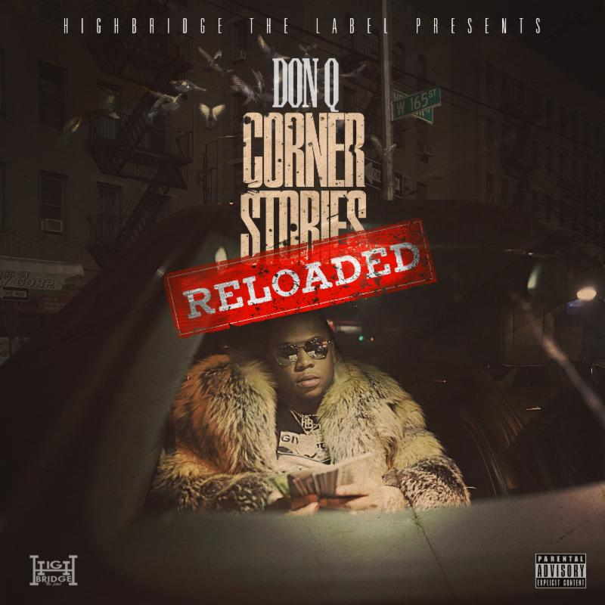

CORNER STORIES RELOADED TRACKLIST
1. Intro: RELOADED (Explicit Album Version)
2. 2 Perks (Explicit Album Version)
3. Oh You The Plug (Explicit Album Version)
4. Chosen One (Explicit Album Version)
5. Chasing These Bands (Feat. PNB Rock & Fabolous) (Explicit Album Version)
6. Do It Bigger (Explicit Album Version)
7. Don Vito (Explicit Album Version)
8. Protect Ur Patek (Explicit Album Version)
9. I Told You (Feat. A Boogie Wit Da Hoodie) (Explicit Album Version)
10. Young Veterans (Feat. Loso Loaded) (Explicit Album Version)
11. #FREEDA9 (Feat. Rowdy Rebel) (Explicit Album Version)
12. 100 Mil (Explicit Album Version)
13. Get Up N Get It (Feat. Zoey Dollaz) (Explicit Album Version)
14. Thank God (Explicit Album Version)
15. Corner Stories (Explicit Album Version)

SOCIALS
twitter.com/DonQHBTL
instagram.com/DonQHBTL/
facebook.com/DonQHighbridge
soundcloud.com/therealdon-q

FOR PRESS INQUIRIES: Biz 3 / Dana Meyerson Dana@biz3.net & Yashar Zadeh Yash@biz3.net

